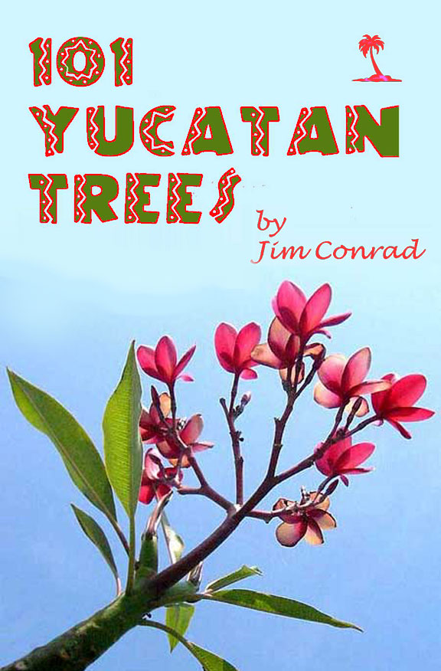

Thanks to the folks who hosted me during various seasons happily spent tree-watching in the Yucatan: Ana María Palos near Dzemul, Katharine Wingate near Telchac Pueblo, Diego Nuñez in Río Lagartos, Marcia and Kim Bales at Mayan Beach Garden Inn, the villagers of Sabacché and Yokzenot, and Belisa Barbachano and Bruce Gordon at Hacienda Chichen -- where I stayed for three and a half years in a real Maya hut provided by them.
Also thanks to Bea Laporte in Ontario for proofing. Any typos or befuddling word order were added during my page layout ordeal, after her expert reading.
INDEX TO SPECIES
{clickable unless this is on paper}
ORNAMENTALS
ROYAL PALM 1
ARECA PALM 4
BAMBOO PALM 5
GUMBO-LIMBO - Chaká 6
CHINESE BANYAN - Laurel 8
BO TREE 10
SPANISH BAYONET 11
MEXICAN PONYTAIL - Despeinada 13
SCREW-PINE 14
SHAVINGBRUSH TREE - Amapola 16
FRANGIPANI -Flor de Mayo 18
CIRICOTE - Ciricote 19
ROYAL POINCIANA - Flamboyán 20
LEBBECK-TREE - Algarrobo Blanco 22
PURPLE ORCHID TREE - Árbol Orquídea 24
TROPICAL LILAC - Balché 25
INDIAN CORAL TREE - Colorín Pinto 26
DWARF POINCIANA - Chaksikin 28
GOLDEN SHOWER TREE - Lluvia de Oro 30
PINK TABEBUIA - Roble 32
BLUE JACARANDA 34
MORNING-GLORY TREE - Campanilla 35
OLEANDER 36
YELLOW OLEANDER- Aki'its 38
HOJA SANTA 39
POINSETTIA - Nochebuena 41
LADY OF THE NIGHT - Galán de Noche 43
MEXICAN ELDER - Sauco 44
TREE COTTON - Algodón 45
GIANT MEXICAN SUNFLOWER - Árnica.......48
FRUITING TREES
SAPODILLA - Chicozapote 50
MAMEY 52
CANISTEL 53
STAR-APPLE - Caimito 54
CUSTARD APPLE - Anona 56
SWEETSOP - Saramuyo 57
SOURSOP - Guanábana 58
POMEGRANATE - Granada 60
AVOCADO - Aguacate 62
MANGO 64
PAPAYA 67
BANANA- Plátano 68
GRAPEFRUIT - Toronja 71
BITTER ORANGE - Naranja Agria 74
SWEET ORANGE - China 76
KEY LIME - Lima Agria 78
SPANISH PLUM - Ciruelo 80
BARBADOS-CHERRY 83
NANCE 84
GUAVA, Guayaba 86
GUAYA 88
TAMARIND - Tamarindo 90
NONI 92
COW OKRA - Pepino de Árbol 94
ANNATO - Achiote 96
INDIAN-FIG - Nopal 97
THE YUCATAN'S FORESTS......................101
SCARLET-BUSH - Coralillo 103
SENNAS 104
BUTTERCUP TREE - Madera de Pasta 106
CECROPIA - Guarumo 108
WILD PAPAYA 110
MALA MUJER 111
SU-TUT 114
TREMA - Capulín 115
AUSTRALIAN PINE 116
COCONUT PALM - Cocotero 119
THATCH PALM - Huano 122
CHIT PALM 125
PAUROTIS PALM 126
COYOL 128
MANGROVES IN THE YUCATAN 130
RED MANGROVE - Mangle Rojo........131
BLACK MANGROVE - Mangle Negro:134
WHITE MANGROVE - Mangle Blanco:135
BUTTONWOOD - Botoncillo................137
BEAN FAMILY TREES .................................138
GUANACASTE - Piich 139
SWEET ACACIA 141
GAUMER'S ACACIA 143
BULL-HORN ACACIA 146
BAHAMA MIMOSA 148
WILD TAMARIND #1 - Uaxim 150
WILD TAMARIND #2 - Tsalam 152
BALCHÉ 153
FISHPOISON TREE - Habim etc. 155
BLACKBEADS 157
KIK-CHÉ 159
MADRE DE CACAO 161
STRANGLER FIGS 163
POISONWOOD - Chechén 165
BEC 168
IGUANA HACKBERRY 169
SPANISH CEDAR - Cedro 170
VITEX 172
SIP-CHÉ 174
PIXOY 176
BREADNUT - Ramón 178
MORA 181
ALVARADO 183
PEPPER BUSH 185
COW-ITCH - Ortiga 187
BONETE 188
HELICOPTER TREE 190
"GAUMER'S BAKERIDESIA" 193
"DOG JASMINE" 194

ROYAL PALM
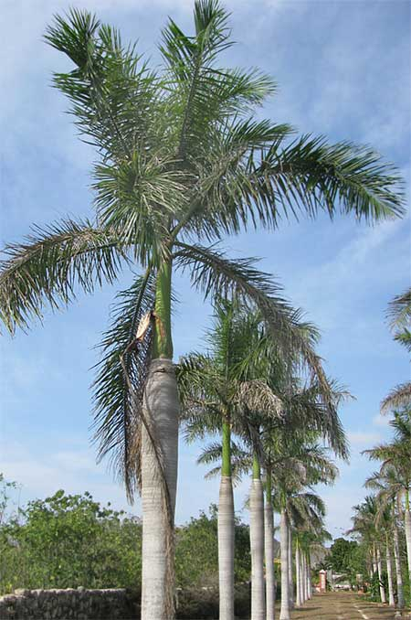
Back during the heyday of henequen production when Mérida boasted of being home to more millionaires per capita than any other city on Earth, entry roads to the most prosperous plantation mansions often were framed with tall, stately Royal Palms, Roystonea regia, such as those shown above.
Something special that helps distinguish Royal Palms from other palm species is their prominent, green "crownshaft" -- that smooth, green area between the gray trunk and the tuft of shaggy fronds. Crownshafts are formed by the leaves' very broad, overlapping petiole-bases, a petiole being a leaf's stem.
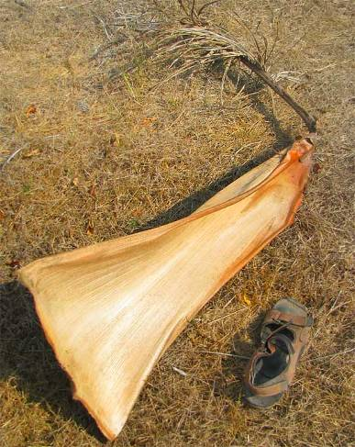
Here's something all property owners with lots of Royal Palms on their grounds know: The bottom leaves or fronds of Royal Palms always are drying up and falling off as new, larger fronds emerge above them. What's shown at the right is very typically found beneath Royal Palms.
Old fronds fall mainly during the dry season. The tree is ridding itself of older, less efficiently photosynthesizing leaves, and is a water-saving adaptation. Another adaptation is shown below.
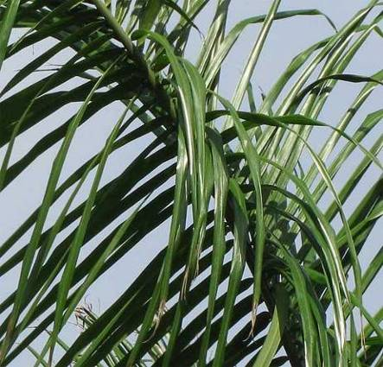
The Royal Palm fronds' closely spaced leaflets arise from the midrib at various angles. That's very different from most other feathery-leafed palms whose pinnae are like flat feathers. Why would such a dignified palm permit itself such disorderly appearing fronds? The answer became clear one morning as I breakfasted beneath a Royal Palm and noticed what's shown atop the next page.
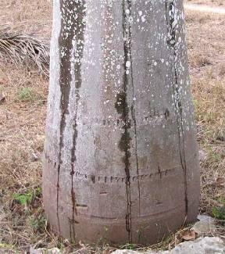
All during the meal cool water droplets showered onto my bare back from the palm's shaggy leaves. Also, little streamlets of water drained down the palm's trunk, as shown at the right.
The palm's many leaflets thrusting ever-which-way into the morning's moisture-saturated air were wicking moisture from the air, gathering it and dropping it onto its own roots, and letting it run down its smooth, absorbent-looking trunk!
Royal Palms also produce enormous flower clusters, which sometimes buzz very loudly with bees and other pollinators, as shown below:
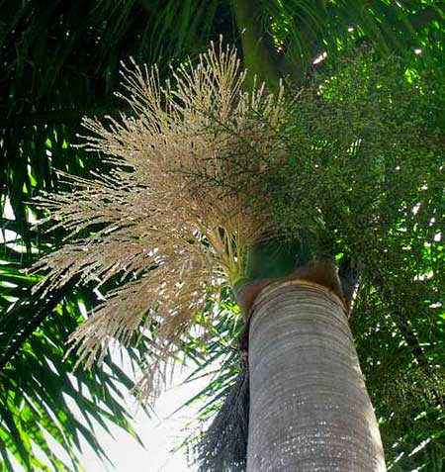
Sexually, Royal Palms are "monoecious," which means that each tree bears separate male and female flowers. In the picture, the dark green flower cluster on the right bears hundreds of developing fruits, which when mature will be only about half an inch wide (1.3 cm); the white cluster at the left bears thousands of male flowers that when spent will flurry to the ground like a gentle snow. Sometimes the ground becomes white with discarded male flowers.
Royal Palms are native to southern Florida, southeastern Mexico, including the Yucatan, as well as Cuba, the Bahamas and the Cayman Islands. Earlier the Florida populations were regarded as a different species, but genetic studies show that they are not distinct enough to be regarded as a separate species.

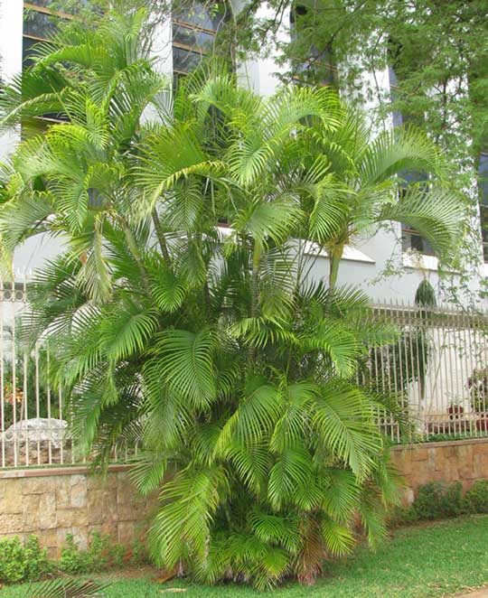
ARECA PALM
On Mérida's grand Paseo Montejo you might see the palmshown at the left. The fronds may look familiar if though you can figure out what it was. It's an Areca Palm, Dypsis lutescens. It looks familiar because Arecas are much planted in pots. The one in the picture is unusual because it's so large and planted in the ground.
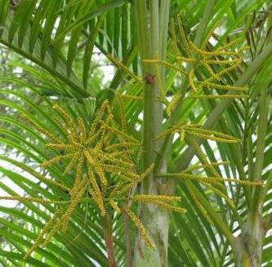
Some larger Arecas bear flowering heads such as those shown at the right.
The Areca Palm is native to Madagascar but abundantly planted throughout the world's tropics and subtropics. One reason for its popularity is that it's easy to grow, thriving in full sun or shade. It can be grown from seeds or offshoots can be cut from the trunk's base and used to start new plants.

BAMBOO PALM
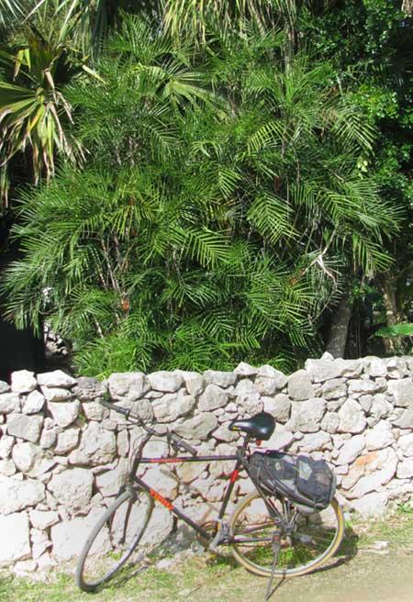
Sometimes you see very dense clumps of slender-stemmed palms like those shown at the left.
That's the Bamboo Palm, Chamaedorea seifrizii, native to southern Mexico, including the Yucatan, and Central America, where it thrives as an understory species in the shade. On mature Bamboo Palms often you find unusual, colorful flowers and fruits like those shown at the right, One Internet page declares that the species' mature fruits are toxic.
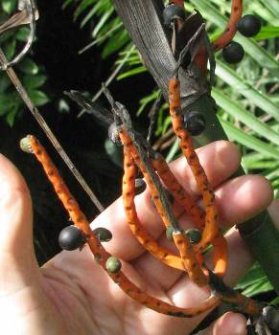
A closely related and similarly shade-loving palm, Chamaedorea oblongata, grows wild in the southern Peninsula where it's rainier and the forest is higher.

GUMBO-LIMBO - Chaká
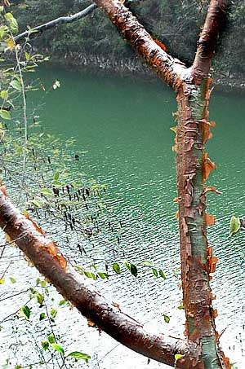
One of the most common and best-known trees in the Yucatan -- in fact of most of Mexico -- catches the eye because of its reddish, flaky bark, shown at the left.
The Maya call the tree Chakah, and many savvy visitors call it that, too. However, the same species, Bursera simaruba, also grows in southern Florida, where it's called Gumbo-Limbo, so probably that's the best known English name we have.
Below, you can see Gumbo-Limbo's pinnately compound leaves, which look like those of the North's ash trees. Also you can see the tree's grape-sized fruits, which appear deep in the dry season, in April or so. Birds, squirrels and other critters relish the fruits, often eating them before they turn their mature purplish. Humans find the fruits bitter, tasting like a blend of menthol and pine resin.
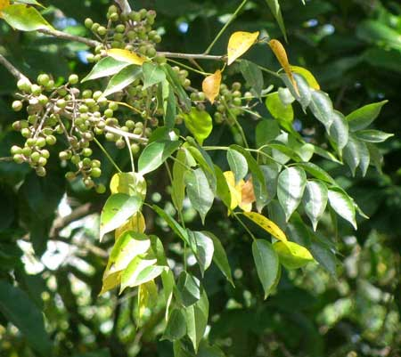
Gumbo-Limbo's wood is brittle and juicy, and its sap smells a little like turpentine. I read that in the Caribbean people use its resin as glue, varnish, water-repellent coating, and incense. Gumbo-Limbo is considered medicinal nearly everyplace it grows. In fact, it's one of those plants whose listed cures are so varied that you suspect them all. However, its sap has such a clean, crisp odor that just smelling it probably makes you feel better.
Something else impressive about Gumbo-Limbo is that it's very flexible in terms of habitat requirements. You find it holding its own in fairly undisturbed forests as well as appearing as a "weed tree" along roads and in chopped-over cornfields. In southern Florida it makes a handsome street-tree.

CHINESE BANYAN/ Laurel
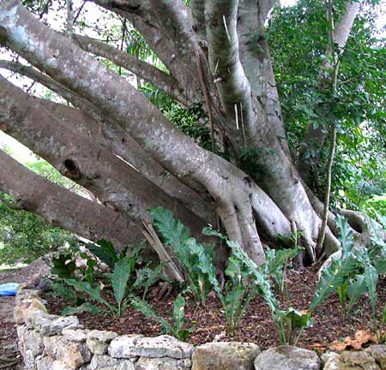
When you see big, multi-trunked trees with smooth, gray bark,whether it's sprouting from the top of a Maya ruin or out in the forest, probably it's one of several native, wild species of Yucatan's "strangler figs." However, if you see such a tree in town or around an old hacienda, there's a good chance that you have a fig tree brought from outside the country. That's the case with the one in our picture.
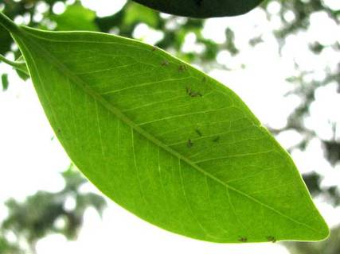
That's a Chinese Banyan, Ficus microcarpa, from southern Asia and northern Australia but now widely planted in the tropics worldwide. Since it's a Ficus you know that it's a real fig tree, despite its leaf, shown at the right, not having a "fig-leaf shape.
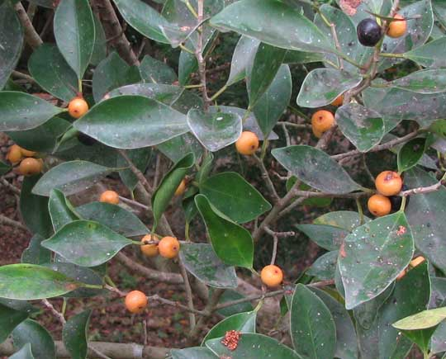
Like most fig species, banyans produce spherical, pea-sized fruits which are very unlike the Common Fig's large, pear-shaped fig. At the left you see a branch of a Chinese Banyan loaded with figs.

One feature causing that fig-loaded branch to be so typical is that its leaves are well splattered with bird poop, for many bird species eat figs. Sometimes as they fill the trees with their hopping, flitting and calling they eat so many figs that they get the runs! That's part of nature's plan, however, for wherever the splattered poop lands, the fig's tiny seeds are sown.
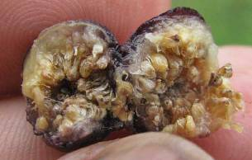
At the right you see a split-open Chinese Banyan fig. Such figs are edible but they're so small and tasteless -- not to mention the bird-poop problem -- that hardly anyone bothers to snack on them.
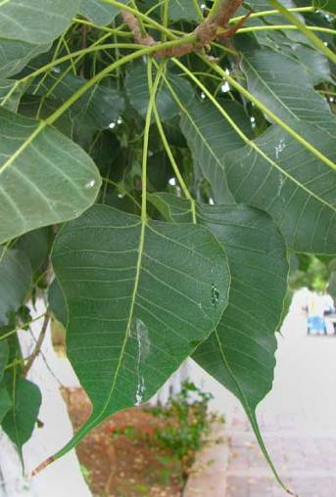

BO TREE
The Bo-Tree, Ficus religiosa, is an introduced fig tree much planted along Mérida's famous Paseo de la Reforma and elsewhere. Though the Bo-Tree's trunk system is like that of the Chinese Banyan's, its leaves are very different, being more or less triangular with long, slender "drip tips" like those shown at the left.
Bo-Trees are native to India and thereabouts, where some regard them as sacred. The Buddha sat beneath a Bo-Tree when he "awakened."

SPANISH BAYONET
Spanish Bayonets, Yucca aloifolia, are yuccas, same as Joshua Trees of the US southwestern desert. That's one below.
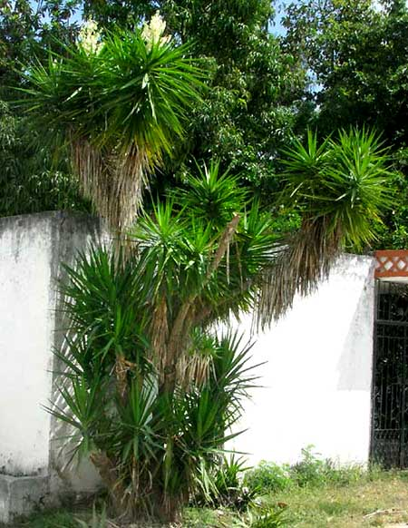
Typical of Spanish Bayonets are their brown, dried-up "shags" of old leaves gathered like grass skirts below the stiff, sharp-pointed leaves at the top of each trunk.
Atop the next page you see the Spanish Bayonet's typical yucca flowers.
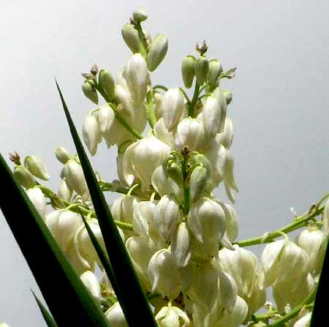
There's a similar yucca, known as Spanish Dagger, Yucca gloriosa, native to US coastal areas from North Carolina to Florida, also much planted and escaped, and likely to be confused with Spanish Bayonet. However, that species, Spanish Dagger, is more branched, presents an overall moundlike appearance instead of our plant's tall-standing one, plus its leaves are bluish-green instead of our plant's dark green.
Spanish Bayonet is native to US coastal areas from North Carolina to Louisiana, as well as the Caribbean and eastern Mexico. It's "gone wild" in much of the US Southeast and elsewhere. Several cultivars have been developed, including 'Marginata' with yellow-margined leaves.

MEXICAN PONYTAIL - Despeinada
Below, that 20-ft-tall (6m) palm-like tree in full bloom next to a bank along Mérida's Paseo de Montejo is a native Yucatec plant found in the Peninsula's more arid, scrubby parts. You might think it's some kind of yucca or maybe a palm, but it's unrelated to those plant groups.
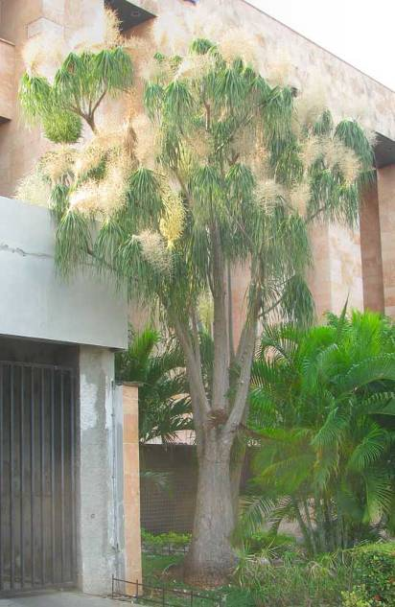
It's the Mexican Ponytail, also known as the Ponytail Palm, Elephant-Foot Tree, and by many other names. It's Beaucarnea pliabilis.
Probably you are more accustomed to seeing Mexican Ponytail in pots where sometimes they produce very large, spherical, water-storing bulges at their trunk bases. Often you see them in hotel lobbies and the like. They're planted in the tropics worldwide because they are such unusual, handsome plants.

SCREW-PINE
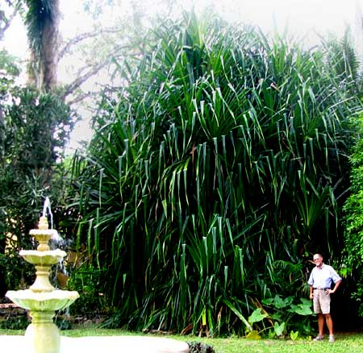
Above you see a 25-ft-tall (7.5m), much-branched, unusually large (for the Yucatan) specimen of a species that surely is one of the most misidentified and underappreciated of our ornamental plants. This one used to be at Hacienda Chichen Resort adjacent to Chichén Itzá ruins.
It's the Screw-pine, a member of the genus Pandanus, maybe Pandanus veitchii from Polynesia. About 600 Pandanus species are recognized. The main difficulty in being sure which species we have is that flowers seldom or never appear here, and flowers are needed to identify them.
Screw-pines are unrelated to pines. They're vaguely like palms, yuccas or enormous amaryllises, but they're not closely related to those plant groups either. They're their own thing, members of the Screw-Pine Family, the Pandanaceae. Screw-pines are native to the Old World tropics, mostly of Malaya and the Pacific islands. They are monocots, like grasses and lilies. Plants are either male or female.
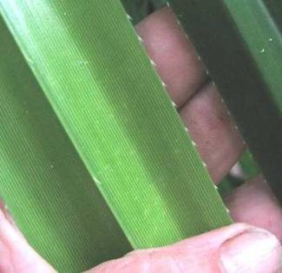
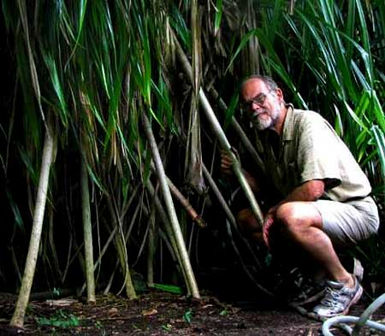
In the Yucatan mostly you see only young individuals without well developed stems. People plant them expecting them to look like leafy agaves, never dreaming that if left alone they'll grow to tree size. Also, mature Screw-pines develop prop roots like those shown at the right.
If you're unsure whether you have a baby Screw-pine or something similar, check out the leaves. They should be stiff like plasticised paper, with a prominent midvein amidst many parallel secondary veins, and bear sharp, thick-based little spines on the margins like those shown at the left.

SHAVINGBRUSH TREE - Amapola
During the dry season sometimes you see medium-sized trees with thick, pale gray, semisucculent, gangly branches at the tips of which arise four-inch-high (10cm) flowers like the one shown below.
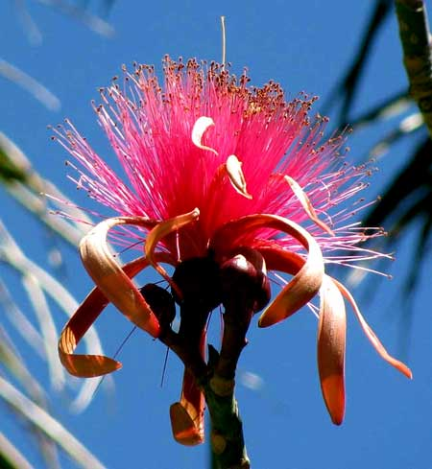
That's a single flower, and flowers can be either pink or white; a white one is shown on the next page. The tree producing these gorgeous flowers is sometimes called Shavingbrush Tree. It's Pseudobombax ellipticum, a member of the Hibiscus Family, the Malvaceae.
Right before they open, Shavingbrush Tree's flower buds look like four-inch-long (10cm), brown cigars. The brownness is on the outside of long petals slightly connected to one another along their margins. When the long bud is about to open, usually just after dawn, first the connected petals buckle outward at their bases making slits.
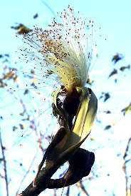
That's when birds such as Hooded Orioles come, stick their bills through the vertical slits, and sip nectar. There must be a lot of nectar, too, for sometimes the birds' throat muscles vigorously work as they sip, and glistening beads of nectar cling to the birds' withdrawn beaks. Also, the nectar-feeding birds pee as frequently as sapsuckers at sap-rising time up North.
As the morning warms, the blossoms open, attracting not only birds but also honeybees. It's nothing to see a yellow and black oriole probing deeply into the stamen tuft while six to ten bees work the same flower's stamen tips. Pretty!
During the rainy season Shavingbrush Tree is green with digitally compound leaves -- the leaflets arising from the leaf petioles' tops like digits from hands. The fruits look like large okra pods filled with pea-sized seeds and white fuzz. When still green, before the fuzz has become dry and the seeds hard, the pods' contents can be eaten. In Maximino Martinez's Las Plantas Medicinales de México it's reported that the flowers can be cooked to make a tea for fevers and coughs, and powdered bark from the tree can tighten gums.
This magnificent species is native to our area -- southern Mexico south to Honduras and El Salvador, and is grown as an ornamental in Florida, Hawaii and other semitropical parts of the world. It can reach 60 feet high (18m).

FRANGIPANI -Flor de Mayo
Frangipani, genus Plumeria, is commonly planted throughout the Yucatan as well as the rest of the whole world's tropics because the flowers are so pretty and fragrant. Below you can feast your eyes on some blossoms.
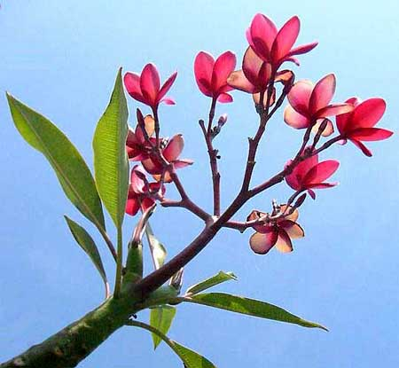
Hawaiian leis typically are made of Frangipani flowers, so people often assume that Frangipanis are Hawaiian. In fact, Frangipanis are native to the Yucatan. Out in the Yucatan woods you can find Frangipanis blooming as prettily as the one above. Two species are listed for the Yucatan. The above one is Plumeria rubra.
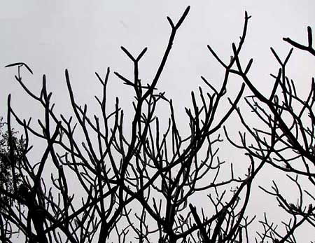
During the dry season Frangipani trees lose their leaves, resulting in their naked branches looking like a jumble of dead twigs. At the right you can see what I mean.
However, when the rainy season returns in May or thereabouts those same branches once again become gloriously arrayed with flowers. The locals often call Frangipanis Flor de Mayos -- May Flowers, because of this spectacular May blossoming.

CIRICOTE - Ciricote
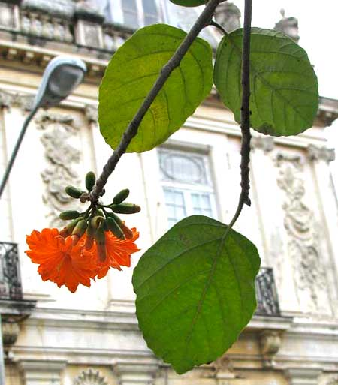
The Ciricote, Cordia dodecandra, is found in every Yucatan village and along many city streets not only because its reddish-orange flowers are so pretty, but also because it's native to the Yucatan. In northern Yucatan you find it just as prettily flowering out in the scrubby woods as along Mérida's Paseo de Montejo, shown above. However, Ciricote isn't as common in the wild as it used to be because its colorful wood is highly regarded for use as furniture wood, plus it's known to hold up under wet conditions.
Ciricotes are distributed from southern Mexico into Belize and Guatemala. A similar and closely related tree, in English sometimes Geiger-Tree, Cordia sebestena, has flowers with only 5-8 corolla lobes, as opposed to the Ciricote's 12-16.

ROYAL POINCIANA - Flamboyán
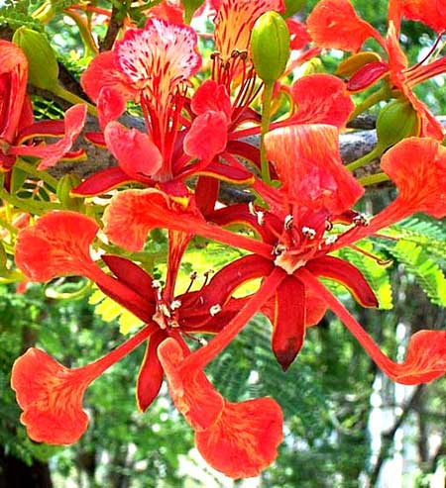
Any fair-sized, ornamental, tropical tree with dark green, twice-compound leaves and with branches absolutely burgeoning with bright red, saucer-sized flowers surely is the abundantly planted and much-loved Royal Poinciana, also called Peacock-Flower, Flamboyant and other English names. It's Delonix regia, a native to Madagascar but one of the most planted of all tropical, ornamental trees.
The Royal Poinciana's peak flowering time occurs as the dry season changes to the rainy, in May or thereabouts. The twice-compound, Acacia-like leaves cue us to the fact that Royal Poincianas belong to the big Bean Family. The Bean Family relationship becomes more obvious deep in the dry season when the tree loses its leaves and drops its two-ft-long (60cm), legume-type fruiting pods. Below, that's the woody half of one split-apart legume.
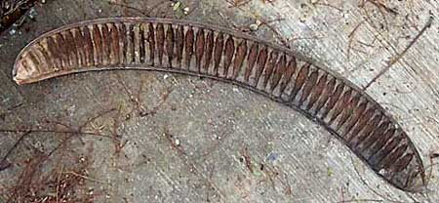
The "notches" in the legume's inner wall are where the beans nestled before the pod split apart. During the dry season when Royal Poincianas are leafless and full of dangling, brown legumes of this kind, the tree is a bit homely. However, as soon as the rainy season brings back the lush herbage and gorgeous flowers, all is forgiven.

LEBBECK-TREE - Algarrobo Blanco
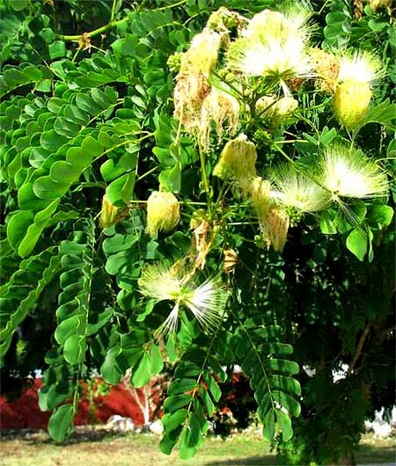
The Lebbeck-Tree, Albizia lebbeck, also a member of the Bean Family, catches our eye during both its flowering and fruiting season. In the late rainy season, in September or so, these good-sized trees issue egg-sized, powder-puff-like clusters of perfumy, greenish-yellow flowers that show up very prettily against the tree's twice-pinnate leaves, as shown at the right.
In the flower clusters the slender, fuzzy items are the male parts -- the stamens. Each stamen is tipped by a tiny anther that opens to release pollen. In the picture the stamens in some flower clusters are drooping and turning brown after their blossoms have been pollinated, and the stamens are no longer needed.
Despite the tree's prettiness and the sweet fragrance of its flowers, it's possible that most Northerners mainly notice the tree in the late dry season, in April or so, when leafless Lebbeck-Trees are heavily laden with legume-type fruits, as shown atop the next page.
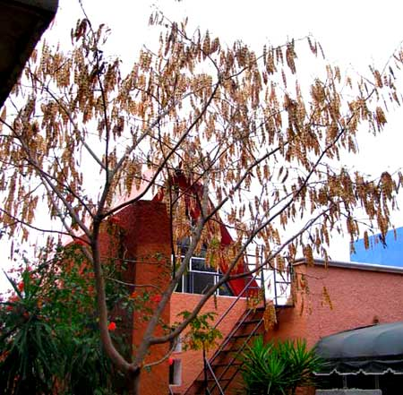
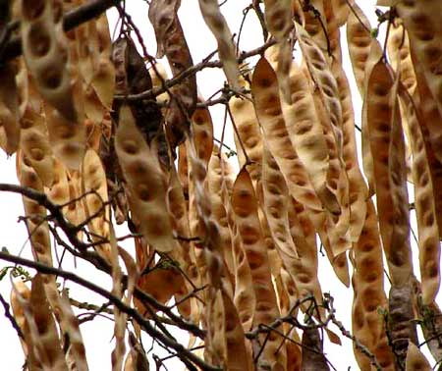
Lebbeck-Trees have been planted along many of Mérida's most used streets. Many drivers on those streets never notice the trees' flowers as they rush by, but late in the dry season when long lines of leafless trees appear, with all those dry, brown legumes clacking against one another in the afternoon wind, more than one person has wondered why such ugly trees were planted. If they'd just see and smell the flowers during the rainy season, they'd know.
At the right, a closer look at the above tree shows the 10-inch-long (25cm) dry pods with their widely spaced beans inside them clearly visible.
Lebbeck-Trees are native to tropical Asia and northern Australia, though they're planted widely throughout the world's tropics. "Lebbeck" is its Arabic name.

PURPLE ORCHID TREE - Árbol Orquídea
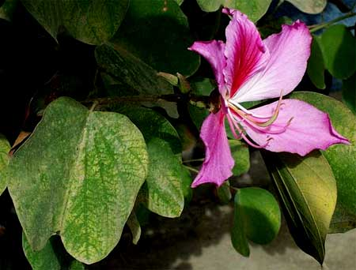
If you see a smallish tree with saucer-sized leaves curiously shaped like the prints of cow hooves, with similar-sized lavender to purple flowers, it's the Purple Orchid Tree, or just Orchid Tree, Bauhinia variegata. That's one below:
Purple Orchid Trees belong to the big Bean Family, though admittedly they're unusual members. For one thing, most Bean Family members bear compound leaves, but this one's leaves are simple and have that strange shape. In the Yucatan's forest and in weedy places often you see small trees with similar leaves but with much smaller, white flowers. They're also members of the genus Bauhinia, but few people plant them as ornamentals.

TROPICAL LILAC - Balché
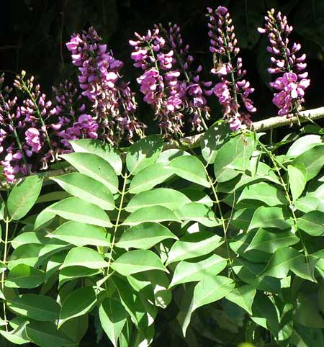
Among the Maya the Balché tree is an important native ceremonial tree found in the forest. The pretty tree shown at the right, often seen along streets and in villages, is very closely related (same genus) but is not that ceremonial tree, though many people in the Yucatán still call it Balché.
That's Lonchocarpus violaceus, native to the Lesser Antilles and Northern South America. Below, you see its flower, which is similar to many Bean Family species.
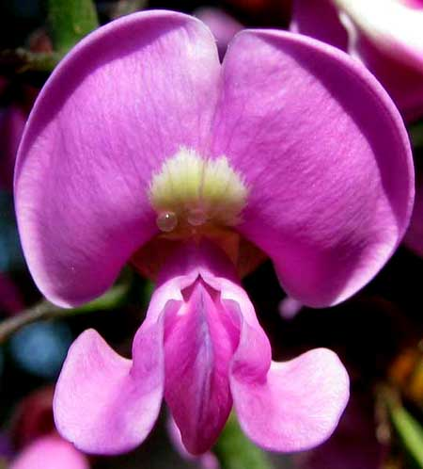
Fruits produced by members of the Bean Family are legumes which split open to release several to many beans. Balché's legumes are unusual because they bear only one or a few beans. Atop the next page you see the ornamental Balché's pods, sunlight from behind revealing just one or two beans in each legume.
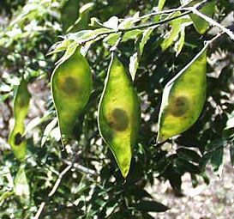

INDIAN CORAL TREE -Colorín Pinto
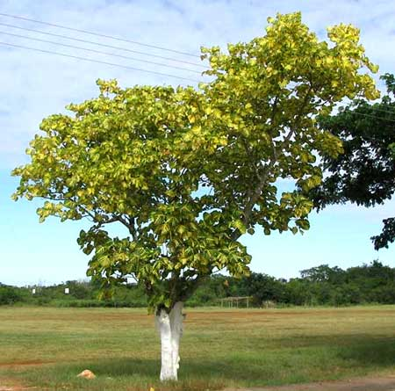
Here and there along streets and roads all through the Yucatan you see smallish trees with leaves boldly striped with yellow as shown at the right. It's the Indian Coral Tree, Erythrina variegata. The word "coral" is in its name because people call almost anything red "coral," and deep in the dry season, in February or so, the Indian Coral Tree does produce dense racemes of very red blossoms, as shown below.
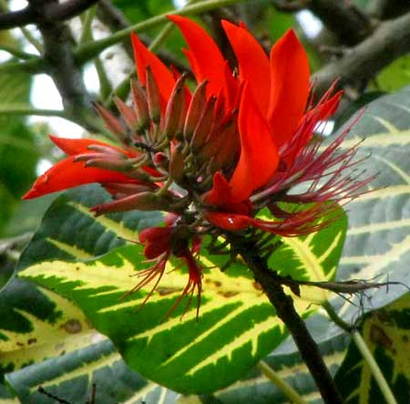
Indian Coral Tree is a member of the Bean Family, so those 2½-inch-long (8cm), red flowers are typical bean-type blossoms except that the top petal, the "standard," is much oversized relative to the lower petals -- the "wings" and "keel."
Besides being pretty and easy-to-grow, in many cultures Indian Coral Trees are regarded as useful. In southern Florida they're often planted as hedges. In India they're used to support vine crops such as black pepper, vanilla, yam and betel. During the hottest months their leaves shade the vines, keeping them moist. When it gets cooler the leaves fall and the vines receive more direct sunlight, which is what they need at that season. Indian Coral Trees are popular shade trees in many places, and make excellent living fence posts. Their leaves make good feed for most livestock, containing 16-18% crude protein.
Medicinally, in Asia, juice from the tree's leaves is mixed with honey to kill tapeworms, roundworms and threadworms. Women take the juice to stimulate lactation and menstruation. A warm poultice of its leaves relieves rheumatic joints. The bark is used as a laxative, diuretic and expectorant. The Maya I've talked to don't know about these uses, which is to be expected, since this is a non-native tree that wasn't around as their traditions evolved.

DWARF POINCIANA - Chaksikin
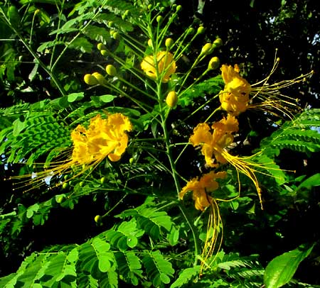
At the right you see one of the Yucatan's most frequently planted bushes or small trees.
That's the Dwarf Poinciana, Caesalpinia pulcherrima, a tropical American native but planted in the tropics worldwide. Flowers of Dwarf Poinciana vary in color. Our picture shows the yellow flower but maybe those with predominantly red flowers like those atop the next page are more often planted.
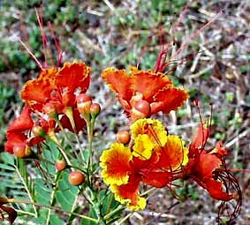
Since Dwarf Poincianas belong to the Bean Family, their fruits are legumes containing beans. If you are ever near a Dwarf Poinciana heavy with mature legumes ready to open and it's a particularly hot, dry afternoon of the kind that occurs in April and May, notice if you are hearing occasional snapping sounds.
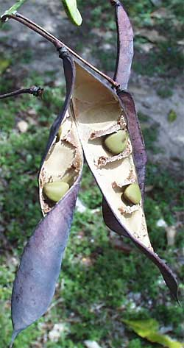
Dwarf Poinciana pods are explosive. As they dry, tensions within the legume reach a point when suddenly the whole pod splits, the tough sides twist like electrified earthworms, and beans are thrown everywhere. A recently-split legume is shown at the left.
Dwarf Poincianas are so frequently planted that they're known by a host of other English names as well, such as Peacock Flower, Barbados Pride, Barbados Flower-fence, Red Bird-of-Paradise, and more. Since it's a native plant, in the Yucatan the Maya name Chaksikin often is used.

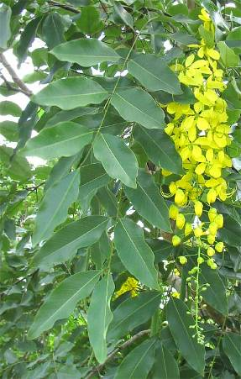
GOLDEN SHOWER TREE - Lluvia de Oro
Golden Shower Trees, Cassia fistula, are native to southern Asia, where they're designated as Thailand's national flower. Planted throughout the tropics worldwide, in our area they catch our eye twice during the year.
The first time is toward the end of the rainy season, in September or so, when they adorn themselves with two-inch-wide (5cm), canary-yellow blossoms densely clustered in dangling, foot-long (30cm) racemes among handsome pinnate leaves, as shown at the right.
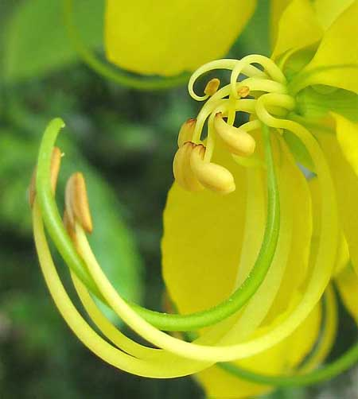
Ahe flower, a little unusual for the Bean Family appears at the left. The long, slender, green, U-shaped item is the ovary, the future legume-type frui. The other slender, curving, yellow items sprouting from the blossom's center are stamens consisting of curving, stalk-like filaments tipped with baglike anthers, which open to release powdery pollen.
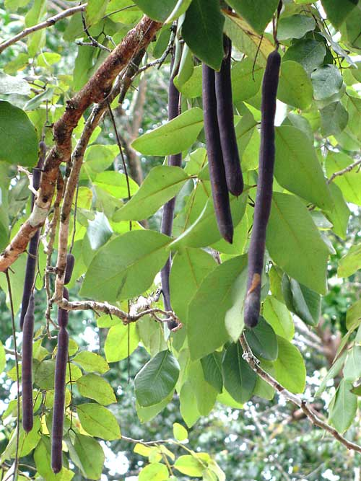
The second time this tree catches our attention is during the late dry season, in March or so, when the slender, green ovaries in the above photo become dark brown, two-ft-long (60cm), dangling legumes, as shown at the right
The ripe legumes are of special interest because they constitute an important part of the traditional pharmacopia, or body of information pertaining to medicinal plants, of many cultures -- not the Maya, however, since this is an introduced species. If you list all the pods' documented uses you end up with such a list that you wonder if any cures work at all.
One use, however, is repeated so frequently that there must be something to it: The uncooked pulp of the pods cures constipation. A cracked-open pod showing greenish pulp between beans is shown atop the next page.
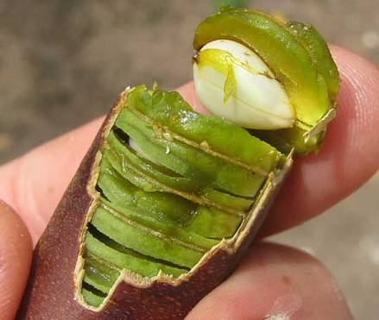
The pulp tastes and smells a little like the "honey" in Honeylocust pods up North.

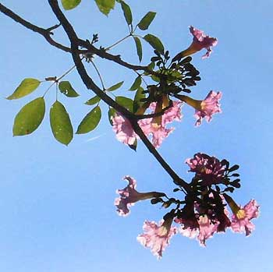
PINK TABEBUIA - Roble
Pink Tabebuias, Tabebuia rosea, belong to the same Bignonia Family as Blue Jacarandas, considered next. During the dry season, in February or so, you may see both species completely leafless but resplendent with finger-size, funnel-shaped, flowers -- pink on Pink Tabebuia, purple on Blue Jacaranda. During the rainy season they may bear both leaves and flowers as in the previous picture.
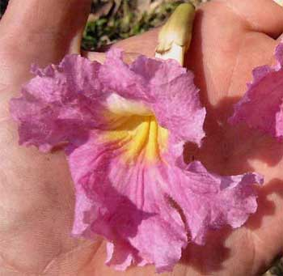
Pink Tabebuia's leaves, instead of being ferny and twice-compound like the Blue Jacaranda's, are "digitately compound" -- their five or so leaflets arise from atop the petiole like digits, or fingers.
At the right you can see how large the flower is.
In towns across the Yucatan Pink Tabebuias often are planted along streets. Sometimes when you see their intense pinkness beneath a deep blue sky they look unreal. However, not only are they real but, unlike Blue Jacarandas, Pink Tabebuias are native to the Yucatan, extending from Mexico to Venezuela.
Being a native tree, Mexican country folks traditionally brewed tea from its bark and leaves to bring down fevers.

BLUE JACARANDA
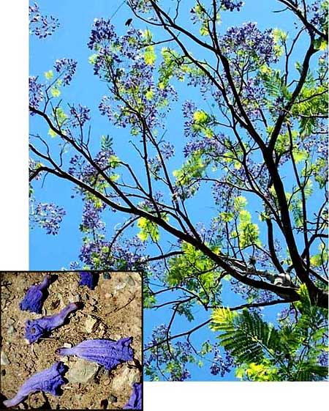
Toward the end of the dry season, in May or so, you see trees gorgeously decked out in purple flowers, sometimes with the branches completely leafless, sometimes with the season's leaves emerging with the flowers.
At the right, notice the tree's ferny, twice-compound leaves composed of many tiny leaflets. In the inset at the bottom left you see the tree's funnel-shaped flowers littering the ground below.
One English name for this wonderful tree -- one of the most frequently planted in the tropics worldwide -- is Blue Jacaranda. It's Jacaranda mimosifolia, a native of South America. Besides being so pretty, jacarandas are popular because they grow easily from seeds or cuttings.
Belonging to the same plant familyas Purple Tabeguia, the flowers of both species are well adapted for pollination by large bees and hummingbirds. Field studies show that the flowers are also vulnerable to smaller "nectar robbers" who take the nectar without pollinating the flowers. For Blue Jacarandas, honeybees are significant robbers.

MORNING-GLORY TREE - Campanilla
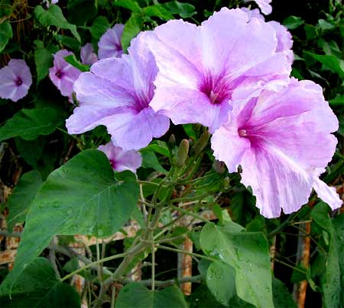
If you know your flowers, you recognize that the above blossoms could hardly be anything other than those of a morning-glory. However, everybody knows that morning-glories are herbaceous vines, not woody, small trees like this plant. Well, this is the Morning-Glory Tree, Ipomoea carnea. The genus Ipomoea is the morning-glory genus, so it's a real morning-glory, too.
Tree Morning-Glories are native to tropical America, often showing up in the Yucatan woods. Because of their beauty, ease of propagation and general toughness they deserve to be planted much more than they are. However, beyond tropical America the species is becoming a weed species threatening native plants. Tree Morning-Glories are prohibited in Florida and Arizona.
Medicinally, the shrub's roots are boiled to use as a laxative and to provoke menstruation, and the milky sap is used by traditional healers for skin diseases. However, it's dangerous when used wrong, for it depresses the central nervous system and relaxes muscles. It's regarded as poisonous to cattle.

OLEANDER
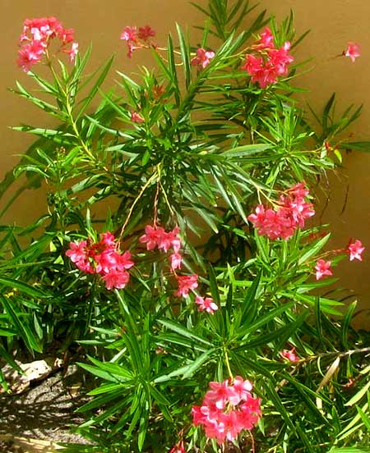
So many Oleander cultivars exist that it's hard to generalize about what the Oleander, Nerium oleander, looks like. The one at the left is a special dwarf type but some other Oleanders reach 20 feet high (6m). Still, Oleanders do share a number of features, such as their tendency to produce many branches bearing narrow leaves along the stems. Also, the flowers -- unless they're "double-blossomed" types -- look like those shown below.
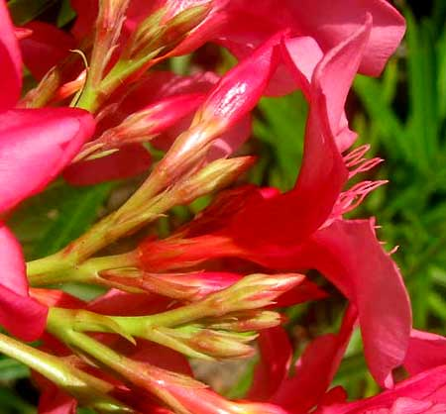
Cutting an Oleander blossom down its center reveals some distinctive features, shown below.
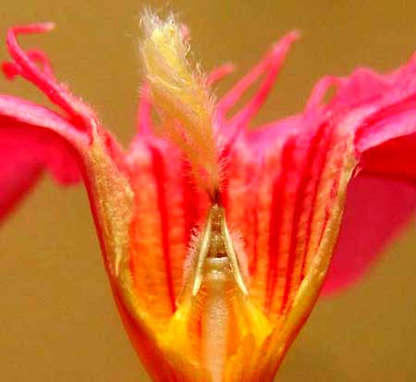
The white, columnar item at the bottom, center is the ovary, or future fruit. Notice the "tepee" covering the ovary. The tepee consists of five fused stamens. The erect, fuzzy items in the picture's top center are appendages arising atop the stamens' anthers. Maybe they help pollinators hold on as they do their work.
Oleanders are native to the Mediterranean region. All parts of the plant are poisonous, but they are very bitter and one would have to eat a lot to die.

YELLOW OLEANDER- Aki'its
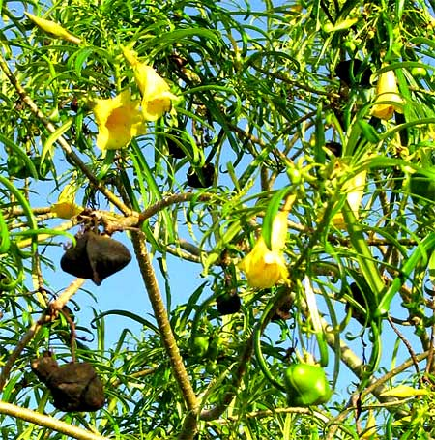
Much-planted Yellow Oleanders, Thevetia peruviana, with their small size, yellow, 2.5-inch-long (6cm) flowers, black fruits and willow-like leaves are easy to recognize. That's one below:
Yellow Oleander is not a yellow species of Oleander; it's its own thing, a Yellow Oleander. Yellow Oleanders and "real" oleanders belong to the same family, the Dogbane Family, or Apocnaceae, but they are in completely different genera. One feature the two species share, however, is that all their parts are toxic.
Yellow Oleander's thick, four-sided, black fruit is unusual. While immature it's green, then turns bright, glossy red, and finally it becomes the dull black shown in the picture. Inside the fruit resides a smooth, brown stone sometimes called a "lucky nut." Enterprising natives have been known to string lucky nuts on necklaces and sell them as charms for carrying in the pocket.
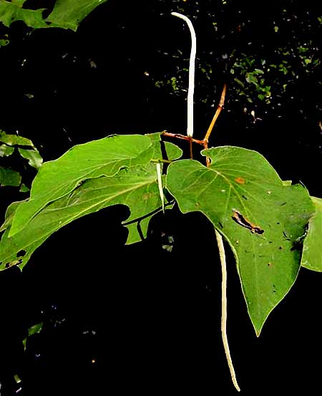
Yellow Oleanders have been planted so widely for so long that it's unclear where they're from, though most experts, despite the species name peruviana, think it comes from southern Mexico, the Caribbean area and Central America. However, it's not found in the Yucatan's forests.

HOJA SANTA
This small tree, native to Mexico but requiring more rain than falls in the northern Yucatan, often is planted around houses here. The words Hoja Santa mean, more or less, Blessed Leaf, because the tree's fresh leaves when crushed fill the air with a delightful odor, one that reminds some of anise, but which I always think of as the odor of root beer. Hoja Santa's foot-long (30cm) leaves are soft and have rounded ears at their bases, and its tiny white flowers are grouped in long, slender spikes.
Hoja Santa, Piper auritum, is a member of the Black Pepper Family and belongs to the same genus as the southern Indian vine from which the pepper of salt-and-pepper fame comes. When the ovaries of Hoja Santa's tiny flowers' mature, the resulting fruits are genuine peppercorns, but they're too small to be worth drying and grinding into black pepper.
Something else interesting about Hoja Santa -- and you can confirm this in our picture -- is that when its small, greenish spikes of immature flowers first emerge they hang down. As the spikes enlarge and the flowers become ready to be pollinated by visiting insects, the spikes turn vividly white and are held erect. After pollination, when the flowers no longer need to be visited by insects, the spikes once again turn downward.
By moving its spikes up and down like this, and making the spike brightly white when its flowers need pollination, Hoja Santa is communicating with its pollinators. It's telling its pollinators to pay attention to conspicuous flowers on the upright spikes needing to be pollinated, but not to bother visiting the less noticeable flowers on the down-hanging spikes, which are either too young or too old for pollination.

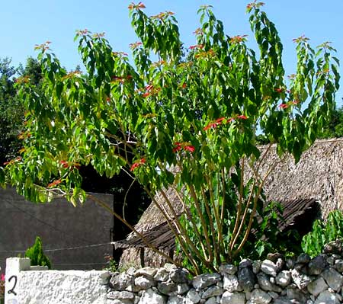
POINSETTIA - Nochebuena
Above, that's what the Yucatan's Poinsettias, Euphorbia pulcherrima, look like around Christmas time. Probably you already know that Poinsettias are named after Joel Roberts Poinsett, the first United States Minister to Mexico,. who introduced the plant into the US in 1825.
So, Poinsettias are native to Mexico, but the Yucatan is too arid for this species. Here Poinsettias like the above are planted, as they are in much of the world's tropical lands. Christmas Poinsettias sold in pots up north are basically branch tips of this plant managed by horticulturalists to flower at a certain time. Below you see one of our branch tips near the top of the above tree.
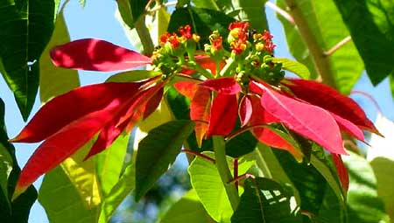
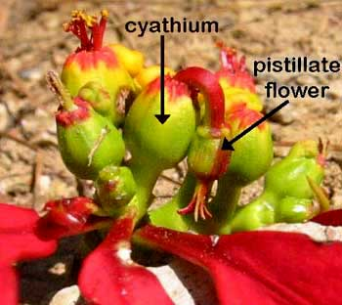
Above, that's not a flower, and the big red items aren't flower petals. The long red parts are modified leaves called bracts, which attract pollinators to the real flowers, which reside in the center of the cluster of bracts. At the right, those are real Poinsettia flowers, and they need explaining.
In the picture, the structure labeled as a cyathium is like a bowl containing a few male flowers and one female flower. Above and to the left of the labeled cyathium you can see another cyathium from which male stamens are protruding. But notice that to the right of the labeled cyathium there's a "pistillate flower" -- the female flower -- on a curved stem dangling outside the cyathium. This just shows you how surreal things can get in the world of flowers!

LADY OF THE NIGHT -Galán de Noche
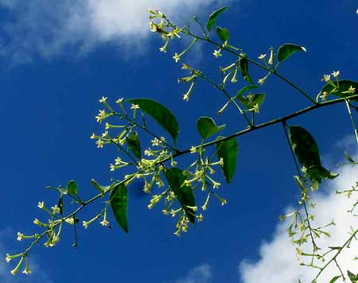
Sometimes nondescript trees draw your attention because they smell so good. That's the case with the Lady of the Night, Cestrum nocturnum, which visually presents itself as an Orange-Tree-size, much branching, very dense bush or small tree with leaves and narrow, tubular , white flowers.
Lady of the Night's fruits are pea-sized, occur in small clusters, and are white. The tree is native to the Yucatan and is much planted in the tropics worldwide. In India and elsewhere in South Asia its flowers are used in perfumery, for medicinal applications and in religious ceremonies, though some parts of the plant are poisonous.

MEXICAN ELDER - Sauco
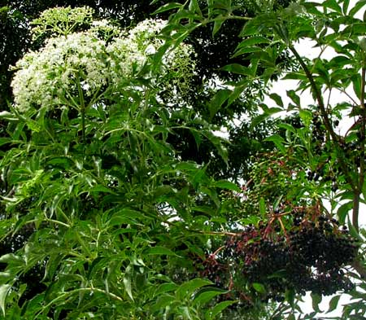
Sometimes you see compact, hut-high bushes or small trees bearing basketball-sized heads of tiny, white flowers and/or clusters of black, pea-sized fruits, as shown at the right.
That's the Mexican Elder, Sambucus mexicana, native to the Mexican uplands but not to the too-arid Yucatan. Here it's strictly planted as a garden species. Mexican Elder is closely related to western North America's Blue Elderberry whose fruits are very tasty and nourishing, both for wildlife, and people. However, the Maya I know don't trust the fruits enough to eat them.
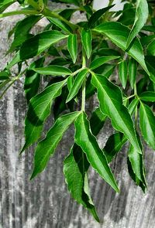
The plant's leaves are distinctively twice-compound, as shown at the right.

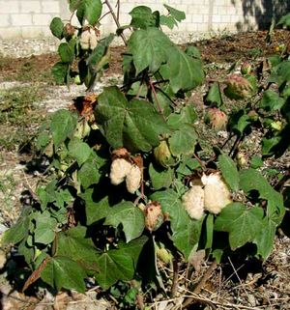
TREE COTTON - Algodón
Sometimes during the dry season in villages you see leafless, shrubby bushes or small trees bearing what appear to be clusters of cotton fiber. Sometimes in rainy season the bushes bear leaves as well as cotton, as at the left.
If you are familiar with cotton grown in the US our plants might confuse you because you know that cotton grown up north is herbaceous, maybe around knee high, while our plants are definitely woody and can reach ten feet (3m) or more.
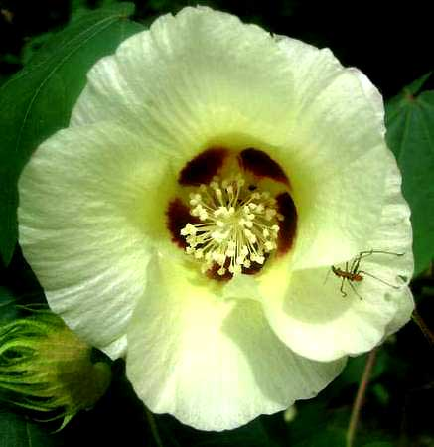
ln the Yucatan we have two species often known as Tree Cotton: Gossypium hirsutum, often known as Upland Cotton, and Gossypium barbadense, sometimes called Sea-Island Cotton. I find Upland Cotton mostly planted in the interior but Sea-Island Cotton growing wild along the northern Yucatan's coast. Both of these "Tree Cottons" produce pretty, hibiscus-type flowers about two inches across (5cm) as shown below.Flowers emerge as yellow but after pollination turn rose-purplish, so often two different colors grow on the same branch. Also, often the fiber produced by the fruits isn't pure white, but rather beige or brownish. This is explained by Tree Cotton's history.
For, cotton was originally domesticated by indigenous people in the Andes, who at first were less interested in weaving textiles from the fiber than in making fishnets from them. And they knew that fish were more easily caught with dark nets than light ones, so they encouraged plants producing dark fiber.
Eventually they had dark, chocolate-colored fiber. Of course once they had different strains of cotton producing different-hued fibers, multicolored textiles were sure to follow.
Fray Diego de Landa, in his 1566 book Relación de las Cosas de Yucatan, often mentions how the Maya, both before and after the Spaniards' arrival, slept under cotton blankets and in war wore cotton jackets as body armor. In Chapter 49 of Relación he writes that two kinds of cotton were planted: an annual dying after its first year and a small tree that produced cotton for five or six years.

GIANT MEXICAN SUNFLOWER - Árnica
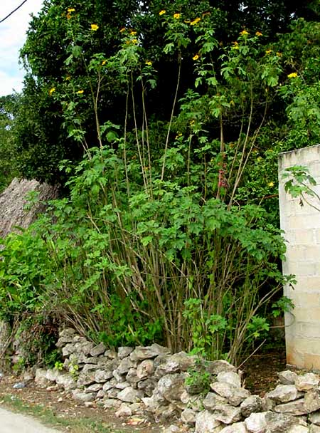
Maybe a sunflower shouldn't be considered a tree, but this one grows so tall and is so frequently planted in Mayan villages that here we'll call it a tree just so we can have the pleasure of featuring it. Look:
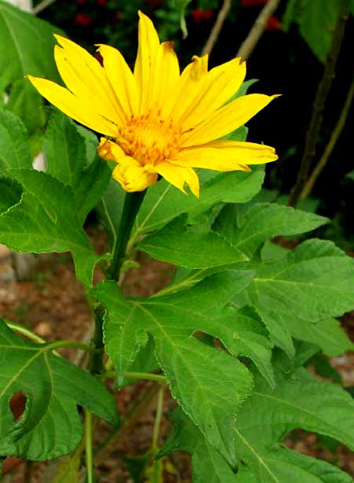
That one is at least 15 feet tall (4.5m). Its lanky stems stand next to a typical village cinderblock house. Atop the next page you can see its blossom and leaves.
This is Tithonia diversifolia, native to Mexico, including the Yucatan, and Central America, but planted throughout the world's tropics. As such, it's known by many English names, including Mexican Sunflower, Tree Marigold, and Mexican Tournesol.
Giant Mexican Sunflower produces so much biomass that African farmers use it as an organic fertilizer. Elsewhere it's considered to have important medicinal properties. In China it's used for skin diseases, night sweats, as a diuretic, for hepatitis, jaundice and cystitis. In Taiwan tea made from it is supposed to improve liver function. This native Mexican plant is so well established in Thailand that it's the provincial flower of Mae Hong Son Province, and in Vietnam it's the unofficial symbol of La Lat city.
My Maya shaman friend José says this about Giant Mexican Sunflower:
"Because it grows so fast and becomes so big beneath the sun, in the wind and rain, it soaks up these strong influences. Therefore, when you work outside too much, with the body absorbing so much energy from so many sources that you ache and feel bad, you can soak seven leaves from this plant, with some Rue (Ruta graveolens), and wash yourself with that water, letting it drain over your head. It'll absorb those excess energies inside you, bring your energies back into balance, and let you feel good again... "

SAPODILLA - Chicozapote
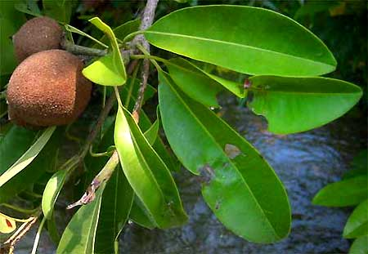
Sapodillas, Manilkara zapota, produce one of the tropic's most delicious fruits, which are eaten raw. Especially farther south in the Yucatan where there's more rainfall Sapodillas fairly commonly occur in deep forest, but in the most arid parts of northern Yucatan they are only planted. The tree's leaves are leathery and green, and fruits brown with sweet, creaym-colored flesh and big seeds.
In the forest there's an interesting way to identify a Sapodilla tree by its trunk. A typical deep-forest trunk is shown on the next page.
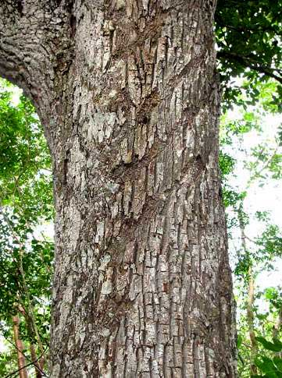
Do you see those diagonal slashes across the trunk? That's the way you know it's a Sapodilla. I've never seen a deep-forest Sapodilla tree without those slashes.
That's because Sapodilla latex coagulates into chicle gum, which for many years was the base for chewing gum. Most chewing gums nowadays are made of synthetic compounds but in 1930 US companies imported about 15 million pounds (6.8 million kilos) of chicle gum. The slashes indicate that not too long ago backwoods Maya were still slashing Sapodilla trunks to collect the chicle sap that oozed from the wounds.

MAMEY
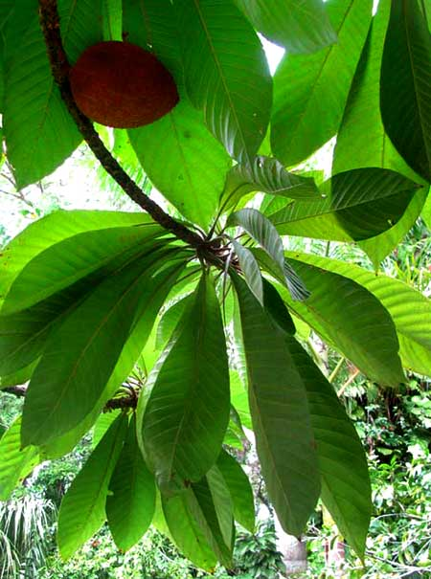
At the left you see a softball-size mamey fruit on a branch with large, tongue-like leaves clustered toward the branch tip.
Mamey trees, Pouteria sapota, belong to the same Family as Sapodillas, and mamey fruits are just as wonderful. Newcomers can have problems distinguishing Mamey trees from Sapodilla trees. The Mamey's leaves are larger and wider toward their tips than the Sapodilla tree's, plus mamey fruits are oval and contain only one large seed while sapodilla fruits are more spherical and usually bear more than one seed.
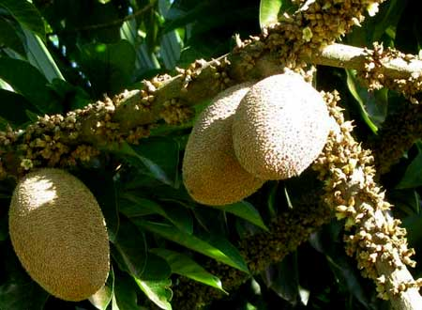
Mamey fruits, like sapodilla fruits, have a custard texture and the flesh is "bright burned-magenta-orange," according to one color-savvy person.
Another distinctive feature of the Mamey tree is that its very numerous, small flowers arise directly from stout stems instead of in typical flower clusters such as spikes, racemes or panicles. Below, you can see immature mamey fruits dangling from a thick stem covered with dozens of flowers, the vast majority of which will fall off after pollination.

CANISTEL
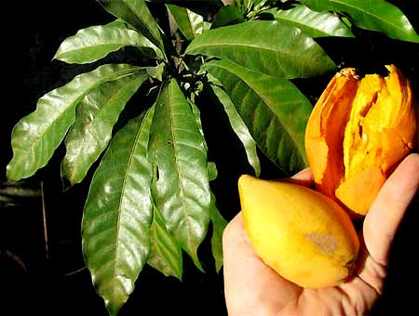
Yet another member of the Sapodilla Family is the Canistel, Pouteria campechiana, shown at the right.
Canistel is native to the Yucatan and parts of Central America, but the wild plants tend to produce much smaller fruits than those in the picture. The excellent taste is the same, though. The fruits contain two or three large, shining seeds embedded in soft, orange flesh textured and tasting like a well baked sweet potato.

STAR-APPLE - Caimito
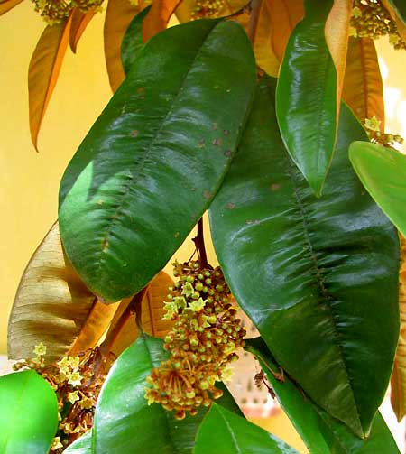
Accompanying Sapodilla, Mamey and Canistel in the wonderful Sapodilla Family is the Star-Apple, or Caimito, Chrysophyllum cainito. Star-Apple is an especially handsome tree, often growing quite large, and it's easily identifiable at all times by its five-inch-long (13cm), leathery, evergreen leaves which are dark green and glossy on top but fuzzy-golden-brown below. The above flowering branch was photographed during the late rainy season, in August:
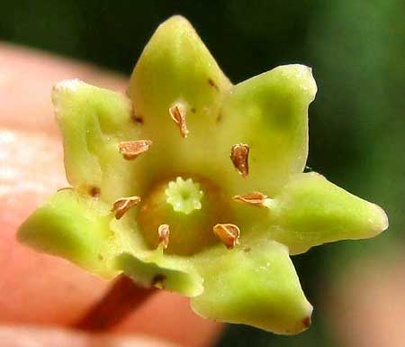
An unusual feature of Star-Apple's blossoms is that their pollen-producing stamens arise opposite the corolla lobes, at their bases. Stamens in most flowers alternate with their corolla lobes. Also, it's a little unusual for stamens to simply arise from a corolla wall instead of beneath the ovary. However, stamens like those are characteristic of the whole Sapodilla Family.
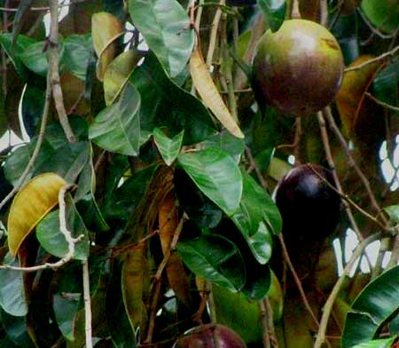
As with the other members of the family we've looked at, Star-Apple trees produce large, delicious fruits. At the right You see what ripe, purple-skinned, 3½-inch-across (9cm) Star-Apple fruits look like hanging on a tree.
Star-Apples are sweet and juicy, and their juice is so sticky that afterwards your lips slightly stick togeth, and your fingers are sticky. The fruit's skin is just tough enough to make you wonder whether to eat it or not. I eat the skin of fruits from trees I know don't have chemical residues on them, but I peel those from markets. A sliced-open fruit is shown below.
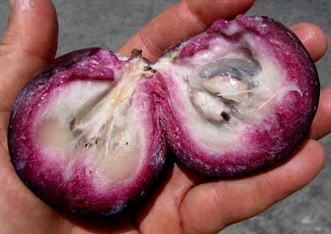
Star-Apples are native tropical American trees, but not to the arid Yucatan. They are planted widely throughout the Earth's tropics.

CUSTARD APPLE - Anona
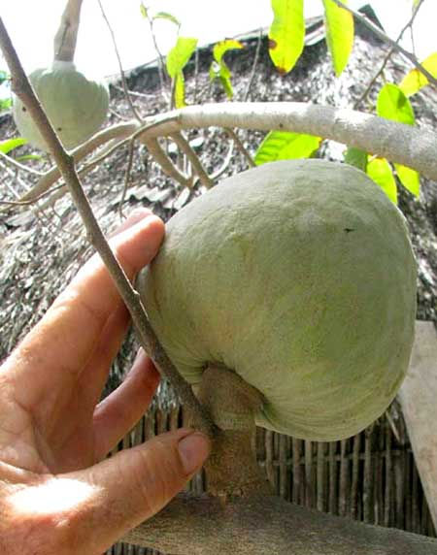
Custard Apple trees ares Annona reticulata. The fruit at the right was maturing during the late dry season, in March, while most of the tree's leaves were falling off.
Custard-Apple fruits are variable. When ripe they can be yellow or brownish with a pink, reddish or brownish-red blush, and their skin can be faintly, moderately, or distinctly impressed with a scaly effect.
The somewhat granular flesh contains many hard, dark-brown or black, glossy seeds and a pointed, fibrous, central core that's attached to the stem.
he flavor is sweet and agreeable but often not considered as flavorful as the closely related Sweetsop. Custard Apples are thought to be native to the West Indies, but were carried into the Yucatan in prehistoric times.

SWEETSOP - Saramuyo
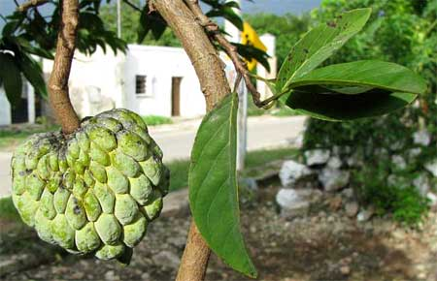
Sweetsops, sometimes also called Sugar-Apples, are Annona squamosa. Their fruits are sweet and good tasting, though a bit too seedy for most Northerners. Maya who take the time to work with their tongues as they eat, and spit, like them just fine.
Sweetsop fruits especially clearly show a feature shared with other members of the highly edible genus Annona: They're "syncarps," which means that each fruit is derived from a single flower with two or more pistils, which partially fuse as the pistils mature. When Sweetsop fruits are past their peak of ripeness they turn brown and start drying out, the bumps separate from one another and the fruit falls apart.
Sweetsops are native tropical American, but the Yucatan is a bit too arid for them so the Yucatan's trees are all planted.

SOURSOP - Guanábana
Soursops are yet another member of the genus Annona. They're Annona muricataa. Fruits of all three species share the same basic structure and have a somewhat similar taste, but they look different. That's a Soursop fruit atop the next page, each soft "spine" indicating a distinct pistil (comprising stigma, tyle and ovary) of the single flower from which it derived.
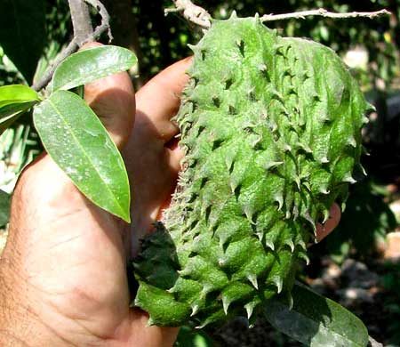
Soursop fruits are a bit acidy, as well as juicy. Sometimes the taste is compared to that of pineapple. The fruits are whitish inside and fragrant. They're used mostly for making sweetened, fruity drinks, and for making into preserves. Traditionally the juice has been considered a remedy for dysentery.

POMEGRANATE - Granada
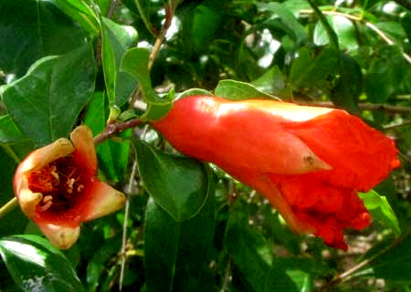
In the late dry season, around March, you might see 10-ft-tall (3m), slender-stemmed bushes graced with very bright red flowers a little over an inch broad (3cm), as shown above. They're flowers of the Pomegranate, which Spanish speakers call Granada. They're Punica granatum, members of the Loosestrife Family, the Lythraceae, and native to the area of modern-day Iran and Iraq.
Those are curious flowers. At the right in the above picture you see the blossom's unusually large, leathery, red calyx subtending a somewhat larger, wrinkled corolla. In the same picture at the left the corolla has fallen off leaving the calyx's interior walls bristling with pollen-producing stamens. In most flowers the calyx is small and green, plus normally stamens arise below the ovary or from the corolla's walls, not the calyx's walls.
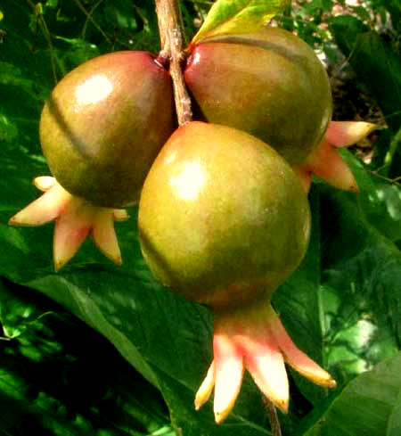
Once the flowers' ovaries have matured a little we start seeing the form of our future pomegranate fruits, shown at the right.
By late in the rainy season, in August or so, we begin seeing mature pomegranates like those shown below.
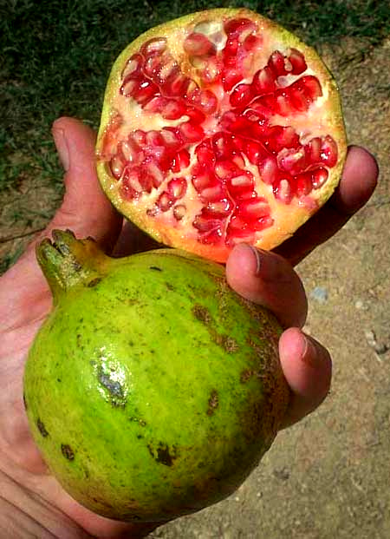
Technically, pomegranate fruits are thick-skinned, several-celled berries, with seeds enmeshed in juicy pulp. It's the pulp that tastes good, which can be very sweet and juicy. The seeds are so soft that I just chew them, but probably finicky folks spit them out.
Notice how the fruit bears a "crown" of 5-7 thick, leathery sepals. Sepals are the separate divisions of the usually green, leafy, cuplike calyx that resides below the corollas of typical flowers. Sepals usually wither and drop away as a blossom's ovary develops into a fruit, but pomegranates for some reason decided they needed those sepals, and made them big and tough.

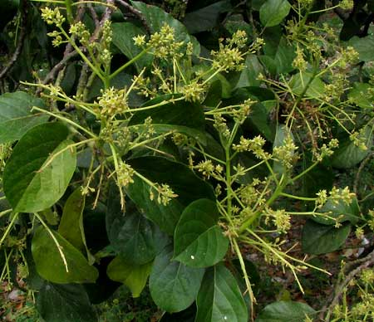
AVOCADO - Aguacate
Deep in the dry season, in March or so, certain good-sized trees suddenly break out with diffuse, yellowish, basketball-size flower clusters, or inflorescences, such as those at the left.
These trees' leaves are about as nondescript as leaves get, so the sudden appearance of such conspicuous flower displays can be surprising. If you keep watching the inflorescences as the season progresses you'll see nearly all the tiny yellow flowers fall off, maybe with only one or two per cluster setting fruit, and you'll have the pleasure of watching the fruit develop. Then, about half a year later, toward the end of the rainy season, you'll see what's shown atop the next page.
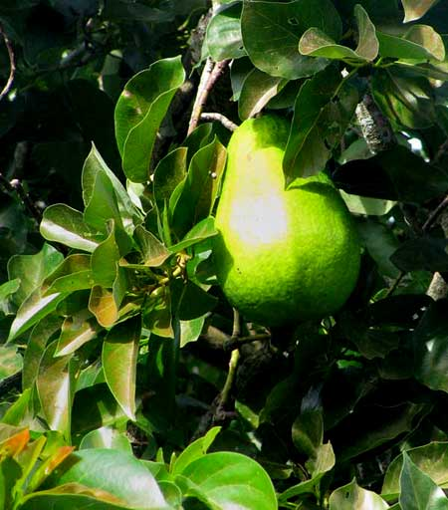
That's an avocado on an Avocado Tree, Persea americana. In the Yucatan several different avocado cultivars are to be found, some with smooth skin, others rough, some are small and the one in the picture is a big one, about eight inches long (20cm).
Avocados are native Mexican plants -- though not to the Yucatan -- and Mexico is by far the world's greatest exporter of them.
If you have an Avocado tree and want to identify which cultivar it is, a helpful piece of information is that Avocados come in two flowering types: "A" and "B." "A" cultivar flowers open as female on the morning of their first day and close in late morning or early afternoon. Then on the second day they open as male in the afternoon. "B" types open as female on the afternoon of their first day, close in late afternoon and reopen as male the following morning.
Once you know whether you have an "A" or "B" type, you can rule out about half the possible cultivars it might be. Help in identifying your cultivar can be found online by searching on the keywords "avocado cultivar identification."
Avocados belong to the Laurel Family, the Lauraceae, in which we also find Sassafras, Spicebush, Cinnamon-Tree and the Laurel itself, all fragrant and spicy species.

MANGO
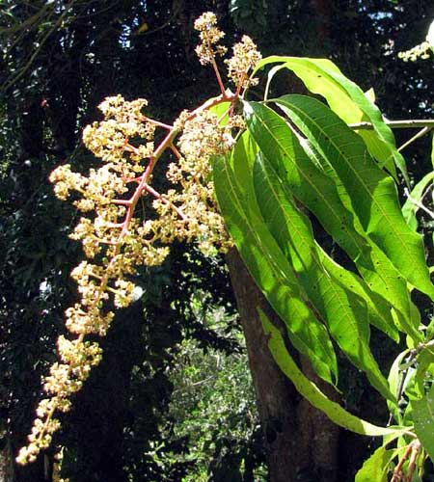
In the late dry season, in April or so, the Mango tree, Mangifera indica, -- which can grow to be fairly large -- draws attention to itself with foot-long panicles of tiny, white flowers at the end of branches equipped with slender, foot-long leaves with herring-bone venation as shown below.
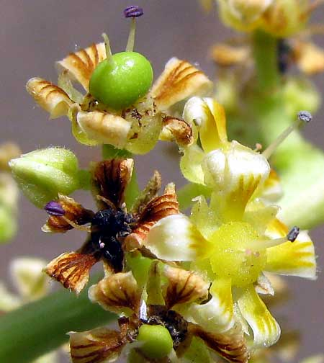
Mango trees are members of the Cashew Family, the Anacardiaceae, along with not only Cashews but also Pistachios, the sumacs, and Poison Oak and Poison Ivy. Flowers in the family typically bear 3-5 petals. Flowers can be unisexual or bisexual. Mango flowers display all those family features, plus they add some interesting innovations. Above you can see some of them.
In the flower at the picture's top, left, the green, spherical ovary -- the future mango -- is easy to make out. Mango ovaries are unusual in that their styles don't emerge from their centers, but rather to one side. This results in mango fruits that are a bit lopsided, too. Note behind that flower's ovary that there's a single stamen, its dark purple, pollen-producing anther attached atop a pale, slender filament. Some mango flowers may have up to five stamens, but usually only one or two are fertile, the others hardly developing. All the flowers examined on the tree producing these flowers bore only a single stamen, and in the flower world that's an unusual situation.
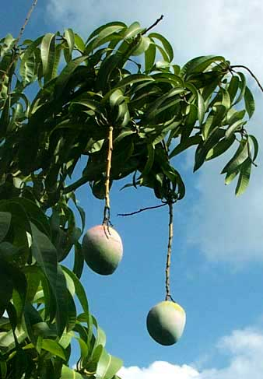
Notice the younger flower in the picture's lower right. That blossom has no ovary at all. It's strictly a male, unisexual flower. The dark flower to the left similarly is a male, unisexual flower in which the stamen has shriveled up.
When a plant bears unisexual flowers mixed with flowers bearing both male and female parts, the plant is said to be polygamous.
In each many-flowered panicle, all male flowers shrivel and fall off leaving nothing behind, and all but a few female flowers also shrivel and fall. In the end, each panicle bears only one or two fruits. Most flowers with ovaries, even if they get pollinated, abort, leaving only the strongest to mature into fruits. Well into the rainy season, in July or thereabouts, fruits appear on trees, as shown above.

PAPAYA
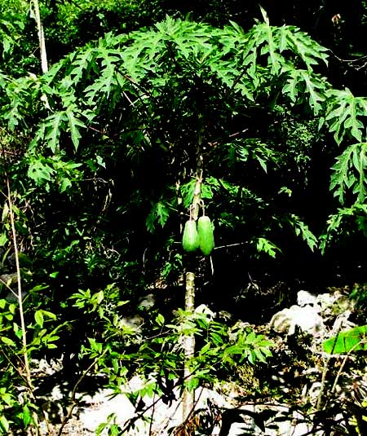
A garden Papaya with its enormous immature fruits is shown at the right. When those fruits ripen they'll be orangish yellow and big as large watermelons.
Maya country people know to harvest their papayas a little before they turn ripe because critters, especially certain birds such as woodpeckers and orioles, love to eat them. You cut the unripe fruit, store it where you can watch it, and then everyone gives his or her opinion as to the exact moment the big fruit is at its peak of perfection, and you eat it. It's a happy time for all.
In my opinion, a papaya isn't perfectly ripe until its skin begins looking almost disagreeable -- the yellow surface browning here and there, even with spots of white fungus breaking out. Well, you cut off that part and eat the perfect stuff that's left. I say "in my opinion" because I'm always astonished by how many people think that any fruit with brown spots is beyond eating. "In my opinion," fruits like papayas and bananas are at their best when brown spots are appearing. But the advertising industry has put it into people's heads that fruit skins need to be unblemished, so what can you do?
Papayas please with much more than their mere taste, texture and appearance. Something in them sets the stomach at ease, and makes the guts smile on hot, sunny afternoons. That shouldn't surprise us, for traditional cooks have known for millennia to wrap their pigs in papaya leaves before baking them, and even our own culture has realized that papay contain "the natural meat tenderizer" called papain. Papain is the "something" that helps our stomachs digest food.

BANANA- Plátano
Banana trees are herbaceous or at most only semiwoody, so arguably they shouldn't be considered here. However, most people think of them as trees, so here we are.
The thing is, technically, the Banana tree's actual "trunk" is below the ground. The item we think of as a Banana "tree" is actually a sprout arising from the underground trunk, which technically is thought of as a stolon. What looks like a trunk is actually the clustered petioles, or stems, of the Banana's big leaves. If you cut across a Banana tree's trunklike aboveground part you'll see how the petioles nest within one another. And these leaf petioles are so tough and fibrous that they can seem woody, and maybe they halfway are.
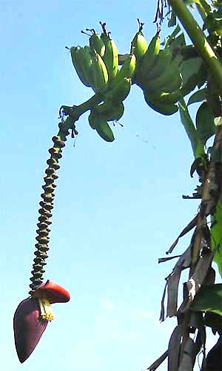
Banana flowers are even more interesting than the stems. At the right you see a typical Banana flower cluster, or inflorescence. In that picture male flowers cluster at the bottom of the dangling inflorescence (where the purple item is) and female ones arise at the top, their green, maturing ovaries the future bananas. Bananas are just the matured pistils, or female sexual parts, of female flowers.
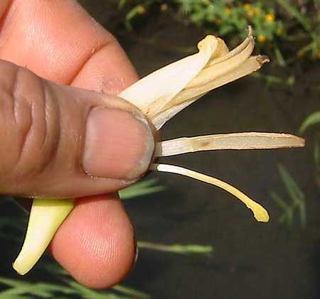
On the male flower shown below, the flat, long item with powdery lines along its margins, extending from the center of my thumbnail, is a stamen -- the male sexual part. The blunt, yellow-tipped thing below that is a sterile staminode, maybe giving pollinators something to hold onto as they pull themselves into the flower's throat, dusting themselves with pollen. T
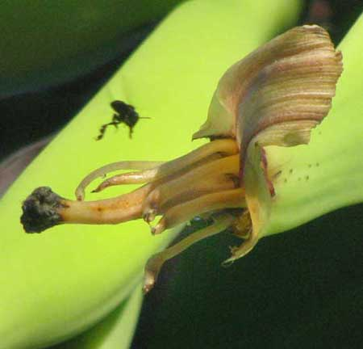
In our picture of the dangling banana stalk, notice that the immature bananas at the top all have something sticking from their tips. At the left you see what that is.
In that picture, the ribbonlike, striated item curving toward the top, right is the calyx, which started out as a cylinder, then split down one side and curled back, and soon will fall off. Earlier on the other side there was a similar ribbonlike thing; but that was the corolla, and it's already fallen off. The pale, slender, fingerlike objects arising at the base of the single, thicker, dark-headed item are sterile, vestigial stamens. The black item at the left is the stigma, where pollen theoretically germinates, atop the ovary's "neck," the style.
Actually, these sexual parts are useless to the cultivated Banana plant, since Banana genes have been so scrambled during centuries of domestication that the flowers of cultivated bananas no longer produce fruits with viable seeds.
This genetic scrambling means that the usual binomial system (genus plus species) for naming plants isn't appropriate for Banana plants. In the past they were called Musa paradisiaca, but nowadays there's no good two-part binomial for the Banana tree. For us amateurs it's best to just call it the genus Musa, and let the species go unsaid.
Finally, the Spanish name for Banana plants varies across Mexico. In the Yucatan most folks I've spoken to call medium-sized supermarket bananas plátanos and the big tough ones Northerners may know as plantains, plátanos machos.

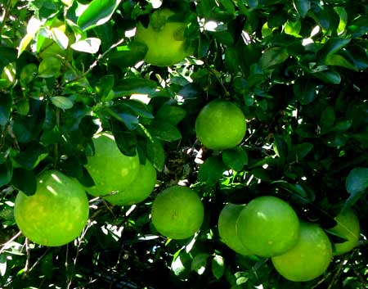
GRAPEFRUIT - Toronja
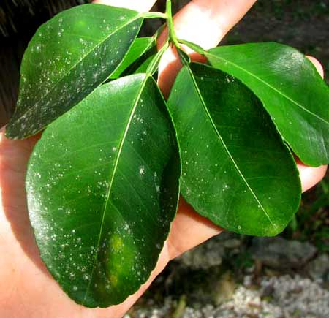
As the rainy season becomes the dry season in November or so it's a pretty thing to see big, round, yellowing grapefruits in dark green trees beside shady village homes. Grapefruits, like oranges and lemons, are citrus fruits -- members of the genus Citrus. Grapefruit trees are Citrus x paradisi. At the left you see typical citrus leaves with "winged petioles" causing the leaves to look jointed at their bases.
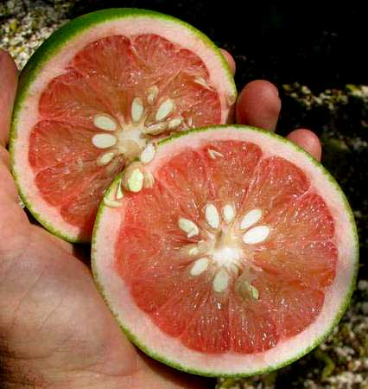
At the right, a sliced-open grapefruit typical of the kind found around Maya homes has a thicker rind and more seeds than those in supermarkets up North. As such, you might wonder whether such fruits derive from stock brought to the Yucatan by the Spanish during colonial times, long before plant breeders produced cultivars with thinner rinds, fewer seeds and juicier flesh.
In fact, I'll bet that the Yucatan's little Maya villages are great places for finding old strains of many cultivars, maybe strains going extinct as flashier ones take their place. And maybe some of those old strains have resistance to diseases, or flavors or textures, which newer cultivars don't.
In the Grapefruit tree's binomial, Citrus x paradisi, the "x" signifies that we're dealing with a hybrid. In other words, there are no Grapefruit trees out in the wild from which today's cultivars have been developed.
The first grapefruits came into being in Barbados in the 1700s when an Orange tree, Citrus x sinensis, was crossed with a Pomelo, Citrus maxima, both taxa originally being from southern Asia. And with that x in the Orange's name, you can see that Orange plants themselves are hybrids. Grapefruit genes have been tinkered with by humans a lot.
Studies show that compounds in grapefruit increase the effective potency of certain medicines, particularly those known as statins. This came to light when several deaths from overdoses occurred among people on medication who ate grapefruit. Grapefruit juice also can interfere with etoposide, a chemotherapy drug, as well as some beta-blocker drugs used to treat high blood pressure, and cyclosporine, taken by transplant patients to prevent rejection of their new organs. Grapefruit juice is powerful stuff!

BITTER ORANGE - Naranja Agria
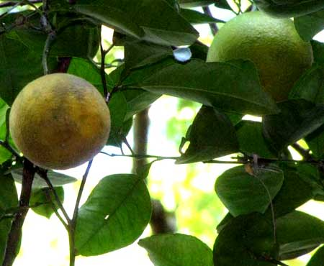
The above fruits are too large, greenish and leathery-skinned to be the sweet oranges Northerners think of when they think "orange." They are Bitter Oranges, sometimes called Sour Oranges or Seville Oranges. Until 2011 most experts thought that Bitter Orange trees constituted a regular species. However, now Chinese researchers have done gene sequencing studies that show that the trees, like Sweet Orange trees, are hybrids of Tangerine (also called Mandarin), Citrus reticulata, and Pomelo, Citrus grandis, and usually are named Citrus x aurantium.
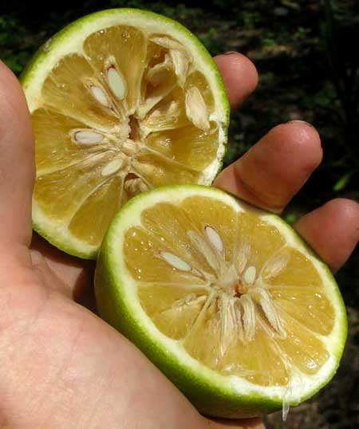
Juice from bitter oranges makes great lemonade, plus it's nothing to see a Mexican cut one in half, salt it generously, sprinkle hot-chili powder over it, and eat it. Gringos find that remarkable because these oranges are as sour as chili peppers are hot. At the right, a cut-open sour orange from near a Maya hut displays a thicker rind and very many more and larger seeds than most of us are accustomed to.
Bitter Orange is native to southeastern Asia. By the 9th Century Arab traders had introduced it into Arabia. It was reported in Sicily as early as 1002, then for 500 years it was the only orange known to Europeans. It was recorded growing in Mexico as early as 1568. I'll bet that some of the Bitter Orange trees around Maya homes in the Yucatan are direct descendants of stock introduced by the Spanish 500 years ago.

SWEET ORANGE - China
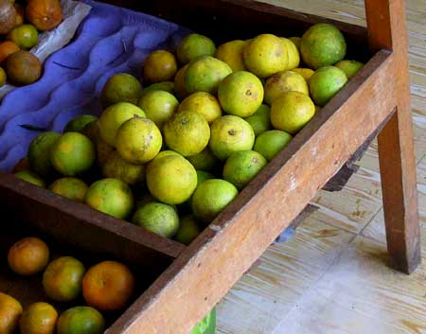
Above you see what typical sweet oranges look like in a typical frutaría bin. Notice that these very sweet, super-flavorful oranges at the peak of perfection for eating in early December aren't very orange. That's because the notion that a good orange must be brightly orange in color is a marketing ploy. Marketers tout the orangeness of oranges because it's easier to make oranges orange than to deliver tasty oranges to distant customers. People in the Yucatan, however, are sophisticated orange eaters, so they know that to determine a good orange you check for blemishes, you might feel firmness, you smell them, but you certainly don't buy them because they're orange.
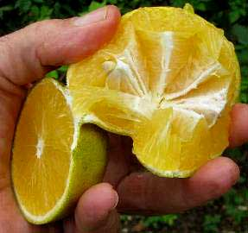
The ones in the frutaría are especially thin-skinned and juicy, perfect for squeezing orange juice from, though I just eat them. Since this cultivar's peel is hard to remove, I've developed a special way to eat them, shown at the right.
First I cut them in half, then from the back of a half I push inward so that it splits in the way shown in the picture. Now it's easy to tug the wedges from their peel with my teeth, eating what comes off.
The Orange tree is Citrus x sinensis, "sinensis" meaning "Chinese," which coincides with the local word for sweet oranges, which is chinas. Today the Sweet Orange is the most commonly grown fruit tree in the world, and there's a world of cultivars to choose from. In the US, most oranges grown in California are either 'Washington Navel' or 'Valencia'. Florida's commercial cultivars are mainly 'Hamlin' (early); 'Pineapple' (mid-season), and; 'Valencia' (late).
The owner of the frutaría with the oranges in our pictures says that his chinas are Valencias. That makes sense since Valencias are known to be the cultivar most planted in the tropics, and one producing relatively small but very juicy, rich-tasting fruits that often don't develop a deep orange color.

KEY LIME - Lima Agria
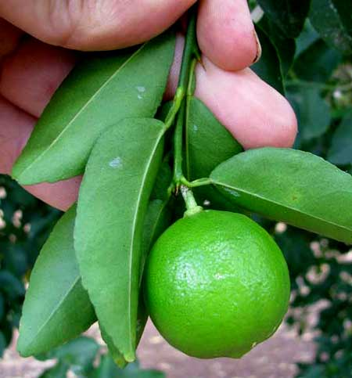
Up North it's easy to distinguish between a lime and a lemon. A lime is a sweetish fruit tasting like lime Lifesavers and smelling like lime-scented aftershave. Lemons are oval, yellow, very sour fruits with a low, broad nipple at one end.
Down here I never see what gringos call lemons, but here people call fruits not seen up North limones, or lemons, and the fruits they refer to as limas, or limes, are more acid-puckery than any gringo lemon.
Whatever the situation, here we're referring to a small, super-sour citrus fruit best known in the English-speaking world as the Key Lime, or sometimes Mexican Lime. It's Citrus aurantifolia, and that's one shown above. Mature, it's, a bit smaller than what Northerners think of as a lime.
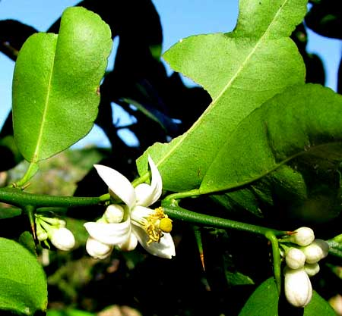
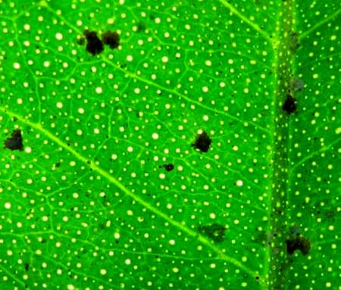
At different times of the year the Key Lime tree might break out in very fragrant, smallish flowers, as shown at the left. Notice the branch's spines, the typical citrus "wings" on the leaves' petioles, as well as the close-together dots on the leaves' undersurfaces. Those dots, typical of citrus leaves, are glands filled with fragrant oils. If you hold such a leaf up against the sun you can see what's shown below.
Such dots also appear on other citrus leaves, plus similar oil glands occur in unrelated Eucalyptus , Allspice and a few other kinds of non-citrus leaves. Such translucent dots are said to be "pellucid.
Though the Maya regard this species as their own, sometimes calling it Limón Criollo, or "Native Lemon," what we're calling Mexican Lime is native to Asia's Indo-Malayan region. It's Citrus x aurantiifolia.
t's thought to have been introduced into Europe by Crusaders from Palestine, where it had been introduced by Arabs who'd carried it from Asia. The Spanish introduced it into the New World, there being a report of it commonly growing in Haiti in 1520. It must have been brought to Mexico early during the Conquest.

SPANISH PLUM - Ciruelo
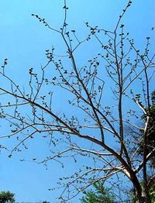
As the dry season begins, in May or so, you see leafless trees around people's homes bearing hundreds of plum-sized fruits, as shown at the right.
If you look at the fruits closely, probably they'll still be green, because as soon as they're ripe critters and people snatch them away. Some green ones are shown on the next page.
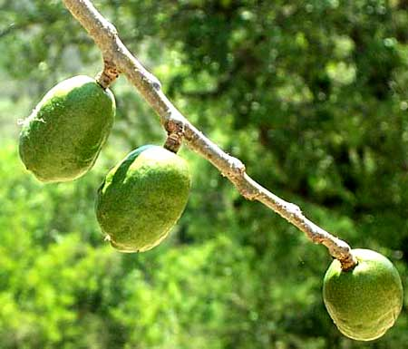
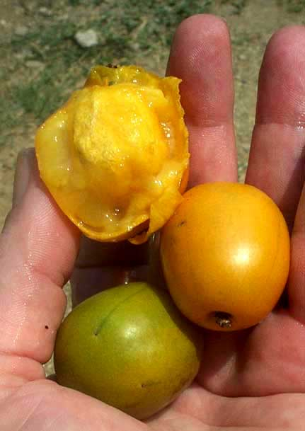
Mexicans call the tree Ciruelo," which translates to "plum," and in fact in English often we call them Spanish Plums, as well as Mombins and other names. Actually, there are two species that go by these names. There's a species with both yellow- and red-fruited forms, Spondias purpurea (both occur in the Yucatan) and there's another closely related species, Spondias mombin, which produces only yellow fruits. The way to distinguish them is that the flowers and fruits of Spondias purpurea cluster along the stem as in the above picture, while in Spondias mombin they're clustered at the end of branches.
By June the plums are ripe and ready to eat, as shown at the right. They look and taste like northern plums, and similarly can be eaten raw and made into preserves. However, note the large, hard, white, blocky seed, which is very unlike the northern plum's lens-shaped pit.
Spanish Plums belong to the mostly tropical Cashew Family, in which we find not only cashew and mango trees but also sumac, Poison Oak and Poison Ivy. The North's plums are members of the Rose Family. By the time Spanish Plum fruits are ripe, the trees' pinnately compound, walnut-tree-like leaves have emerged and the plentiful yellow fruits set amidst fresh, emerald green leaves are very pretty, as shown below.
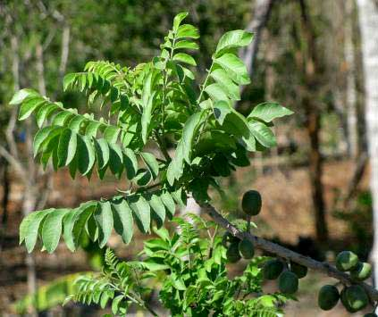
A big problem with Spanish Plums is that sometimes every ripe plum on a tree will be wormy.
Just about any country Maya person can tell you, though, how to ring a tree's trunk with salt to keep that from happening. Be be careful about doing that, however, because too much salt can kill plants.

BARBADOS-CHERRY
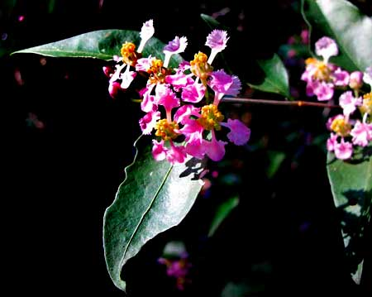
Here's another tree drawing attention to itself twice each year. First, as the dry season begins, in November or so, you notice its peso-sized, pinkish flowers, shown at the left.
Later, in May or so, at the beginning of the rainy season, once again the tree becomes very pretty with all its bright red, crabapple-like fruits, as shown below.
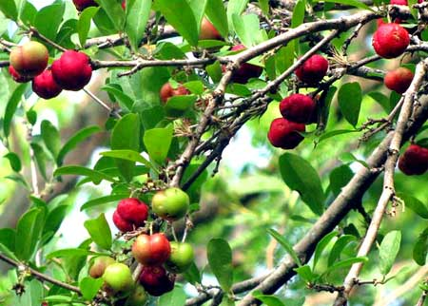
This is the Barbados-Cherry, sometimes called Wild Crape Myrtle by Northerners focusing on the pretty flowers. It's Malpighia glabra, a member of the tropical and subtropical Malpighia Family, the Malpighiaceae. In most of North America there are no wild members of the Malpighia Family.
The acidy fruits are thin-skinned and good to eat. They contain 32 times more Vitamin C than a similar quantity of orange juice. When eleven fruit pulps were tested, that of Barbados-Cherry scored the highest anti-oxidant potency. Unfortunately, the ones I pick nearly always are inhabited by worms.
Barbados-Cherries grow from southern Texas through our area all the way to northern South America.

NANCE
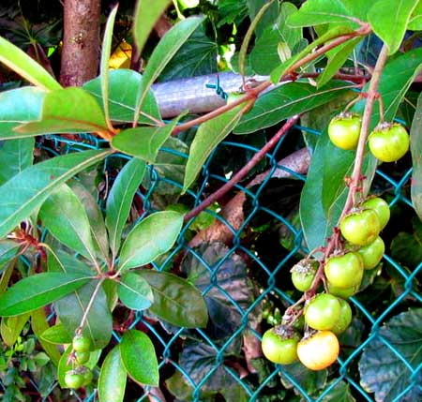
Of all the cultivated fruit trees in this book, one smallish species may be both the least known by Northerners, and yet one of the most commonly found around Maya homes. A raceme of its yellowish, 2/5ths-inch wide (1cm) fruits appears at the right.
That's the Nance, the name written the same in Spanish and Engling, but pronounced differently. In Spanish it's NAHN-seh. It's Byrsonima crassifolia of the Malpighia Family, a family little known to Northern plant lovers.
My impression is that in the old days the tree's fruits were much more appreciated by the Maya than now. Before the days when every Maya felt entitled to his or her daily Coke, Nance fruits were used to make a sweet beverage reminding me of Kool-Aid. Mash a pan of Nance fruits into juice and pulp, add about a quart (liter) of water, sweeten to taste, and you have a nice drink.
Recipes vary from family to family. Nance fruit pulp is white and oily, and varies in flavor from sweet to acid to cheesy, to having not much taste at all. Depending on the flavor, the fruits might also be eaten raw, cooked as desserts like plum stew, added to soups, or even used as stuffing for meats.
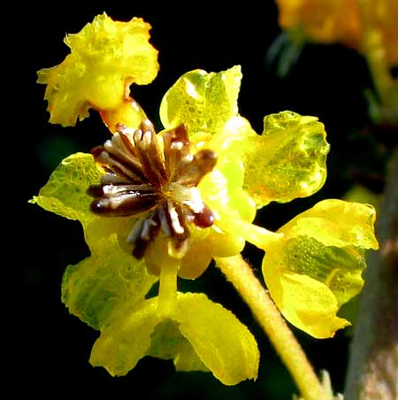
Families who no longer use their Nance fruits might keep the tree around just for their pretty flowers, shown at the right. Individual ¾-inch-wide flowers (2cm) are elegant little things.

GUAVA, Guayaba
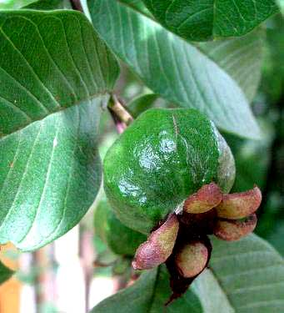
At least when kept watered, guava trees, Psidium guajava of the Myrtle Family, might produce guava fruits almost throughout the year. At the left that's a half-grown one in July.
In that picture, notice how Guava tree leaves have close-together, parallel veins whose tips arc and more or less unite just inside the leaf's margin. That helps a lot when identifying this tree, especially in the woods, for Guavas are native to the American tropics, including the Yucatan.
But, it's the five leathery, purplish items forming a kind of star at the fruit's bottom that makes this a guava fruit and nothing else. To grasp what they are you need to remember that a typical flower has its colored corolla and sexual parts arising from a green, cuplike calyx. Most calyxes have five lobes, or sepals. The five leathery, purplish items in the picture, then, are the calyx lobes, or sepals, remaining on the maturing fruit long after the flower's corolla and male sexual parts have shriveled and fallen off. In most flowers the calyx and its lobes also shrivel and fall off, so these "persistent calyx lobes" on guava fruits are peculiar to the guava.
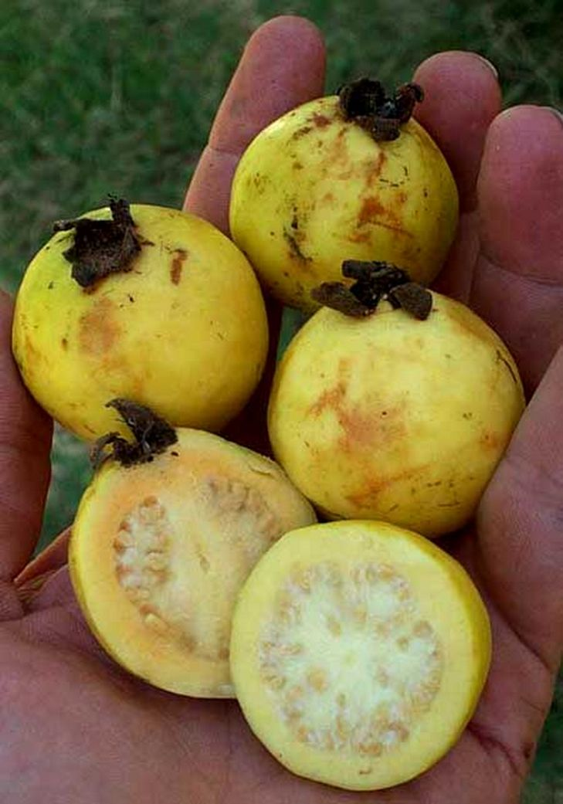
A fellow once gave me a bag of ripe guavas, which I put away. Around midnight I had to get up and take them outside because they created such a strong odor.
At first the smell is fragrant and perfumy with only a slightly musky undercurrent. However, as time passes the muskiness takes over, grows heavy, smothers with its insistence, and I'll bet there are sexual pheromones involved, too, stirring up subconscious cogitations. There's a saying among Spanish speakers, "Hard to hide as a guava," and that's why.
The guava fruit's many seeds are a little hard (sometimes awfully hard) and they bother some fastidious folks, but to us gulpers they're no problem at all. Just don't bitetoo hard or you'll crack a tooth. Sort of smush your guava, skin and all, then swallow.

GUAYA
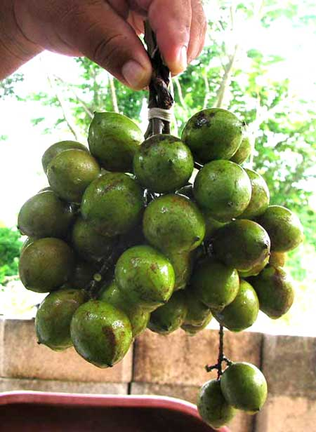
There's Guava, and there's Guaya -- unrelated and unlike one another, just with similar names. Northerners often discover Guaya fruits piled on stands along streets or as they slow their cars at topes on the highway where folks are standing holding up guaya fruits -- maybe calling them by the Spanish name mamoncillos, or the Maya name uayum. Those are guaya fruits at the right.
You buy a bunch, pull off a fruit, bite through the somewhat brittle, green shell not too hard, and the thin husk readily cracks apart freeing a succulent, pinkish-cream pulp, as shown on the next page. The pulp with the big seed inside easily plops into the mouth.
It tastes like slightly sour grape flesh, and it's disappointing that so little of it covers the seed. As you suck on it all, the flesh expands.
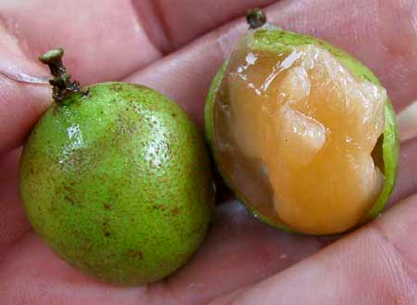
The seed, I read, can be roasted like a chestnut. Some folks chill Guaya fruits in their freezers, then during hot times serve them as cold, tangy snacks. The local Maya eat them with chili powder, salt, and lime.
The Guaya tree is Melicoccus bijugatus, a member of the same family that includes Litchi fruits and the North's weedy balloon-vines, the mostly tropical Soapberry Family, or Sapindaceae. Guaya trees are fairly large and bear pinnately compound leaves typically with four leaflets.
Confusion can arise about what tree is actually the Guaya. The Guaya producing the fruits shown above, Melicoccus bijugatus, is native to northern South America but is widely planted and often naturalized through all of hot tropical America, and beyond. It's not a wild tree in the Yucatan's forests.
However, if you ask a Maya farmer to show you a Guaya, he may well lead you to a large, wild tree in the forest -- one also with pinnately compound leaves bearing four leaflets -- and say that it's a Guaya, or Uayum. In fact that's the very similar, closely related, native tree Talisia oliviformis. If you ask the Maya directly about different kinds of Guaya or Uayum, usually it'll be admitted that indeed there are two kinds of Guaya, one producing the big fruits illustrated above, and the other, this forest-dwelling one, with a smaller fruit, also edible, but not eaten as frequently, and that's Talisia oliviformis.
The leaves of wild Guayas are wider, thinner and hairless, while those of the planted Guayas are more narrow, leathery and hairy. The planted Guayas have been cultivated for so long that several cultivars have been produced, including some with extra sweet fruits.

TAMARIND - Tamarindo
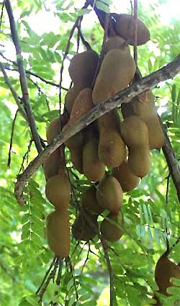
f you see a large, graceful tree with ferny, acacia-like leaves next to a Maya home, there's a good chance it's a Tamarind Tree, Tamarindus indica, a native of tropical Africa. And if the tree bears dangling fruits looking like brown, bloated, green bean pods like those at the right, then it's definitely a Tamarind.
Tamarind trees deserve to be planted if only because they are such handsome trees and provide good shade. However, they're also famous for their pods, which actually are legumes, since Tamarinds are members of the Bean Family. A cracked-open pod is shown below.
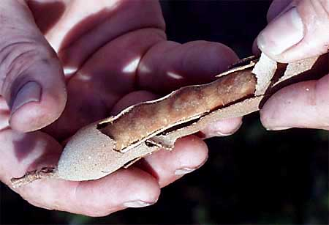
I say "cracked open" because the pods' coverings are hard and brittle. Inside the pods you find the large beans typical of a Bean-Family member, but the beans are embedded in a soft, brownish pulp through which a few tough fibers run. It's the pulp people like, for it's extremely sour, and makes a lemonade-type drink when mashed in water and sweetened.
To make the drink, remove pulp from about a dozen good-sized pods, dissolve the pulp in about 1½ cups of warm water, strain it, add about a quart of cold water, then sweeten to taste. To dissolve the pulp you may need to squish it with your fingers or else remove the seeds and use a blender until you have a thick sauce.

NONI
In fruit markets sometimes you see heaps of greenish-yellow to white, potato-size fruits of a kind that until just a few years ago were never seen in this part of the world. It's one of those "wonder fruits with a great future" which from time to time get introduced with great fanfare as an "important, alternative, money-making crop."
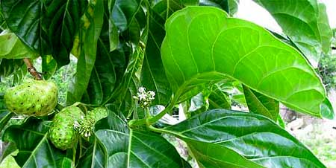
The fruits are produced by a small tree called Noni. Noni is Morinda citrifolia, a member of the large, mostly tropical Coffee Family, the Rubiaceae. Nonis are native to Southeast Asia and Australasia, but today it's not uncommon to see them growing next to Mayan homes in the Yucatan. Below you see typical Noni leaves and immature fruits.
If you Google Noni fruits you'll find extravagant claims about their medicinal value and you'll see that much research has been done on the chemicals in them. The fruits certainly taste medicinal, more bitter than sweet. In fact, usually when I see them in markets they're just lying there rotting because very few people buy them. Some Noni producers say they've found markets for their fruits but others say they can't give them away. One Maya store-owner I asked says he makes a drink from Noni juice, softening its bitterness with orange juice, and he looks like he's 45 but says he's 63, so...
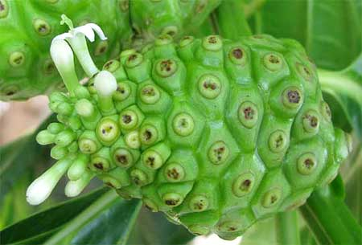
Abovet you see an immature Noni fruit with white flowers attached to it. This picture explains why Noni fruits are so bumpy and each bump bears a little "eye." For, Noni fruits don't develop from single flowers. Rather, as the flowers on the left in the picture show, each bump on a fruit develops from a flower's ovary. The Noni "fruit," then, is a "multiple fruit" consisting of several to many packed-together simple fruits. Mulberries, Osage Oranges, pineapples and figs are other examples of multiple fruits.

COW OKRA -Pepino de Árbol
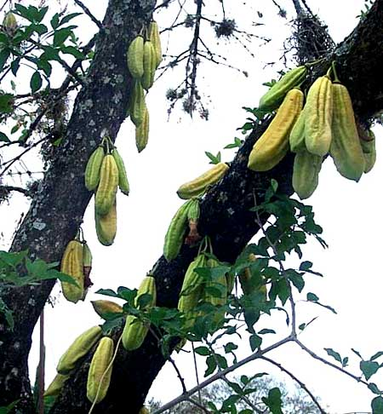
The remarkable thing about the nine-inch-long (23cm) pods on the tree in the picture above is that, instead of dangling from branches, they grow right off the tree's trunk, like cacao fruits. The Maya call the tree Kat-but, and in English it's known by the evocative name Cow Okra. It's Parmentiera aculeata, a member of the Bignonia Family, along with North America's Trumpet Creeper and Catalpas. The leaves are compound 3- or 5-foliate, with a short, stiff spine at the base of each petiole.
Cow Okra is native to southern Mexico, including the Yucatan, and Central America. Traditionally the Maya made an infusion from its roots to control diabetes. In fact, I've read in a scientific paper that chloroform extracts from Cow Okra reduce blood glucose levels in diabetic mice by 44%, and 30% in normal mice. The Aztecs of central Mexico were known to use the plant for kidney diseases, indigestion, colds, and ear infections. Supposedly each day they drank tea made from 1.8 oz (50g) of leaves in one quart (liter) of water. For ear infections they soaked a cotton ball in this mixture and inserted it into the ear.
The raw fruits can be eaten, though they're not particularly good tasting when raw. Some Maya sprinkle sugar on them. Cow Okra pod rinds are too tough and fibrous to bite through, but the flesh inside the fruits has the texture of cucumbers, and is filled with many small seeds that are easy enough to ignore and swallow. Some Maya roast the pods, covering them with ashes and embers, and this improves the taste tremendously. As the fruits bake they soften, sweeten, and get juicier. I've baked them in a solar oven and loved how as they bake they issue a rich, molasses aroma. To me the gummy flesh tastes like campfire-baked plantains (the really big bananas), though others say it's more like sweet potatoes. The pods I bake in the solar oven turn out so sweet and gooey that sometimes I'm accused of packing them in brown sugar, or piloncillo. Unfortunately they're so fibrous that after a meal you may be picking fibers from your teeth for hours.

ANNATO - Achiote
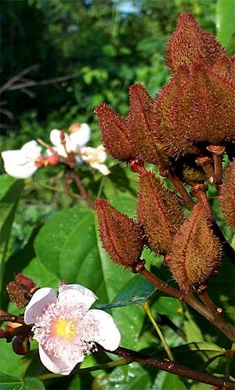
Sometimes you see a small tree or shrub with heart-shaped leaves and bearing white, two-inch broad (5cm) flowers and/or clusters of soft-spiny, reddish-brown capsules like those shown at the right.
That's Annatto, Bixa orellanai, native to Mexico, including the Yucatan, and Central America. In Maya culture Annatto is very important because it's the source of a bright, reddish-orange paste the Maya use in many of their dishes as both coloring and flavoring. Traditional Maya dishes in which you may have seen annatto paste's red signature include Cochinita Pibil and various annatto-marinated fish plates. The recado rojo or "red broth" used in many Maya dishes is red because of annatto.
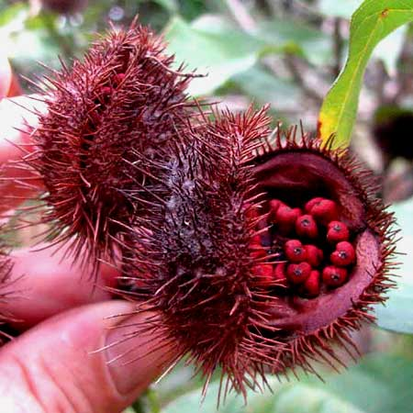
When an Annatto fruit capsule is mature the peppercorn-like seeds inside are embedded in a red-orange paste.. When the capsule matures and starts splitting open, the paste more or less dries and covers the seeds, becoming part of the seeds' pericarp. This pericarp or even the whole seeds can then be ground to make annatto paste.
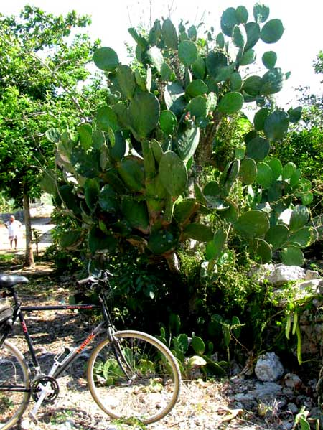

INDIAN-FIG - Nopal
At the right, that's the Indian-Fig, Opuntia ficus-indica, a kind of pricklypear cactus. Many Northerners call it by its Mexican name, Nopal. The feature that makes it so beloved among Mexico's country folks is that its flat pads are edible, and many of its cultivars are spineless. When its immature pads are still tender, they can be collected, processed, cooked, and eaten. Pads ready to be cooked are shown at the right.
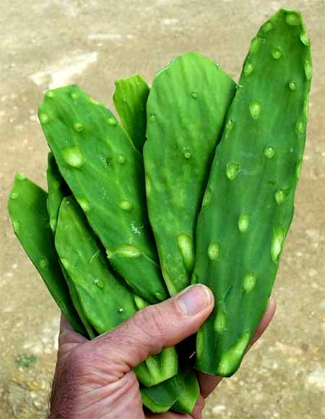
Preparing the pads for cooking consists of cutting little bumps off the pads. Even if the bumps don't sprout spines, they may bear a few almost-microscopic spines called glochids, which can cause plenty of trouble if they stick in your lips, tongue or even your fingers. Once processed, the pads are ready for cooking.
Ingredients for one recipe call for: 3 cups sautéed nopal slices; 3 tbsp chopped white onion; ½ cup chopped cilantro; ½ tsp dried Mexican oregano, and; 2 tbsp fresh lime juice or vinegar.
The Indian-Fig's fruits, called tunas, are edible, too. Atop the next page you can see some tunas still on the cactus plant. The bumps on the tunas produce glochids like those on the pads, and must be removed before the tuna can be eaten.
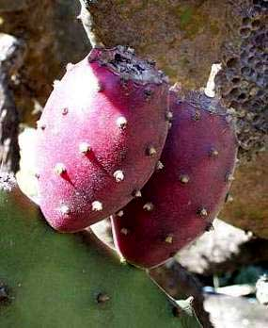
I've seen Mexicans put the tunas on the ground and beat them all around with a brush of soft-leafed weeds. Once you're sure your tunas are free of glochids, cut open the skin and behold what's shown below.
The pulp is succulent and red, almost like watermelon flesh. The taste is even a little like watermelon, but the pulp is full of small seeds. Therefore, you're faced with the same question as with passion fruits and pomegranates: Do you spit out each little seed or swallow them?
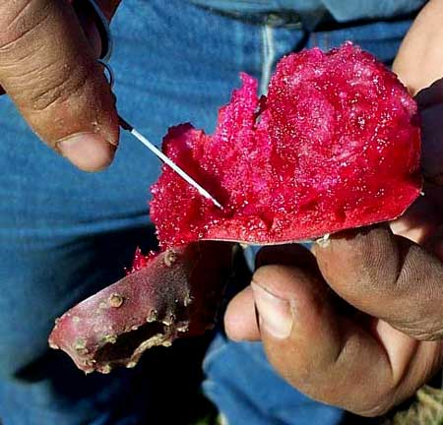
When I ask the Maya what they do, some say they spit, some swallow. Most backwoods folks, as well as myself, are swallowers.
While we have our minds on cacti, it might be fun to think about the special anatomy peculiar to cacti. Mainly, the paddle-like, edible pads that constitute most of the cactus aren't modified leaves but rather modified stem parts. However, on many cacti, including the Nopal, leaves do exist. New pads sprouting from older ones are covered with tiny, green, conical leaves, seen below:
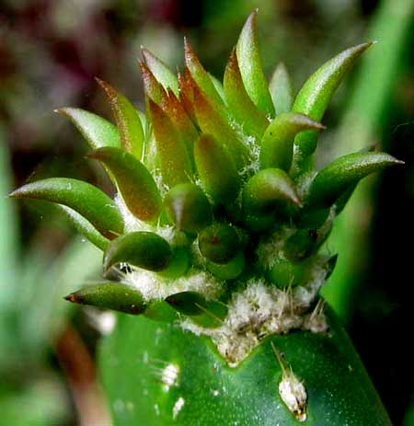

GENERAL NOTES ABOUT
THE YUCATAN'S FORESTS
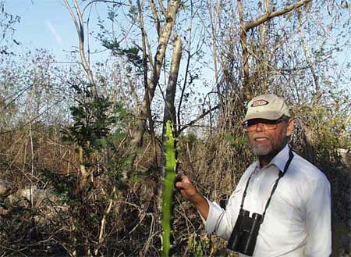
The above picture can teach us some interest facts about the Yucatan's forests. The picture shows me just outside Telchac Pueblo in northwestern Yucatan. Here's what we can learn from the picture:
- First of all, I'm not really that chubby. In the picture I'm wearing five shirts because when the picture was taken I was cold! Therefore, it's not always hot in the Yucatan. The Yucatan has very definite seasons.
- Most of the woody vegetation in the picture is leafless. That's because during the Yucatan's relatively cool dry season -- from about the end of November to mid May -- many deciduous trees and bushes lose their leaves. This cuts down on water loss from the leaves. When the rainy season returns in late May or so, woody branches sprout new stems and foliage.
- The picture shows rather low, scrubby vegetation. That's typical for northwestern Yucatan because, climatologically speaking, in the Yucatan, in general, the farther northwest you go the more arid it gets. There's low, scrubby, cactus-rich vegetation in the northwest, but tall, relatively lush forest in the southeast, and smoothly transitioning forest in between. Some species occur only in the more arid northwestern and northern zone while others live only in the southeastern and southern zone. Therefore, just because a species is featured here as a forest tree, it's not necessarily found throughout the Yucatan.
- In general, the farther southeast you go into rainier territory, the greater the species diversity of the forests. However, in more arid northwestern Yucatan the vegetation accommodates a surprising number of endemic species -- species that in the whole world are found only there. That's because, ecologically, the northern Yucatan constitutes an "island of aridness" with gene flow among individuals of a relatively small population. And in those TV documentaries about the Galapogos Islands, you've learned how new species are encouraged to arise on isolated islands.

SCARLET-BUSH - Coralillo
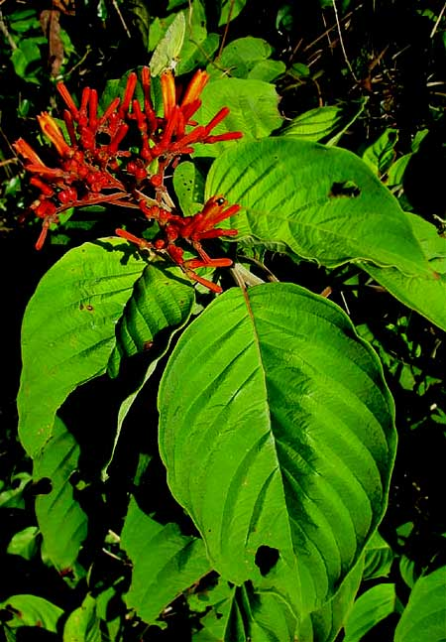
All through tropical America, from Mexico to Paraguay, if you're traveling where there's enough rainfall to support forest at least 20 feet high (6m), the vegetation is weedy and the soil is halfway rich, if you see a head-high shrub aflame with many bright clusters of slender-tubed, red flowers like those shown at the right, probably you have the Scarlet-Bush, Hamelia patens, a member of the Coffee Family, the Rubiaceae.
If you like to take butterfly pictures you can't do much better than to just stand next to a Scarlet-Bush and wait for butterflies to come.
A Maya friend, who called it Kanán, had a high opinion of Scarlet-Bush's medicinal value: "Combine its leaves with those of Pomegranate and Guava, brew a tea from the mixture, and you can cure skin sores by washing the skin with the tea. The tea is also good to swish around in your mouth when it's inflamed and sore. And if you cut yourself, you heal better if you toast its leaves on the comal, grind them to a fine powder, and sprinkle the powder in the wound."

SENNAS
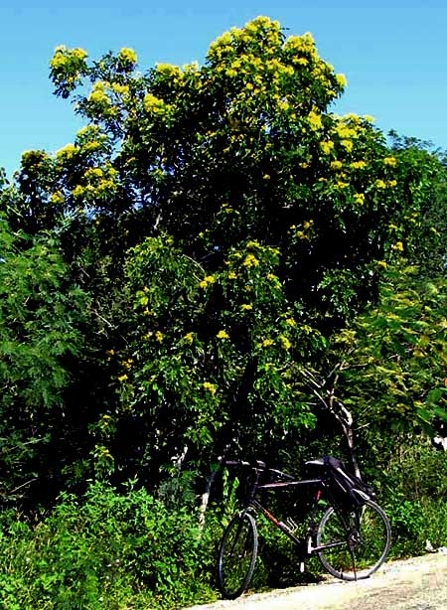
All through the year you're likely to see smallish trees along roads ablaze with bright yellow, peso-sized flowers like the one shown at the right.
Atop the next page you can see that these trees leaves are pinnately compound and the flowers bear five petals that are more or less the same size, but usually at least one petal is of a different size than the others.
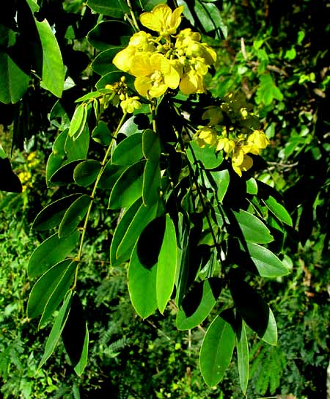
As seen in the flower close-up below, in the blossom's center there are little frankfurter-shaped things. Those are pollen-filled anthers. The long, slender, green thing arising below the stamens is the pistil, which will mature into the future fruit. Seeing the fruit's shape, you might even guess that eventually the fruit will be a green-bean-type legume, which would make perfect sense, since this tree is a member of the Bean Family, whose fruits are legumes.
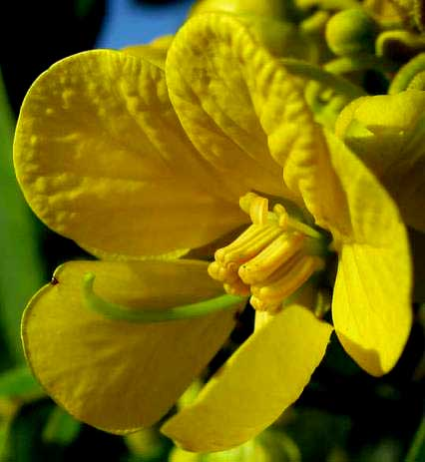
The online Flora de la Península de Yucatan lists 22 Senna species in Yucatan Peninsula, and the species can be hard to distinguish, all of them being bushes or small trees with lots of yellow flowers. Senna is the genus name, and in English we call them Sennas, too. Sennas blossom at different times of the year, so you seldom go for long without seeing the roadside adorned with one or the other species. The one in the picture is Senna racemosa, the Limestone Senna. Sometimes Sennas are known as Cassias.

BUTTERCUP TREE - Madera de Pasta
During the late dry season when many of the Yucatan's deciduous trees have lost their leaves, especially in abandoned fields along roads in arid northwestern Yucatan, sometimes you see leafless, rather gangly-looking, smallish trees spectacularly aflower with four-inch-broad (10cm), orangish-yellow flowers as shown below.
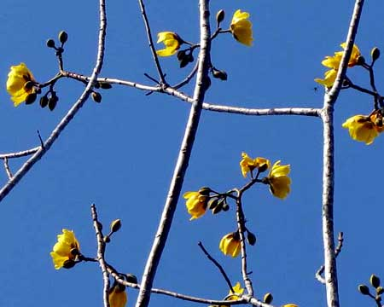
One English name for the tree is Silk Cottontree; another is Buttercup Tree, which is easier to remember. It's Cochlospermum vitifolium, a member of the Bixa Family, in which we also find Annatto, whose fruits produce the Mayas' orange-red cooking paste. Below you see a flower with one side removed to show inner parts.:
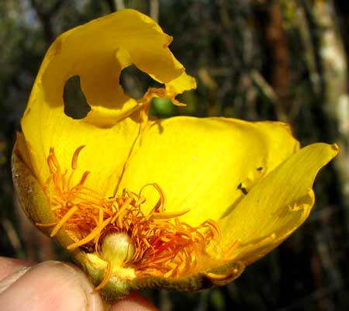
At the blossom's bottom-center, note the pea-sized, spherical, fuzzy ovary atop a saucer-like platform or "disk." Many stamens emerge from between the ovary's base and the disk. Having so many stamens and such a disk below the ovary is a little unusual among flowers, and helps distinguish the Bixa Family, which is a small, quirky one.
Buttercup Tree's fruits are bulbous, brown, jumbo-egg-size structures that split open flowerlike, revealing seeds embedded in masses of white cotton.
The species is widely distributed, not really rare but also not common, from Mexico well into Northern South America, mostly in semiarid areas. It's such a pretty tree that it's planted in gardens throughout the tropics.
A Maya shaman tells me that its Maya name is Nickte' Ch'om, and that resin from the tree is used to treat epilepsy

CECROPIA - Guarumo
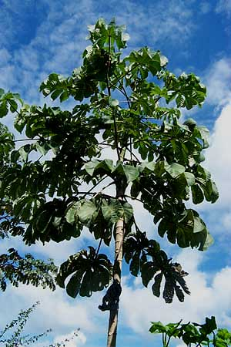
In arid northwestern Yucatan's scrubby forest you do not see the smallish tree shown at the right with its straight, bamboo-like stem and oversized, umbrella-like leaves. That's because this tree likes more rain than falls in the northwest. The farther east and south you travel in the Yucatan, the more Cecropias you see, especially in disturbed habitats such as along roadsides.
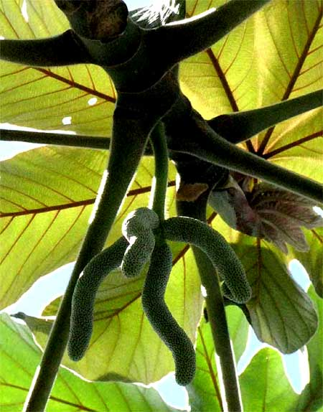
Two Cecropia species occur in the Yucatan: Cecropia peltata, and C. obtusifolia. The one in the picture is C. peltata.
Cecropias come in male or female trees -- they're dioecious. C. peltata and C. obtusifolia can be distinguished by looking at their female flower spikes. The ones shown at the right are C. peltata and are about four inches long (10cm). If they were longer and more slender they'd be C. obtusifolia.
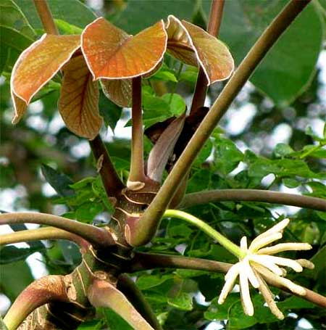
A cluster of white spikes of male flowers of C. peltata is shown at the right.
Cecropia tree stems are hollow and segmented, with some segments bearing holes serving as entries for ants who live in the stems. If a large herbivore comes eating the tree, the biting ants may drive it away. Not only do Cecropia flowers produce sweet nectar that attracts ants but also the tree's mature female spikes are sweet and succulent, and eaten by birds and mammals. Historically the Maya have considered the spikes an emergency food.
Ceropia peltata enjoys high repute as a medicinal plant. The book Las Plantas Medicinales de México describes it as useful against obesity, asthma, liver ailments and diabetes. The trunk's outer layer contains cecropina, considered to be a powerful heart tonic and diuretic.
Once when I was exploring Mexico City's enormous Merced market I asked a big-time medicinal herb dealer which of all the plants he knew he'd take with him if he had to go live on an island with just one medicinal plant. "¡Guarumo!" he replied without batting an eye.

WILD PAPAYA
Big papayas bought in markets grow on cultivated trees developed horticulturally from Wild Papaya trees, Carica papaya, which are native to the American tropics. In fact, Wild Papaya trees are among the most eye-catching species along many of the Yucatan's roads (not in the arid northwest) because they are so unlike other trees with their big, umbrella-like leaves arising atop thick, succulent, mostly unbranched trunks. Two Wild Papaya trees are shown below.
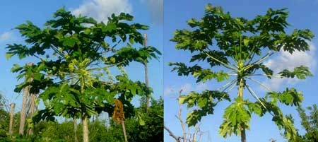
In that picture notice that flowers on the tree at the left grow at the end of long, branched stems. That tree is male. Flowers on the tree at the right arise directly from the trunk, and that tree is female. On the female tree at the right the fruits -- the papayas -- are about the size of golf balls. On wild trees that's about as large as they get. When they turn orange they'll be edible and the flesh will taste OK, but there won't be enough of it for most people to bother with. Birds, though, especially woodpeckers, love eating them. In fact, usually it's hard to find a mature, orange Wild Papaya fruit that doesn't have a hole in it where some critter has been eating it.

MALA MUJER
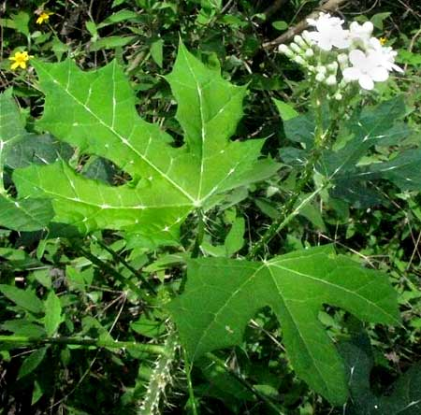
Often at woods edges and along roads you see a scraggly bush or small tree with big, maple-like leaves. That's one shown at the right.
Usually the plant is called, even by English speakers, Mala Mujer (moo-HERR), which means, "bad woman." The plant is "bad" because it abundantly bears many stiff, sharp, stinging hairs of the kind northern nettles have, except that they're much larger and more painful to make contact with. Some stem prickles are shown below.
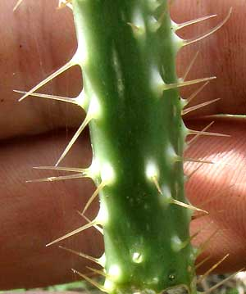
I don't know why the name givers made this plant a woman instead of a man, for it seems to me that men are more likely to be prickly than women.
Whatever the gender issues, it took me awhile to realize that in the Yucatan there are two, not one, very closely related species of "Mala Mujer." The species shown here is Cnidoscolus souzae. The other species is Cnidoscolus aconitifolius, which is very important because it's the wild ancestor of the wonderful Chaya, which produces very nutritious leaves often used in traditional Maya cooking. We look at Chaya elsewhere.
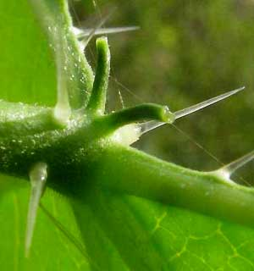
The two closely related species are a little hard to distinguish unless you know a little secret. The secret is that at the top of each petiole (the leaf's "stem") where the petiole joins the leaf blade, there's a secretion-producing gland, and the two species have very different glands. At the right you see the long-stalked glands of Cnidoscolus souzae.
Compare that with the same view below. There, the gland is bathtub-like, not long talked. That's found on Chaya's wild ancestor, Cnidoscolus aconitifolius.
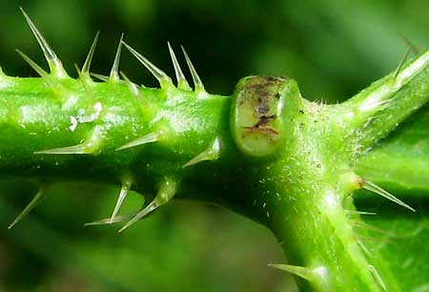
The domesticated, edible Chaya has glands just like the above ones, but its stems and leaves lack the spines. The domestication process consisted of selectively breeding the spines off the wild ancestor.

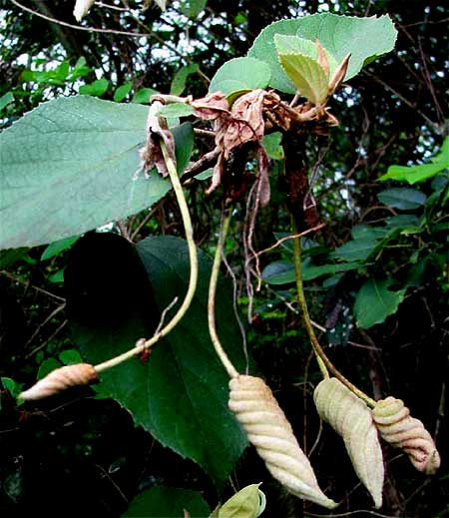
SU-TUT
Especially at weedy forest edges and along roads sometimes you see a ten-ft-high (3m) shrub or small tree with really strange, spiraling fruits at the ends of long stems, shown above. That's Helicteres baruensis, a member of the Hibiscus Family. It has no commonly accepted English or Spanish name, though the Maya I know call it Su-tut.
If you enjoy wandering through traditional markets you may have seen boxes of such fruits sold for medicinal purposes. Once a Maya friend's elderly father told me what the fruits were for. He said:
"Su-tut is for children with speech problems. You put a fruit into the child's mouth, twist it nine times in one direction, then twist it nine times in the other direction, and after you do that for a few weeks the child no longer has problems speaking."

TREMA - Capulín
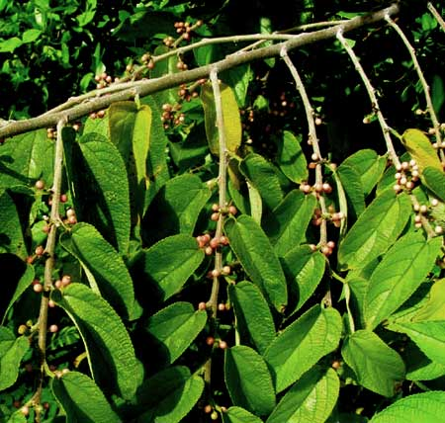
In Spanish the name Capulín is likely to be used for any small, spherical fruit with a fleshy covering. The previous page shows fruiting branches of one of them.
This medium-sized tree often shows up in fields that have been abandoned a few years, and at weedy woods edges. It's Trema micrantha, and you can imagine how birds love those hackberry-like fruits. There's no good English name for this tree, so typically English speakers just call it Trema. It's found in southern Florida and there it's called Florida Trema, but that name won't do in the Yucatan.
It's no accident that its fruits are like northern hackberries, and its leaves look like hackberry leaves. Both Hackberry trees and Tremas are members of the Elm Family. Tremas occur in much of Mexico and the Caribbean area south into South America.

AUSTRALIAN PINE
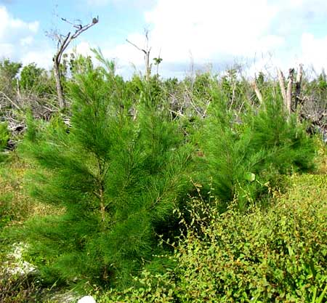
Australian Pine, Casuarina equisetifolia, isn't seen much in the interior but in some places along the coast it's abundant and so unusual that it deserves mention.
At the right you see some young ones next to a Hurricane-Dean-ravaged mangrove swamp north of Chetumal. Basically they look like pine trees.
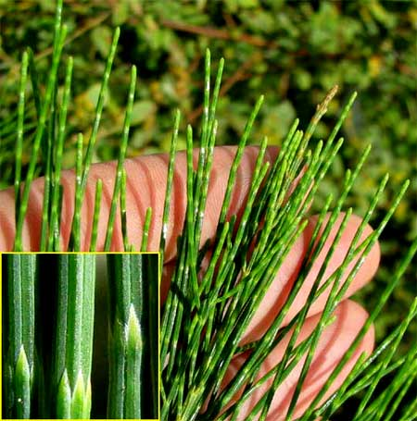
However, if you look closely at the "needles," you see that they're segmented, and pine needles aren't segmented. Australian Pine's "needles" are actually slender, toothpick-wide stems bearing minute scale-leaves in whorls of six to eight, seen in the picture's inset at the lower left.
Australian Pines are a serious invasive species along the Yucatan's coast. Moreover, the species is highly allelopathic, meaning that it produces chemicals which inhibit the growth of other species. Once Australian Pine gets established it can form pure stands with few other plants able to survive near them, offering relatively little food and shelter to wildlife. Dense stands of Australian Pine look lush and green, but ecologically they are deserts.
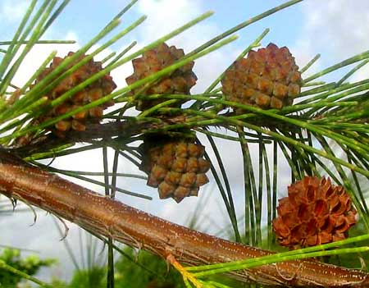
For that reason, in Florida the possession, collection, transportation, cultivation and importation of Australian Pine are prohibited by the Florida Department of Environmental Protection. On the other hand, Australian Pine is very tolerant of sand, sun and salt spray, it stabilizes sandy, windblown soil, and grows quickly producing firewood in places where few other tree species can grow. I've seen it referred to as "the best firewood in the world."
At the left you see how the cherry-sized cones line up among the needle-like stems.
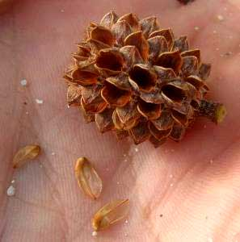
Below, a cone has three papery-winged seeds below it. Australian Pine cones differ from cones of real pines in that their seeds do not fall from beneath woody, overlapping scales, but rather from what look like little turtle heads that spit out the seeds.

COCONUT PALM - Cocotero
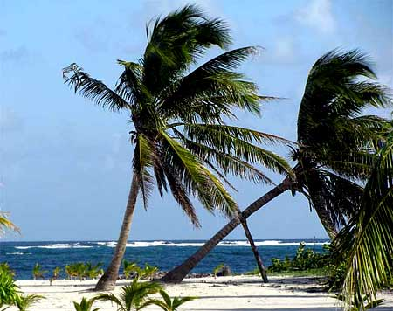
Coconut Palms, Cocos nucifera, grow naturally along the Yucatan peninsula's beaches. Many palm species other than Coconut Palms are planted in the Yucatan and several are native. You can distinguish the Coconut Palm from other spices by these features:
- often they bear large coconuts
- their long fronds are pinnately divided -- like feathers
- their frond bases (petioles) emerge from netlike, brown fiber
- their trunks are tall and slender throughout, with no remnants of frond-petiole bases clothing their upper parts
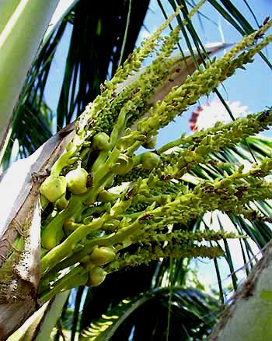
Coconut Palms are "monoecious," which means that their flowers are unisexual, but flowers of both sexes occur on the same tree. In the picture at the right of a Coconut Palm's flower cluster, or inflorescence, notice the many small, greenish items densely arranged along the slender, fingerlike things directed toward the picture's upper, right corner. Those are male flowers, or what's left of them. The much less numerous and larger, oval items in the picture's lower, left corner are female flowers, or female flowers' pistils enlarging as they become coconuts. Notice how the entire large inflorescence arises from a semi-woody, brownish, scooplike spathe. The spathe surrounds and protects the flowers as they develop. Spathes remain on the tree until well after the fruits are mature.
In some parts of the Yucatan Lethal Yellowing Disease has killed most or almost all of the Coconut Palms.
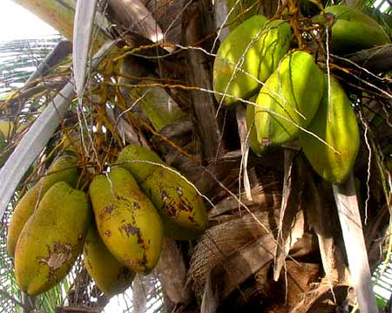
One reason for the disease's devastation is that earlier the Yucatan's diverse natural Coconut Palm population, which included trees bearing nuts of many sizes and shapes, were replaced by just one kind of Coconut cultivar -- one with big, spherical nuts -- which sold better. The disease then rampaged through the resulting monoculture. Now everyone is encouraged to plant native types, even if their nuts are not especially big and spherical.
At the left you see some small, longish coconuts healthily growing on a native strain.

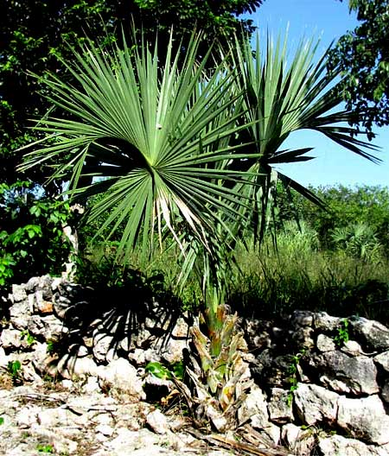
THATCH PALM - Huano
At the right you see an eight-ft-tall (2.5m) palm common in much of the Yucatan, Sabal yapa. North Americans are familiar with palmetto palms of the US Deep South, which also are members of the genus Sabal. Most of the palm's fronds in the above picture have been removed because the Maya use them for thatching roofs.
While putting together this book I was living in a Maya-style hut on the grounds of Hacienda Chichen Resort adjacent to Chichén Itzá ruins. I got to see the hut being constructed, with Thatch Palm fronds used to thatch the hut's roof. On the next page you see what the hut looked like in an early stage.
After chopping off each of the frond's stems, or petioles, so they'd be the same length, the men tied together bunches of them so they could be raised to their working spot on the roof, by rope, as shown belo.
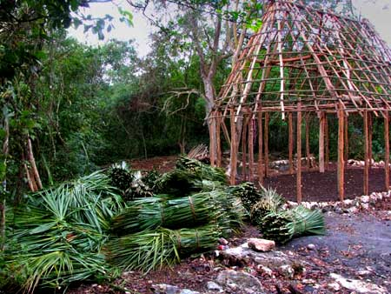
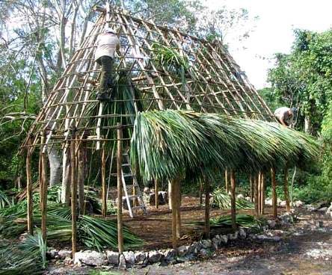
After an hour of thatching the roof, Thatch Palm fronts were beginning to form a skirt around the roof, shown at the right..
One reason Thatch Palm fronds are favored over other palm species is because of how the fronds' petioles extend like a midrib into the fanlike blade. Atop the next page you can see from inside the hut how the fronds hook onto a roof pole.
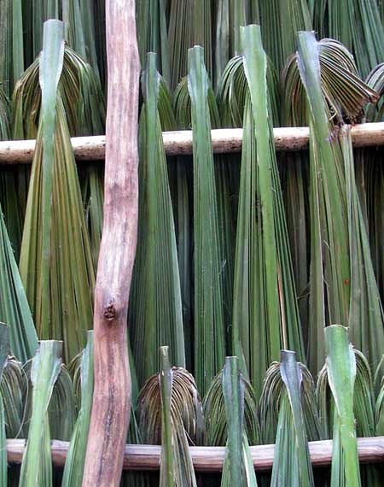
After I had lived in the hut a few weeks, the green thatch turned straw color. I loved living in this hut, and I'm always thankful to the Thatch Palm and Hotel Cichen's owners for building it..

CHIT PALM
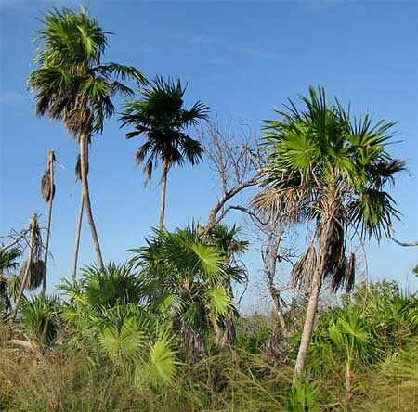
Another famous fan palm is the Chit, Thrinax radiata, shown at the right.
How do you distinguish Chit Palms from Thatch Palms? Returning to the Thatch Palm pictures, notice how the fronds' petioles extend up through the middle of the fronds. Compare that with a Chit's frond shown below,in which the petiole abruptly stops at the frond's base.
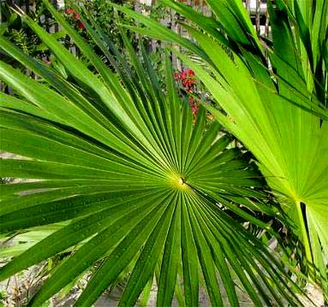
Not only do Chit frond petioles end abruptly atop the petiole, but at the left notice ae toothlike growth rises perpendicularly from the frond at the junction.
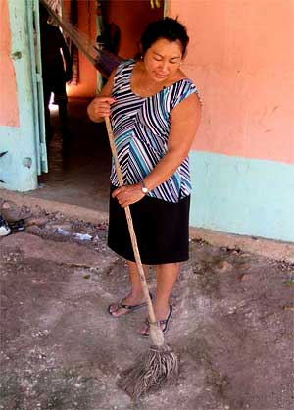
That toothlike item is referred to as a hastula. Hastulas occur on fronds of several palm kinds but in the genus Thrinax hastulas are particularly well developed. Thatch Palm fronds don't have hastulas.
Among the Maya, Chits are famous because of this: Their fronds make good brooms. When the Maya see a Chit, they think "broom." At the right is a former neighbor, Doña Neima, using her well worn but easy-to-renew Chit broom.

PAUROTIS PALM
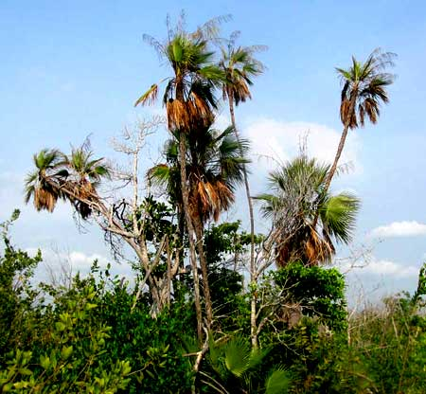
Along the coasts, often among mangroves, sometimes you see tall palms with very slender trunks looking like those at the right.
These are Acoelorrhaphe wrightii. In the Florida Everglades this same species is known as the Everglades Palm, but that won't do in the Yucatan, where there are more of them. Often in English they're known as Paurotis Palms so that's what we'll call them.
Up close, you can see that Paurotis Palm petioles differ from Chit petioles by bearing large, broad-based, forward-curved spines like those shown below, while Chit petioles bear none. In the mangroves, Paurotis Palms mostly occupy the edges, avoiding the most flooded areas.
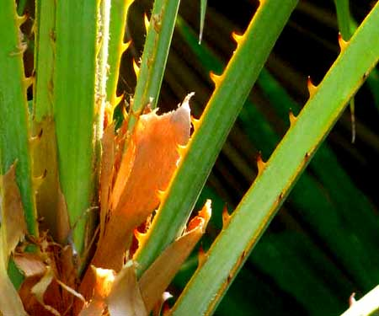
You could say that Chits favor sand while Paurotis Palms go for mud, but not mud where water stands for too long.

COYOL
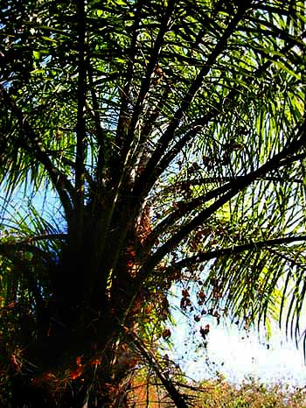
Sometimes you see a naturally occurring palm vaguely similar to an upside-down feather duster. If you stand beneath it, you see what's shown below.
That's the Coyol, Acrocomia aculeata.
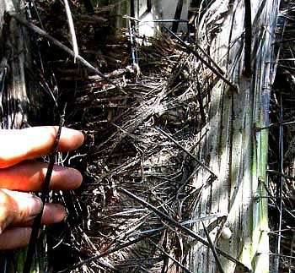
And this is a very spiny species Below you can see that my hand hardly can find a place among the thickly clustered, big, hard, sharp spears which jut. from the trunk at odd angles. Not many critters will be climbing this tree.
Animals might want to climb the tree because it abundantly produces lots of small fruits rather like little coconuts. You can see one tree's crop on the next page.
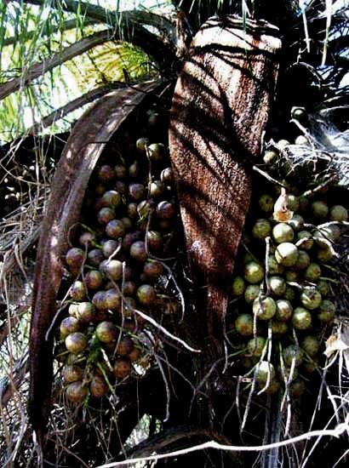
The wonderful thing is that these nuts make good eating for humans, too. In fact, sSometimes you see the Maya selling little plastic bags of boiled Coyol nuts swimming in thick, super-sweet syrup. Usually Northerners don't see the point in them, finding the nuts too hard and tasteless and the syrup too sweet, but the Maya say that they're something sweet that lasts for a long time and, to Maya thinking, that's good.

MANGROVES IN THE YUCATAN
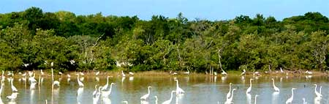
The word "mangroves" refers to a special community of plants and animals occurring in tropical areas that are inundated permanently or occasionally with saltwater. Mangrove communities occur intermittently along all the Yucatan's coasts and surrounding islands.
Few of the Earth's ecosystems are as rich in species and numbers of living things, and few are as important to the broader ecological community as mangroves. The young of many ocean fish species spend their early days in the mangroves, so mangroves are very important to offshore fishing.
However, mangroves are also very fragile. They are vulnerable to hurricanes, human drainage programs and general "development." In fact two of the Yucatan's main woody mangrove species -- Red Mangrove and Black Mangrove -- are regarded as threatened.
Coastal mangrove communities occur in the tropics worldwide, but the species composition of the communities changes from region to region. In the Yucatan usually we think of four different woody species as constituting our mangrove swamps. Sometimes it's observed that, in terms of water depth and salinity, the four species arrange themselves like this:
<<< deep water & salty soil drier & less salty >>>
Red Mangrove Black Mangrove
White Mangrove Buttonwood

RED MANGROVE - Mangle Rojo
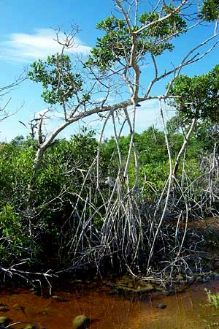
Of the four mangrove tree species constituting the Yucatan's mangroves, Red Mangrove, Rhizophora mangle, is the most eye-catching. It's the one with gangling "stilt-roots," shown at the right.
Red Mangrove inhabits the deepest water of the Yucatan's four mangrove species, and its fruits are the most curious-looking. You can see what I mean atop the next page.
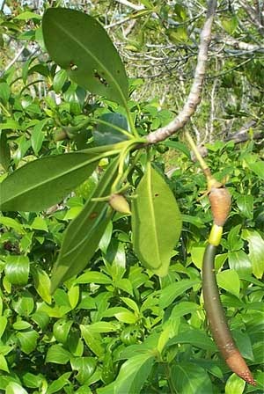
That picture shows two Red Mangrove flowers with fruits developing from the ovaries in the flowers' centers. The fruit on the right is much more developed, as indicated by the fact that inside it a seed has already germinated and now a very sizable root is emerging from the fruit, pointing downward. The dangling root is about eight inches long (20cm). Sometimes when such root-possessing fruits fall from trees the root stabs into the mud, thus planting new Red Mangroves right beneath the parent tree.
More typically, the fruit with its root falls into water and floats away. When the root makes contact with mud it grows into it and then the tree develops as you'd expect. Still, it's fun to know that a Red Mangrove fruit, at least under certain conditions, can actually plant itself.
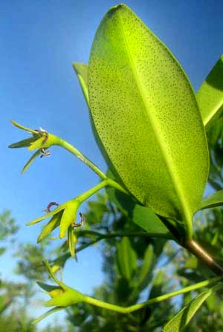
Mother Nature almost always prefers for offspring to settle as far as possible from the parent so that parent and offspring don't end up competing for the same resources. Red Mangroves may constitute an exception, however, since their nature is to grow so closely that their interlocking stilt roots form impenetrable thickets that are the delight of shelter-seeking wildlife. Also, the network of roots catches soil particles that otherwise would wash away, and this builds up the land.
The Red Mangrove's long-rooted fruits are so attention-getting that the flowers preceding them often are overlooked. Above you can see how the pale yellow, leathery, star-shaped flowers arrange themselves in few-flowered, long-stemmed clusters arising from leaf axils:
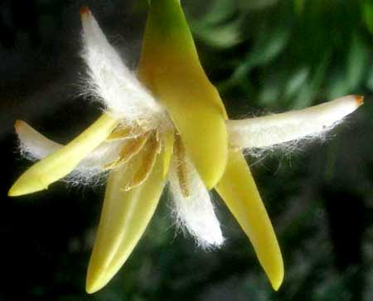
A picture of a little-less-than-inch-wide (2cm) flower with four pale yellow, leathery sepals and four whitish petals with cottony hairs on their inner surface, and eight stamens, appears at the left. Maybe the petals' hairs provide footholds for visiting pollinators.

BLACK MANGROVE - Mangle Negro
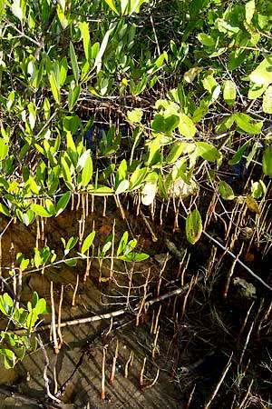
Black Mangrove, Avicennia germinans, is easy to identify because its widely spreading roots send up slender, gray-brown, pencil-like items from the mud and water to about a foot high -- as shown at the right.
These pencil-like things are known as pneumatophores. and they absorb oxygen for the submerged roots. Black Mangrove grows higher above the low-tide mark than Red Mangroves, so often you see Black Mangrove pneumatophores emerging from mud, not water.
Black Mangrove's leaves, reaching only about three inches long (8cm), are hairy below. The four-lobed flowers are white, up to half an inch long (1.3cm). The fruit is a compressed, two-valved, one-seeded capsule up to about 1.5 inches long (4cm) and an inch wide (2.5cm). Here in the tropics Black Mangrove can grow up to 70 feet tall (20m).

WHITE MANGROVE - Mangle Blanco
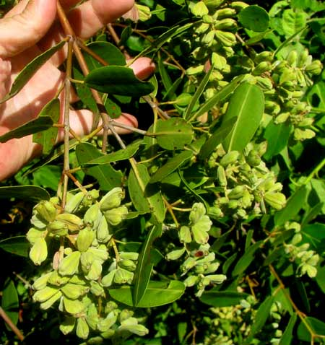
White Mangrove, Laguncularia racemosa, is a member of the mostly tropical Combretum Family. From just a few feet away, dense and much-branching White Mangrove looks like a green wall, but up close you see distinguishing features such as its three-inch-long (7cm) leaves with rounded or notched tips, and long, roundish petioles jutting from the stem almost at right angles. Also there may be clusters of half-inch-long (1.3cm), thick-ribbed, leathery, roughly wedge-shaped fruits.
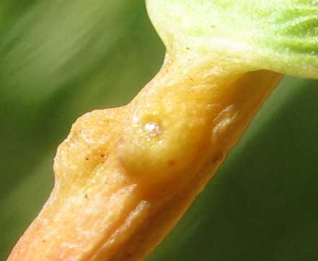
Atop many of the White Magrove's stiff petioles there are two wartlike glands such as those seen at the left. In other species such glands often exude chemicals that either attract ants which protect the leaves from leaf eaters, or maybe repel leaf-eating insects. However, White Mangrove's petiole glands help the plant excrete excess salt.
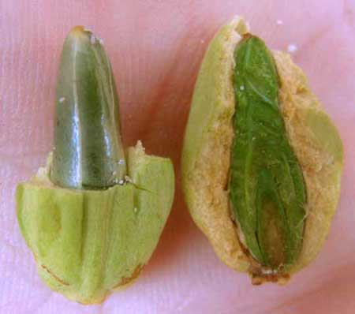
We've seen that Red Mangrove seeds germinate while the fruits still are attached to the stems -- the seeds are "viviparous." A White Mangrove fruit with part of its seed cover removed,s shown at the right, also does something interesting.
The dark green item inside the fruit is the sprout's future green leaves wrapped around one another. In typical seeds we'd find a small, hardly noticeable embryo that would remain dormant for a season but here we have a living shoot that once it's formed never stops developing inside the fruit on or off the tree. This green-leafed shoot will have a head start rooting and growing as soon as the seed is deposited on mud or in water. Since the seeds aren't germinating while still on the tree they're not viviparous like those of the Red Mangrove, but some experts would say that they are "semi-viviparous." Most White Mangroves I see in the Yucatan are only about eight feet tall (2.5m) but I read that they may grow up to 60 feet tall (18m).

BUTTONWOOD - Botoncillo
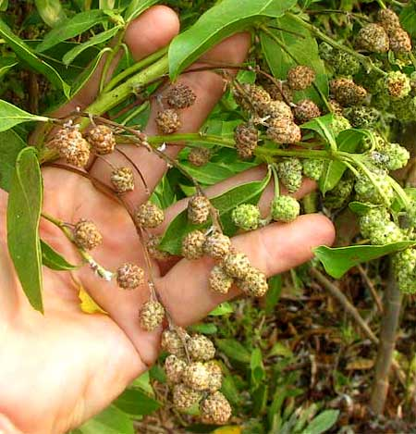
Buttonwood, Conocarpus erectus, a member of the mostly tropical Combretum Family, has the driest feet of the Yucatan's four main mangrove-tree species. In the mangroves, often Buttonwood grows around edges. Usually it bears flowers and/or fruits in distinctive, cone-like clusters like those at the right..
At the peak of maturity when the clusters are brownish they crumble into separate fruits.
Ecologically, Buttonwood is noted for withstanding high winds better than the other mangrove species. Therefore, when they occur at the edges of mangrove swamps they serve as a buffer for the entire mangrove ecosystem. Buttonwood thickets provide habitat for many species, including crabs and Bald Eagles. Unfortunately, its heavy wood makes great firewood and is cut for charcoal production. The species is distributed from central Florida through the Caribbean, and northern Mexico south to Ecuador and Brazil, as well as western tropical Africa.

BEAN FAMILY TREES
WITH COMPOUND LEAVES
In the Yucatan no plant group contains more species of trees and bushes than the Bean Family, the Fabaceae -- also known as the Legume or Pea Family.
Usually the Bean Family is relatively easy to recognize because its species produce legume-type fruits, plus the vast majority of Bean Family members bear compound leaves.
Compound leaves are those divided into leaflets, and there are different ways of arranging the leaflets, as shown on the next page.

- A once-divided compound leaf looks something like what's shown at the right.
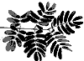
- A twice-divided compound leaf looks "fernier," as seen at the right.
Keep in mind that three-times-divided leaves also can be found, plus not all trees with compound leaves are members of the Bean Family. You also need to see the distinctinve flowers and legume-type fruits.
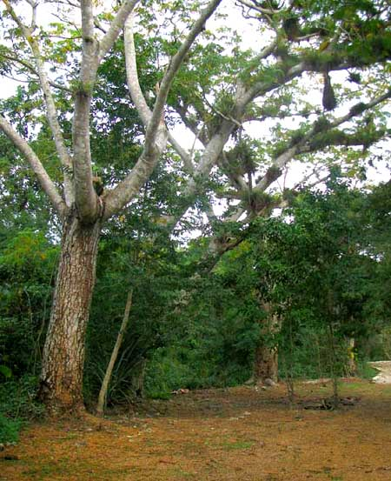

GUANACASTE - Piich
In the Yucatan, three kinds of tree can become gigantic: Ceibas, strangler fings, and the one at the right, what the Maya call Piich and books in English Sometimes name Guanacaste. It's Enterolobium cyclocarpum, and in the Yucatan's rainy southern part it can grow up to 100 feet tall (30m).
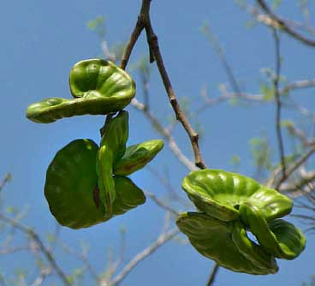
Sometimes English speakers also call it "Ear Tree" because of the shape of its legumes
Guanacaste's twice-compound leaves fall off during the dry season, littering the ground with confetti-like leaflets. Below you can see its twice-compound leaves along with freshly emerged flower heads.
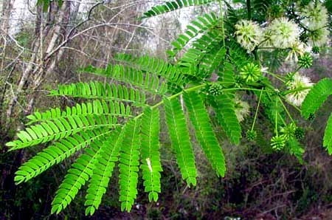
Toward the end of the dry season, in hot, breezy April or so, the, ear-shaped legumes with beans fall to the ground. The beans, when mature, can be roasted and ground to prepare a rich, flavorful, coffee-like drink.

SWEET ACACIA
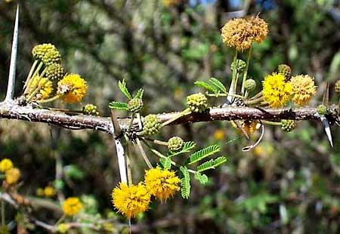
Sweet Acacia is Vachellia farnesiana, until recently known as Acacia farnesiana. In arid northern Mexico and southern Texas where it's abundant it's known as Huisache (we-SACH-eh) but the Maya call it something like Ka'an kilische. It flowers much of the year but seems to reach a peak during the early dry season. Sometimes it gets absolutely loaded with tiny, yellow flowers clustered into globular, mothball-size heads on zigzagging branches with 1.5-inch long (4cm), white spines and feathery leaves as shown above.
In the Yucatan Sweet Acacia is most common in the arid northwestern corner. Since it produces abundant flowers during the dry season when many trees and bushes are in "suspended animation" because of the lack of rain, Sweet Acacia flowers produce a lot of nectar, which attracts many pollinators, including honeybees. Thus this tree is very important to the Yucatan's honey industry. Many insectiverous birds visit the flowers, feeding on smaller insect pollinators.
Sweet Acacia's legumes are short, pudgy items, as shown atop the next page.
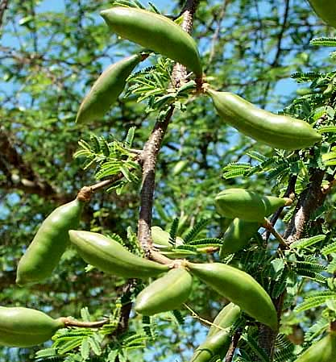
Some of the world's finest, most expensive perfumes are based on an essence called "cassie," which is extracted from Sweet Acacia flowers.
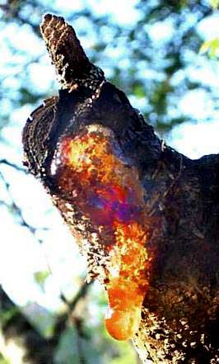
To make cassie, macerate the flowers and mix with melted, purified fats until the fats are saturated with fragrance. Then re-melt the fats, strain and cool. This results in a kind of salve that in some cultures is used as pomade for dressing hair. If alcohol is mixed with the salve and left standing for about a month at below-freezing temperatures the fragrance transfers to the alcohol. When you distill this, the alcohol evaporates leaving a viscous, yellow to brown liquid called "cassie absolute," which is the cassie of expensive perfumes.
Not only that, but at the left the resin that exudes from wounds on Sweet Acacia also is very useful stuff. Maybe you have heard of "gum arabic," which is still used as a natural stabilizer and thickening agent in the food industry, particularly in soft-drink syrups, gumdrops and marshmallows. Gum arabic is normally collected by hand in its dried-hard, amber-like state and is often referred to as a 'tear.' Commercial gum arabic is produced by the African acacia species Acacia senegal. Thing is, some experts say that in certain cases gum produced from Sweet Acacia resin is superior to gum arabic produced by Acacia senegal!
By the way, when a wounded tree exudes resin drops, it's doing so because the gummy resin plugs up the plant's severed conducting tissue in a process called "gummosis." Resin is a lot like the clotting agents in our own blood when we cut ourselves.

GAUMER'S ACACIA
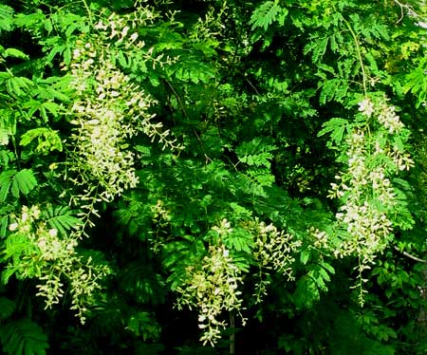
Especially in the central Yucatan there's a common acacia doing something strange for an acacia. The species doesn't have a decent English name so I call it Gaumer's Acacia after the gringo naturalist who discovered it. It's Acacia gaumeri. The Maya call it Box Katzin. The name Katzin or Catzin is applied to several scrubby, spiny acacias and the word box (pronounced bosh) means "black." So, the Maya think of it as "Black Acacia."
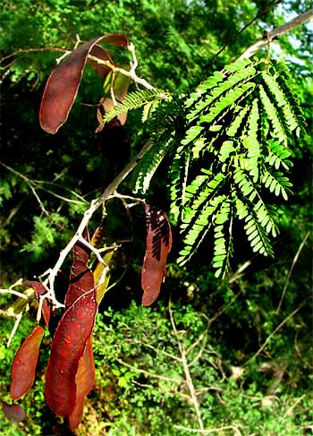
The vast majority of acacia species are like the above Sweet Acacia in that they are low, scrubby, spiny trees with ferny leaves. Gaumer's Acacia is like that, except that when given a chance its branches elongate, become slender and vine-like, and like vines clamber over adjacent trees and bushes. At woods edges they cascade into openings very prettily. During the early rainy season, in June or so, basketball-sized clusters of small heads of tiny, white flowers adorn the dangling branches, as shown on the previous page.
Later in the season, large, flat, brown legumes replace the flowers, as shown at the right.
Why does Gaumer's Acacia produce such long, flexible, un-acacia-like branches? I'm guessing that it's an adaptation for hurricanes. For, Gaumer's Acacia is endemic to the Yucatan -- in the whole world found only in the Yucatan Peninsula -- so it's particularly adapted just to this part of the world. And when the big winds come, it's good to be flexible instead of brittle. If the entire forest gets blown down, it's nice to have vine-like limbs that can grow over the surrounding fallen trees like morning-glory vines.
GEORGE FRANKLIN GAUMER:
The northern Yucatan is home to a surprising number of plants whose technical name, or binomial, end with "gaumeri." "Gaumeri" is the Latinized form of the name Gaumer. George Franklin Gaumer (1850-1929) was a US citizen residing in the Yucatan from 1884 until his death. He collected a remarkable number of rare and endemic species, which he sent to specialists for identification or, if they were unknown to science, for naming. Many of those specialists named the undescribed plants after their discoverer, Gaumer. There's Acacia gaumeri, Caesalpinia gaumeri, Thevetia gaumeri, Vitex gaumeri, Pterocereus gaumeri, Guatteria gaumeri, and many more.

BULL-HORN ACACIA
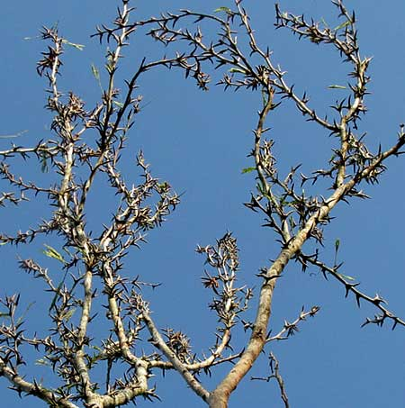
Especially during the dry season when many trees and bushes in the Yucatan lose their leaves you're likely to see what's shown at the left.
That's one of a couple of trees found in the Yucatan known as Bull-Horn Acacia. It's Acacia collinsii, or Subín in Maya. Below, a close-up of some thorns shows what's bull-hornish about them.
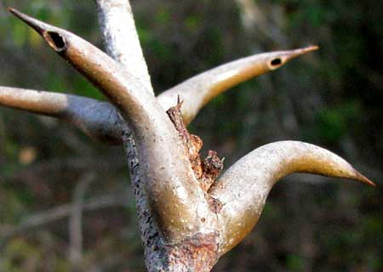
Notice that two of the 2-¾-inch long (4cm) spines bear holes near their tips. Ants chew the holes into the thorns, then enter and live inside. A single ant colony may reside in several adjacent Bull-Horns. If a herbivore comes along disturbing the tree, the ants rush onto the animal and bite. Thus it's a mutualistic relationship, with both tree and ant benefiting.
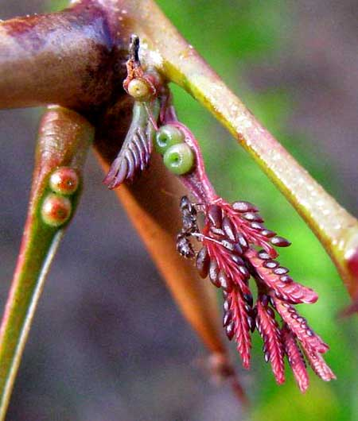
The tree not only shelters the ants but also feeds them. At the right, the purple, feathery at the image's lower rith is the bipinnate leaf about to expand. At the top, left of the leaf the shoehorn-like thing with two green-doughnut-like items in the horn is the leaf's stem, or petiole, and the green doughnuts within the petiole's concavity are glands producing sweet, energy-rich nectar that ants feed on.
Also notice that many of the expanding leaf's leaflets bear teardrop-shaped, dark, shiny things. Those are Beltian bodies, which are protein-rich structures eaten by the ants. Once the leaves are fully expanded, the Beltian bodies will have been eaten and there won't be a sign of them left.
Bull-Horn Acacias also have interesting flower heads, as shown below.
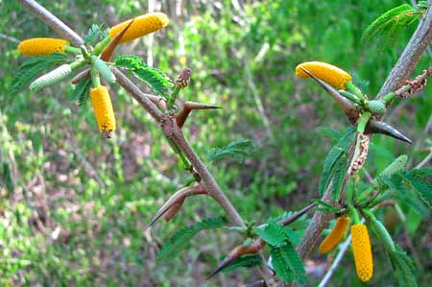

BAHAMA MIMOSA
Bahama Mimosa, Mimosa bahamensis, is known in Maya as Sak-Catzin, catzin being a general name for certain acacias, and sak meaning white, probably referring to the tree's abundant white flower heads, so the Maya think of it as "White Acacia." The species is a small tree very common along roadsides and recently abandoned fields. In other words, it's an almost weedy species. It seldom grows more than 15 feet tall (4.5m). Its flowers and fruits appear atop the next page.
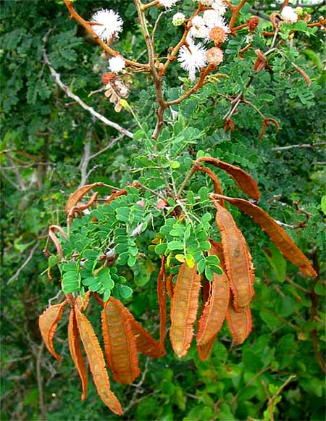
Bahama Mimosa looks like several acacia species, except for its fairly distinctive legumes with their brownish, papery, jagged "wings" along both sides of the flat pods' faces.
The local folks more or less ignore this plant, thinking that it's too small to cut for firewood and not knowing any particular medicinal value for it, though some I've spoken to have a vague notion about its once being used as baby medicine. Its abundant flowers do feed untold numbers of nectar- and pollen-seeking invertebrates, which in turn feed birds, which perform many services in the scrub. Also, it's among the first woody plants to invade abandoned fields, so, ecologically, it's a pioneer species, helping forests. reestablish after being slash-and-burned.

WILD TAMARIND #1 - Uaxim
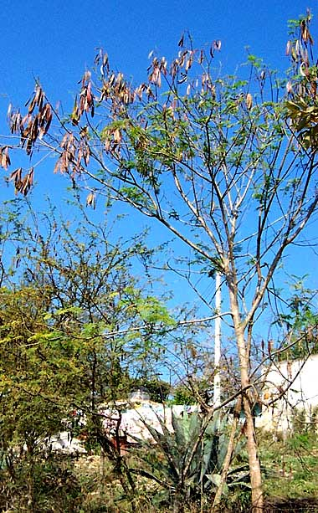
In some places around Mérida and beyond, where abandoned land is slowly reverting to low scrub, the most abundant woody tree is something that looks like a spineless Acacia. The Maya call it Uaxim (wa-SHEEM), and books in English sometimes call it Wild Tamarind, though the next species also is called that. In much of Mexico it's called Guaje. It's Leucaena leucocephala, and that's it at the left during its mostly leafless, dry-season or winter state.
For the most part Wild Tamarind is such a nondescript little tree that you don't notice it until deep into the dry season when it's lost most of its leave and the branches are absolutely loaded with flattish legumes a little like those of the eastern US's Redbuds. Then the trees are noticeable because, basically, they look so ratty.
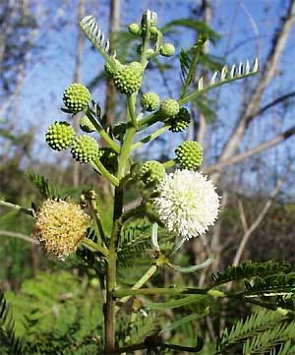
The flowering heads look very much like those of a typical acacia, as seen at the right.
Despite its less than flamboyant appearance, this is a wonderful species! For one thing, it thrives on thin, poor soil, of which the Yucatan abounds, so, ecologically, it's very important as a pioneer repairing the soil. Tthe tree bears flowers much of the year, being visited by an endless parade of pollinators.
Moreover, if you open a slightly immature legume when its beans are formed but the legume sides haven't yet turned brown and dry, the soft, green beans are delicious. You can nibble on them, but good Maya cooks know that their best use is to grind them up and flavor soups and stews with them. They have an unusual flavor with a hint of garlic. Eat just two or three seeds and the flavor stays with you for hours.
In the Yucatan often you see Maya farmers macheteing entire branches of Wild Tamarind to feed to their livestock, stems and all. In fact, sometimes agronomists call Wild Tamarind "the miracle tree" not only because of its worldwide success as a long-lived and highly nutritious forage tree for livestock but also because it provides firewood, timber, green manure, shade and erosion control. This native tree has been planted worldwide, and in 1990 was estimated to cover as much as 12 million acres (5 million ha) worldwide.

WILD TAMARIND #2 - Tsalam
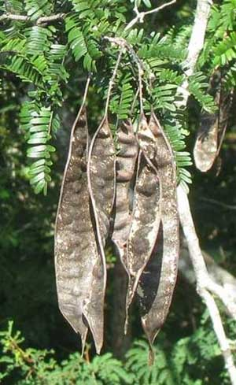
This second "Wild Tamarind," which the Maya call Tsalam, is Lysiloma latisiliquum. Though its ferny leaves look like those of several other acacia-type trees in the area, during the early dry season -- in December or so -- when the tree is fruiting its easy to distinguish because of its large, flat, legumes with swollen edges and, most conspicuously, the odd manner by which the legumes' dark covering flakes off, making the pods look faded and weatherbeaten, as shown at the right.
The Biblioteca Digital de la Medicina Tradicional Mexicana says that traditionally this tree's leaves have been roasted and pounded into powder to apply to sores and wounds.
Traditionally Tsalam has been a source of natural dye, the soaked bark or core wood yielding a reddish brown hue. IThe bark can be stored for a few days and still be effective. It is a natural mordant.

BALCHÉ
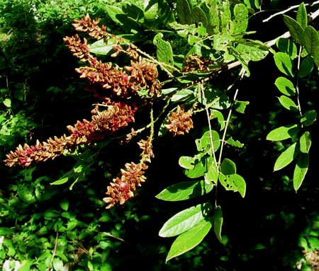
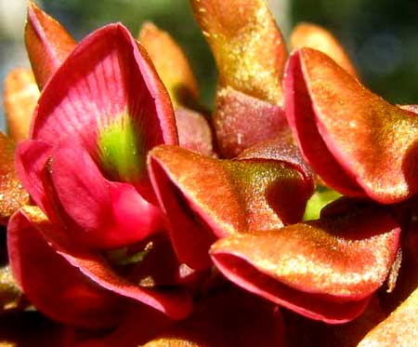
A drink concocted from the Balché tree's soaked bark, also called balché, is much used during Maya rituals. During ceremonies when a shaman pours a liquid toward the four directions, usually he's pouring balché. Traditionally the balché drink was slightly fermented but what I've drunk didn't seem fermented. It was sweetened with honey and tasted of cinnamon and woodsmoke. Over the vast Maya domain different Balché species are used for the drink, including the one shown above.
That's the northern Yucatan's main native Balché species, Lonchocarpus rugosus. A close-up of some of its flowers appears at the left. These are classic "papilionaceous" flowers typical of the Bean Family. Note the distinctive, rusty-colored hairiness on the backs of the top petals -- the "banners." By around Christmas this Balché's abundant flowers carpet the ground like dry, brown confetti. The vast majority of flowers produce no fruits, which are legumes; usually only two or three legumes result on a flower spike. Below, you can see the tree's broad, thin fruits.
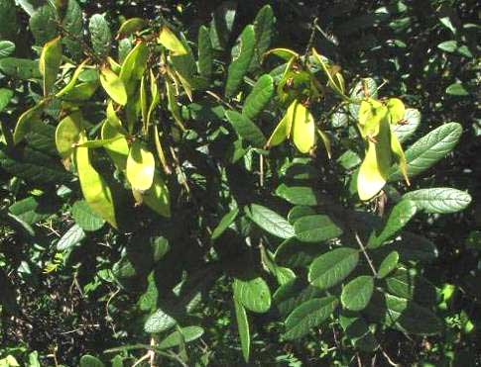
Books I've seen always use the spelling "balché," with the accented é in the Spanish style. That means that the word must be pronounced with the emphasis on the last syllable. However, the shamans I know emphasize the first syllable, pronouncing it "BAL-che."

FISHPOISON TREE -
Jabim, Habim, Habin, Jabin
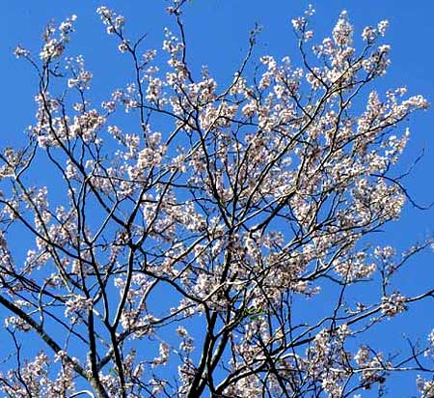
Though this is one of the most common and useful trees in the Yucatan, English speakers don't have a good name for it. I use the Maya name, but one problem with that is that the Maya really don't seem to care whether a word ends with an m or an n, using them interchangeably. Also, in Spanish, words beginning with an h-sound sometimes are written with an h, sometimes with j.
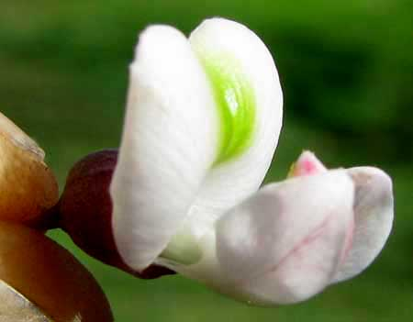
Therefore, this tree's Maya name isn't standardized in print. Habim, Jabim, Habin, Jabin -- you see them all. Whatever the case, the tree is Piscidia piscipula and that's it flowering above in April. A blossom is at the left.
Books in English often refer to this tree as Fishpoison Tree. That's because the tree's bark can be ground up, sprinkled into a pool of fishy water, the fish will rise to the top gasping for air, and they can be captured. Many indigenous American cultures have used the tree this way, but this use is unknown to the many Maya I've asked. I'm not surprised, though, because with no rivers or lakes here the Maya haven't needed such a fish-getter.
The Maya do appreciate this tree, however, because it grows large and its hard wood resists rotting when planted in the ground.
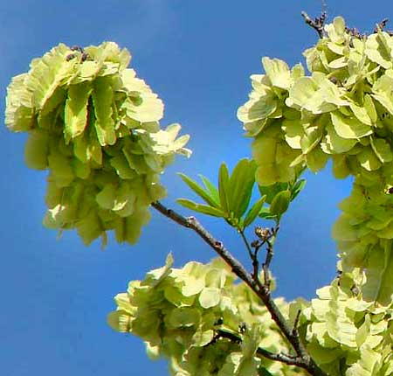
Around mid May, at the end of the dry season, this tree becomes as eye-catching as it is when they flower, by producing enormous numbers of very strange looking, papery-winged legumes, as shown at the left.
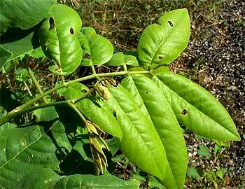
Despite such glorified flowerings and fruitings, Jabim's leaves are fairly unspectacular, rather like the North's pinnately compound ash leaves, as shown at the right.

BLACKBEADS
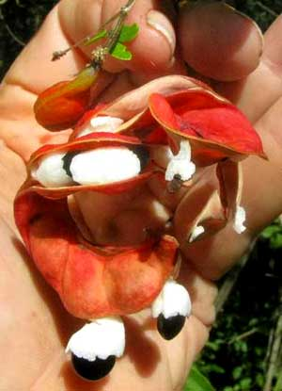
Throughout the year but mostly at the end of the dry season in April or so a medium-sized tree that's easy to overlook suddenly develops curled, red legumes. At the left you see two such fruits curling together and splitting open to release their black beans partly encased in white pulp.
Finding a good English name for Pithecellobium dulce is impossible. Many books list it as Manila Tamarind, but the species is neither from Manila nor is it a tamarind. It's also called Madras Thorn, but it's not from Madras, either. This native Mexican species has been carried to many tropical countries throughout the world, which accounts for the many names. Spanish speakers don't seem to have a consistently used name for it, either. My Maya friends call the tree, approximately, Ts'iu-Ché. Several species of Pithecellobium exist and members of the genus sometimes are referred to as Blackbeads, so that's what we'll call them here: Blackbeads.
Blackbeads is a fairly common tree from southern Mexico into northern South America. In some cultures the legumes are appreciated because the white matter cupping the black beans is somewhat sweet and very edible. Sometimes people secure hooks on poles for snatching the pods just so they can stand around nibbling on them. Technically the white tissue is referred to as the aril, which is a growth arising from the threadlike connection between the bean and the pod.
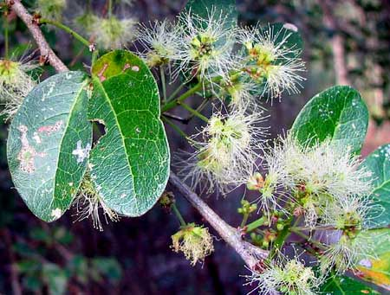
In the middle of the dry season, in February or thereabouts, Blackbeads become covered with white, fuzzy-looking flowers, as seen at the left. The flowers are fairly typical of acacia-type trees, but the leaves are distinctive, as seen better below.
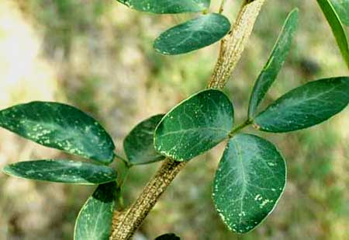
As is typical for the Bean Family, the leaves are compound. In this case they are doubly compound. Usually doubly compound leaves consist of very many tiny leaflets, like the acacias, but here the leaf's first division produces only two subdivisions, then each subdivision forms only two leaflets. Therefore there are four egg-shaped leaflets per leaf, which is very unusual and helpful for us identifiers.

KIK-CHÉ
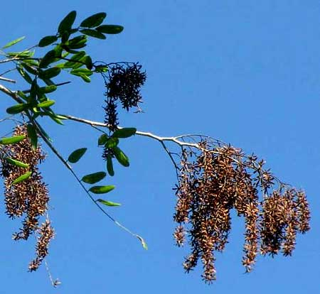
Occasionally throughout the year a common small tree calls attention to itself with the massive, brown, messy-looking fruiting clusters shown at the right.
There's no good English name for this tree. The Maya call it Kik-ché. It's Apoplanesia paniculata, and it's yet another member of the Bean Family.
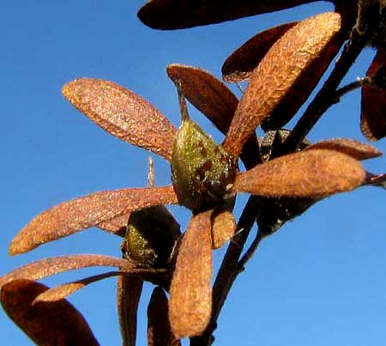
If you look closely at the brown masses of fruits you'll see that something neat is going on, shown at the left
That's a single oval, olive-brown, one-seeded fruit (a legume containing one bean) at the base of which five reddish-brown, veiny, leathery, elongate lobes emerge, like the arms of a star. Each lobe is a much enlarged sepal, or calyx segment. The lobes help disseminate the legumes by wind. Sepals that expand after flowering are said to be "accrescent."
If you hold a Kik-ché leaf up to the sun you see that tiny, brownish glands are embedded in its leaves, as shown atop the next page.
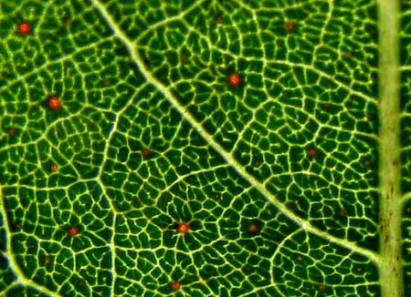
Aromatic oils in the glands must be the source of the fragrant, spicy odor smelled when Kik-ché' leaves are crushed between fingers. In Maya kik means "blood" and ché means "wood," so this is the "Bloodwood Tree." And it's true: Iif you hack the slender, scaly-barked trunk with a machete it exudes reddish sap. In fact, Kik-ché was one of the most important sources of the ancient Mayas' red dyes for mural painting.

MADRE DE CACAO
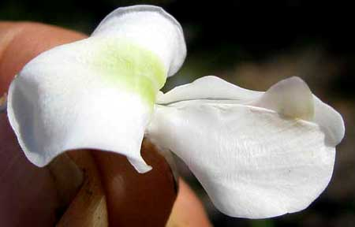
Deep in the dry season, in February or so, a smallish, dry-season-leafless tree similar to a flowering North American Redbud appears with white flowers -- instead of pink as with Redbuds -- like the one at the left.
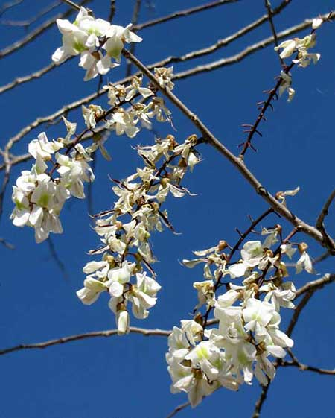
That's a springy-looking flowering branch at the left.
Even in the dry season you might find a leaf or two, dried-up and about to fall off,. If so, you can see the leaf's once-compound structure, as shown below.
This is Gliricidia sepium and while it's native to Mexico, Central America and northern South America, it's also one of the most widely planted of all trees in the world's tropics -- explaining why it has a world of common names, including the English ones Quick-Stick and Cacao Shade.
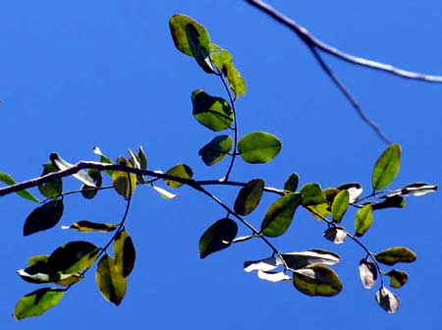
Often English speakers call it by one of its Spanish names, Madre de Cacao, a name reflecting its value for providing shade for Cacao plants.
Cut a leg-long stick of this tree, poke it into the ground, and if the ground is reasonably moist the stick will grow into a new tree in a single season. Place many sticks in a row and in a few months you'll have a "living fence." Livestock love eating its leafy branches, and it's good for them, containing a crude protein content of 18-30% and a high digestibility. In Spanish sometimes the tree also is known as Mata Ratón, or "Mouse Killer," because leaves and bark mixed with ground corn can be used as a rodenticide.

STRANGLER FIGS
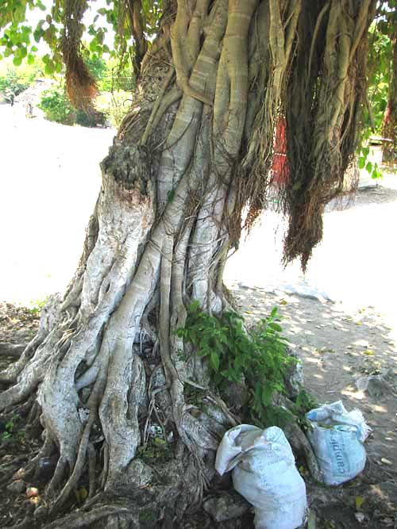
Many species of the fig-tree genus Ficus are regarded as strangler figs. Often people think of fig trees as having "fig-shaped leaves" -- with deep lobes on each side of the leaf -- and of fig fruits as being pear-shaped. However, that's the Old World fig. Leaves and figs of our many American fig species usually look something like those shown on the next page.
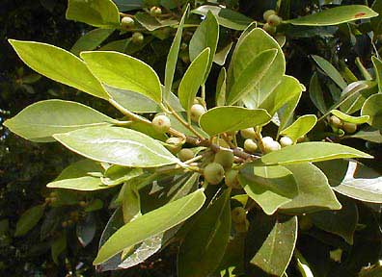
Not all American figs are "stranglers," but the most eye-catching and interesting are. Strangler figs are those which sometimes whose multiple trunks "strangle" their host trees. The strangling works like this:
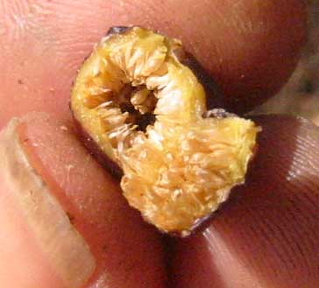
Tiny fig seeds from inside fig fruiting bodies such as the split-opened one at the right are deposited, often in bird poop, on a "host tree" or maybe atop a Maya ruin. The seed germinates, sprouts a shoot that will become a new tree, and issues roots that dangle to the forest floor or creep down the tree's trunk or maybe snake through cracks between a Maya ruin's stones.
The idea is to get to the ground where water and nutrients can be attained. Meanwhile, above, the shoot grows into a small tree, and maybe eventually a big one, even overtopping the host tree. The fig is not a parasite, for it robs nothing from its host's body. It's an epiphyte -- a plant living on another plant, like many orchids and bromeliads.
Eventually many of the growing fig's roots reach the ground. They enlarge and merge with one another. If the roots encircle a tree trunk they may fuse together and form a cylinder around it. Once the fig is shading its host tree and taking much water from it, the host may die. It is "strangled" by the strangler fig. Often strangler figs live atop ruins, old hacienda walls, or just on the forest floor. You don't need to have strangled a host tree to be a strangler fig.
Strangler fig fruits are so tasteless and small that people don't bother to eat them. However, many kinds of wildlife relish them, especially birds such as parrots. The online Flora de la Península de Yucatan lists eight fig species -- members of the genus Ficus -- for the Yucatan.

POISONWOOD - Chechén
People with experience in the Yucatan know that sap from the Poisonwood tree, Metopium brownei, can seriously blister your skin, and that the Gumbo-Limbo tree is supposed to be its antidote. Moreover, people are likely to swear that wherever there's a Poisonwood tree, there's a Gumbo-Limbo growing not far away. It's true that they often share the same habitat, but the two or three times I've gotten Poisonwood juice on me there was no Gumbo-Limbo within sight!
As you can see on the Next page, Poisonwood's pinnately compound leaves even look a little like Gumbo-Limbo's.
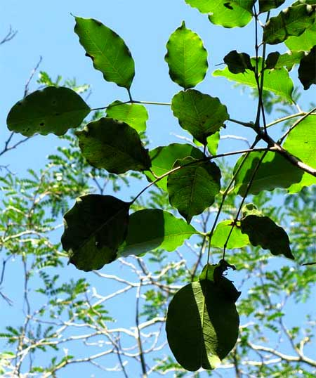
Unfortunately for those who want to avoid Poisonwood, the tree's trunk displays nothing very distinctive about it, except for this:: If the trunk is damaged so that it oozes sap, the sap turns black, as shown below.
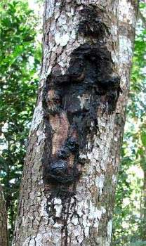

. To have problems with Poisonwood you need to get the juice on you. Just touching the leaves without injuring them is OK. However, I've heard of people who chopped Poisonwood with machetes, got juice in their eyes, and nearly went blind. It's serious stuff!
In fact, a while back I conducted a little experiment. I broke off a Poisonwood leaf and daubed a single droplet of juice onto the inside of my left wrist. Atop the next page you can see d what happened next.

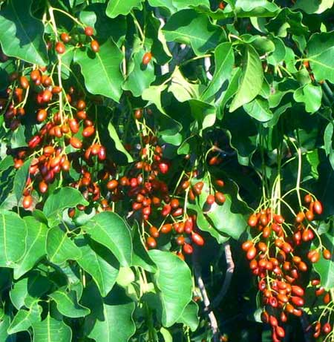
At the right you can see a branch of Poisonwood attractively fruiting toward the end of the rainy season in September.
Poisonwood grows throughout the Yucatan. In most places it's uncommon, but along the coast sometimes, near the beach it can be the dominant species.

BEC
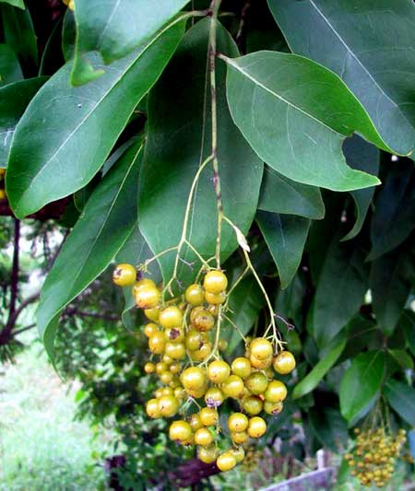
As the rainy season turns into the dry season, in November or so, there's a certain medium-size tree with a pleasing form and dark green, leathery leaves -- a perfect shadetree -- that suddenly attracts our attention with drooping panicles of golden-yellow, cherrylike fruits. The Maya call it Bec, and that's it at the left.
Often along streets and at field edges it is left standing just because it's so pretty and such a handsome shadetree. During the rainy season its abundant white flowers attract clouds of butterflies.
Bec is Ehretia tinifolia, a member of the Borage Family. Up North members of that family nearly always are herbaceous -- Bluebells, Forget-me-nots, Comfrey. It just shows that in the tropics sometimes the Northerner's old stereotypes have to be abandoned.

IGUANA HACKBERRY
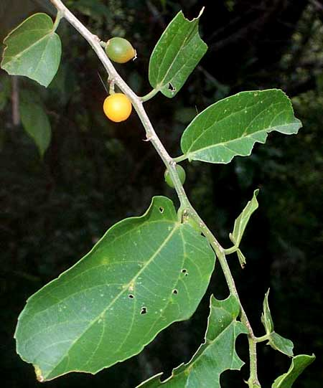
Certain of the Yucatan's trees remind Northerners of plants they know up North, but they're definitely different. For example, the branch at the left bears fruits similar to North America's hackberries and sugarberries, and the leaves have three major veins arising from their bases like those trees.
However, these leaves are too leathery to be hackberries or sugarberries, plus hackberry and sugarberry trees don't have curved spines along their stems like this one. Still, what's pictured is a genuine hackberry -- a member of the hackberry/sugarberry genus, Celtis. It's the Iguana Hackberry, Celtis iguanaea.
Iguana Hackberries generally produce fruit late in the rainy season, in August or so. They show up in dry, sunny places at weedy woods edges and along roads. They're one of those species that start out looking like regular trees but as they grow older and larger their branches become slender and lean onto other vegetation, as if they wanted to become vines, their curved spines holding them in place. Iguana Hackberries occur generally throughout the American tropics and subtropics.
Of course wildlife, especially birds, relish the fruits.

SPANISH CEDAR - Cedro
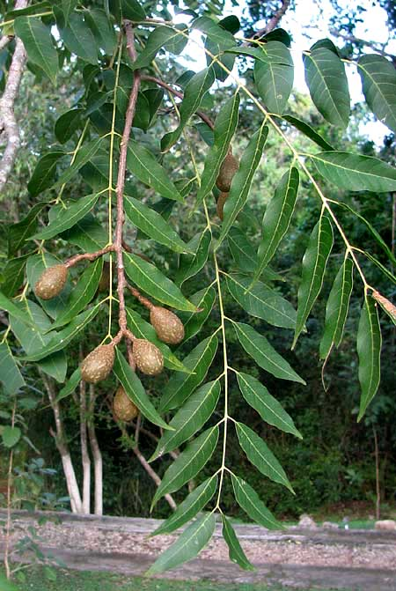
Spanish Cedar, Cedrela odorata, produces particularly handsome, robust, walnut-tree-like leaves and olive-like fruits, as seen at the right.
However, often we don't notice Spanish Cedar until late in the dry season, in April or so, when one day a big tree we've managed to ignore all year suddenly turns up with its dry-season-leafless branches absolutely bristling with 2½-inch-wide (6cm), star-shaped items, as shown atop the next page.
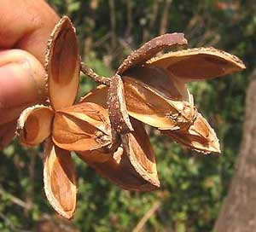
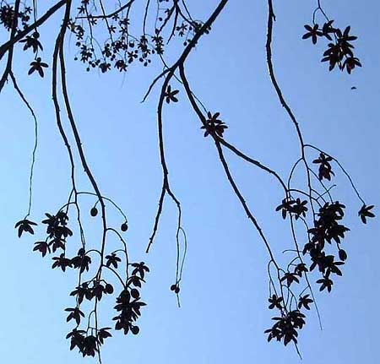
The starry things are split-open, woody husks of Spanish Cedar's capsular fruits. When the fruits open, papery, winged seeds flutter to the ground.
Obviously Spanish Cedar isn't similar to or related to the North's cedars, which are evergreen gymnosperms. The cedar connection is that tree's wood is reddish and emits a sharp, resiny odor like northern cedars.
Spanish Cedars are very important timber trees. In fact, they have disappeared from large parts of tropical America because their wood is so prized, and often exported. The species shares many characteristics with Mahogany, for they belong to the same family, the tropical Mahogany Family, or Meliaceae.
Spanish Cedars live in the hot, humid lowlands of Mexico, Central America and the West Indies.

VITEX
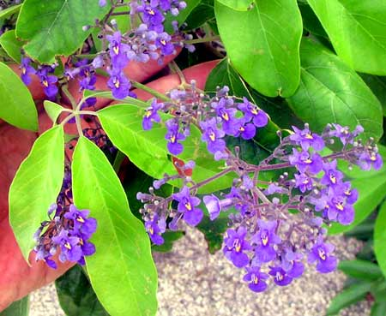
Sometimes you're walking along a forest trail and come upon a spot where the ground is just purple with thumbnail-sized flowers dropped from above. The tree may be so tall that you can't see where the flowers are coming from. Maybe you'll spot some of the tree's curious leaves, though, which are "digitately compound," with five or so leaflets all arising from atop slender petioles, as seen in the previous picture.
This handsome, sometimes-common tree really has no good English name. The Maya call it Ya'ax Niik. It's Vitex gaumeri, so I just think of it as Vitex,. Certain species in the genus Vitex are known as Fiddlewoods so if you want to call it Fiddlewood no one will stop you. Vitexes are members of the Verbena Family.
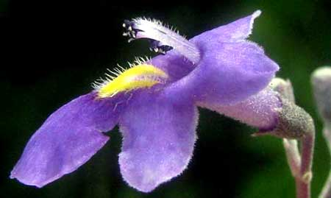
At the right you see that the tree's flower is beautifully adapted for pollination -- the yellow "nectar guide" on the corolla's lower lip leading from the pollinator's "landing pad" beneath stamens whose anthers daub pollen onto the pollinator's back as it enters the corolla's throat.
The IUCN's "Red List" classifies Vitex gaumeri as "endangered," probably because of tremendous habitat destruction throughout the lowland area the tree occupies, and because of overharvesting of the tree for its exceptionally fine wood. The species occurs from southern Mexico south to Honduras.

SIP-CHÉ
Sometimes late in the rainy season, at woods edges, you see small trees with slender branches just bursting with pretty yellow blossoms, as shown below.
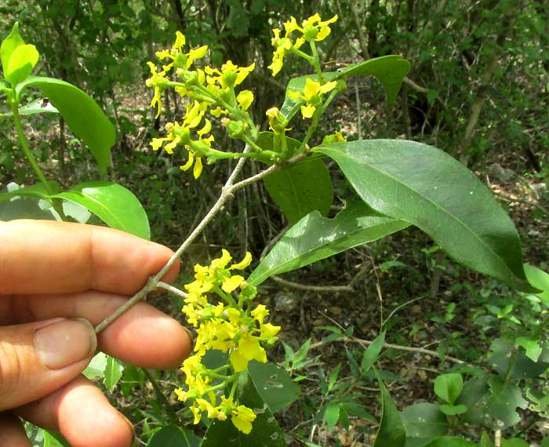
This is Bunchosia swartziana, which has no good English name, so I use the Maya name, Sip-ché. The tree is important in traditional Maya culture because of its healing powers. When you suffer under the influence of "evil winds," a shaman with a handful of Sip-ché branches can brush away your miseries. It "equalizes energies."
If you see Sip-ché, take the time to look closely at its flowers, which are quite elegant, as shown below:
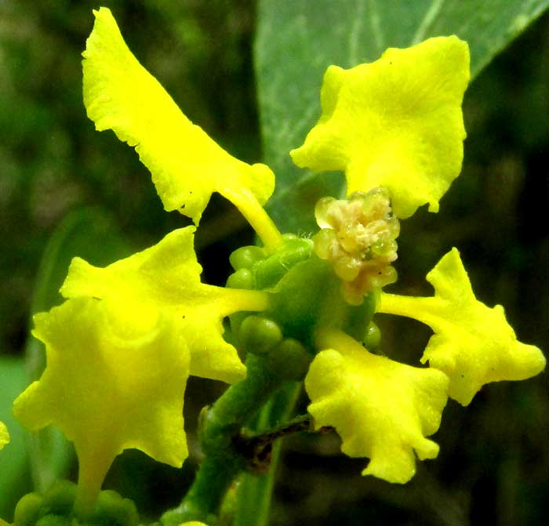

PIXOY
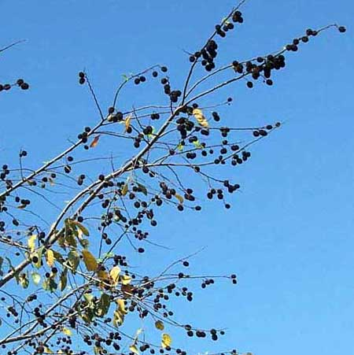
Most people don't notice Pixoy (pee-CHOY) until late in the dry season, in March and April, when the tree's leaves have fallen to conserve water and its branches are heavy with cherry-sized, black, woody, rough-surfaced fruits, as shown at the right.
Some fruits are shown below.
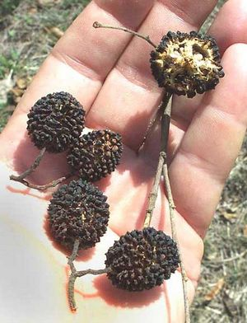
Despite the tree's homely appearance, it's a very important species. In a Pixoy beside my hut, each early morning during fruiting time Yucatan Gray Squirrels come and gnaw and nibble until they're full. The Maya also know that livestock relish the leaves and young stems. Maximino Martínez's classic book Las Plantas Medicinales de México reports that traditionally the tree's bark was used to cure malaria, skin diseases, elephantiasis, leprosy and other ailments. On the Internet, Pixoy extracts are sold under various names as herbal medicine for many uses, including slimming down. You can see what's being offered now by searching on Pixoy's technical name, Guazuma ulmifolia.
When the Maya campesinos I know think about Pixoy, however, they think "rope." A while back my friend Paulino, at Hacienda Chichen adjacent to Chichén Itzá ruins, needed some crude rope for a Maya ceremony so he simply walked over to a Pixoy and macheted off some six-foot lengths of "water sprouts" -- fast-growing, straight sprouts that sometimes emerge at the base of a tree and shoot up through the tree's older, much-branched limbs. The sprouts were about as thick as a banana, so they were pretty substantial.
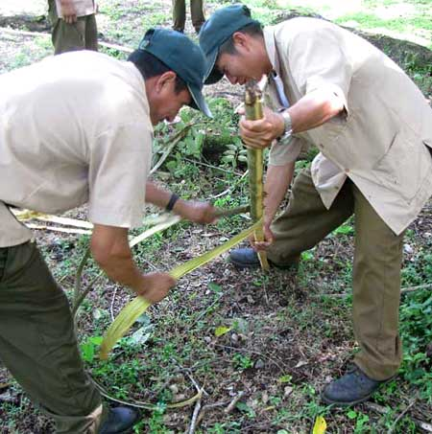
Paulino and his helpers set about beating the poles against old tree-stumps and pounding them with rounded rocks, but not hard enough to crack the bark. This loosened the bark from the wood. Then, shown at the right, each man planted a stick before him and began pulling strips of semi-pliable bark off, each strip an inch or two in width. Once the strips were removed they were still pretty stiff so they needed to be worked to soften up.
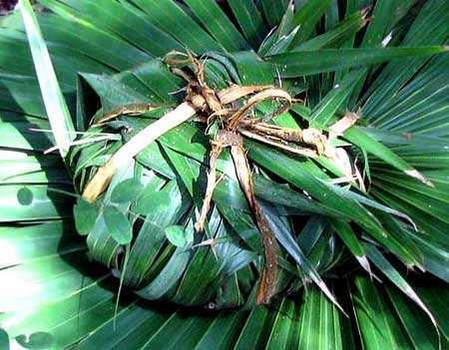
The resulting fibers were used to tie together stacks of ceremonial tortillas wrapped in fronds of Chit Palm before they were baked in a ground pit. You can see how that looked at the right.
Pixoy is a member of the Hibiscus Family. It's native to most of tropical America but has been introduced into numerous tropical countries, where sometimes it has escaped to become invasive.

BREADNUT - Ramón
At least two kinds of tree often are called Breadnuts, both producing highly edible fruits, and both members of the Fig Family. One is Artocarpus camansi, very similar to the Breadfruit tree. Ours is the other, in the Yucatán countryside usually called Ramóns. They're Brosimum alicastrum, and may well be the most potentially useful and important of all the plants considered in this book. But before considering why, its identification marks should be noted, because its appearance is fairly humdrum.
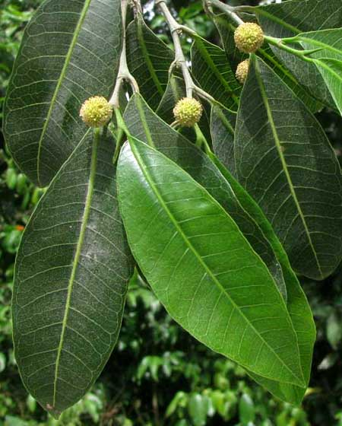
In its dark green, leathery leaves shown at the right, notice how the veins form a "herringbone pattern." In the picture it's hard to make them out but wherever a leaf's petiole attaches to the stem, there's a narrow scar encircling the stem, typical of the family. Also typical is that if you tear across a vein in a leaf, white latex emerges.
The yellowish, spherical flower heads in the picture are present only during the flowering seasons, which may come two or three times a year.
The fruits are the main thing, though, and a handful picked up from beneath a tree is shown atop the next page.

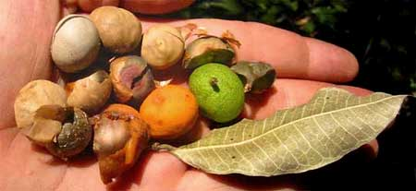
The fruits are remarkably nutritious -- high in calcium, fiber, iron, folate, potassium and antioxidants -- as well as tasty and easy-to-preserve, The hard, nutlike body is encased in a warty skin that's orange when mature. That covering is mildly sweet and not bad to eat, but the main eating is in the nut part.
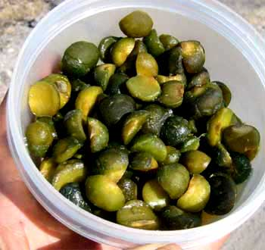
In Chiapas and Guatemala I've been in Maya communities where Ramón fruits were eaten with relish. They'd boil them in water in which they'd added wood ashes to soften the fruits. The finished products are shown at the right.
I've also seen the fruits boiled in salt water, then roasted and sold as a good-tasting snack. In Chiapas I've roasted the fruits, ground them with a hand-turned corn grinder, and made extraordinarily good-tasting "coffee." You can also make bread from them that is many times more nutritious than Mexico's Bimbo white bread.
However, here in the Yucatan I haven't found many Maya eating the fruits. Maya country folks think of the tree mainly as producing leaves and stems that their livestock love to eat, and which is very nutritious for them. Old records show that the fruits were very important to the ancient Maya, especially because they could be stored in dry places for long periods of time. If the corn and bean crops failed, always there was Ramón. This tree should be planted throughout the world's tropics wherever people, livestock and wildlife need food.

MORA
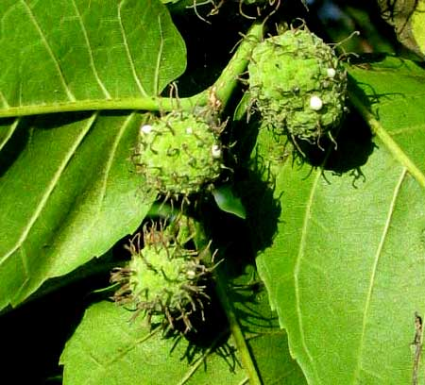
Sometimes in the woods a short stretcht of a trail will be carpeted with long, wormlike yellowish flower clusters like the one shown atop the next page. The tree producing the "worms" -- which are spikelike clusters of male flowers -- is known by everyone as Mora. Mora's female flowers are shown at the right.
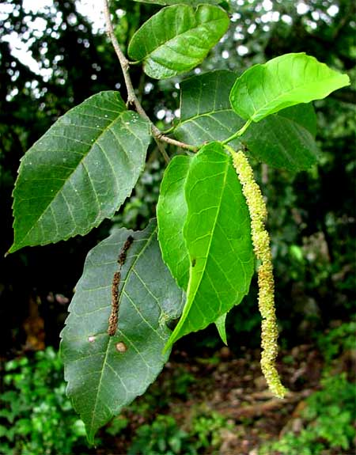
According to every Spanish-English dictionary Mora means "mulberry," but this Mora isn't what Northerners think of as a mulberry.
This Mora is Maclura tinctoria, a member of the Fig Family, like northern mulberries, and like them edible, though ours aren't so tasty.
However, tasty fruits isn't what makes Mora noteworthy. At least in the past, Mora trees were very important because a yellow dye was extracted from their wood. In fact, in the old days sometimes English speakers called Mora "Dyer's Mulberry." During World War I, dye from Mora was used to color khaki fabric for US soldiers.
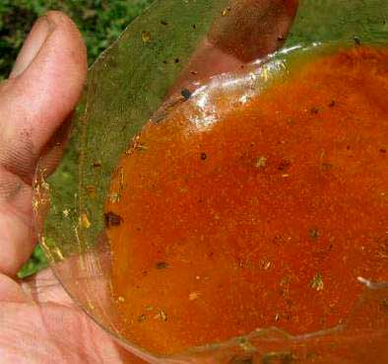
A while back I came upon a spot where campesinos had felled a Mora to make way for a milpa, or cornfield. I collected some Mora sawdust, soaked it overnight in water in a cut-off bottom of a liter Coke bottle and at the right you can see what the water looked like the next morning.
Mora is distributed from southern Mexico south all the way to Argentina.

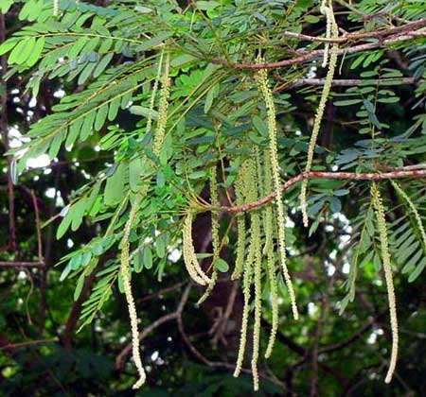
ALVARADO
A bit into the dry season, around New Year, you begin seeing large, often abundantly occurring trees with feathery leaves bearing 10-inch-long (24cm) racemes of male flowers, as shown at the right.
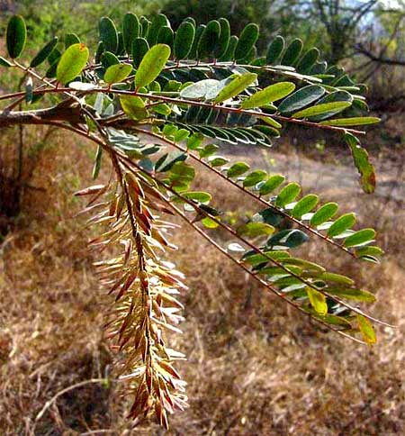
Female trees of this species also bear dangling racemes of female flowers, but they're not as noticeable. However, late in the dry season, in March or so when the landscape is dried-up and brown, it's the female trees that catch your eye with their thousands of drooping fruit clusters, as at the left
Despite this being such a ubiquitous tree in much of the Yucatan, there's just no good English name for it, so I call it Alvaradoa, because it's Alvaradoa amorphoides, a member of the mostly tropical Quassia Family, the Simarubaceae. In North America the best-known Quassia-Family member is the invasive Ailanthus, or Tree-of-Heaven, introduced from eastern Asia.
Certain seed-eating birds, such as finches, gorge on the fruits, which appear when food is getting scarce toward the end of the dry season, in May or so.

PEPPER BUSH
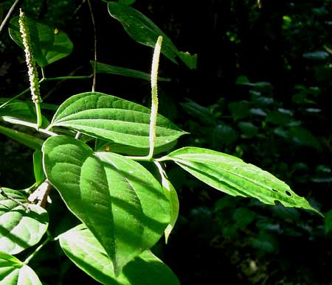
Here's another common eye-catcher that simply doesn't have a good English name. I made up the name "Pepper Bush" just so we can talk about it. That's the plant at the right.
This small tree normally occurs in the shady forest understory. Note its spikes of tiny flowers and its leaves' unusual venation. Five or so primary veins arise from leaf bases, connected by cross-running secondary veins.
This is Piper amalago. The genus Piper contains many species, and often Spanish speakers refer to them all as Cordoncillos -- "Little Strings," referring to the slender flower spikes. It's worth taking a close look at the spikes, as shown atop the next page.
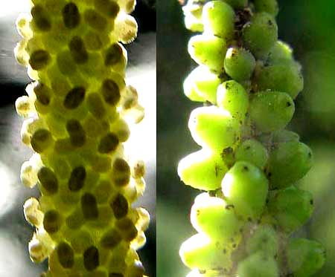
The spike on the image's left side is flowering, while the one at the right bears developing pistils, or immature fruits. When the fruits are mature, they'll be genuine peppercorns.
For, the genus Piper is the very one containing Piper nigrum of southern Asia, whose ripe fruits are the peppercorns ground into the black pepper so often used in Northern cooking.
People in the Yucatan don't bother using the dried fruits of our Piper amalgo as a spice, however, since they're too small to fool with. However, if you find a mature spike of them in the woods you can taste their definite pepperiness.

COW-ITCH - Ortiga
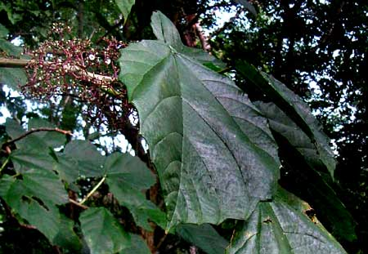
If you see a sprawling shrub or small tree with big leaves and diffuse clusters of flowers and/or white, mistletoe-like fruits arising from the stems behind the leaves, don't touch it. It's bristling with stinging, nettle-like hairs, and that's one above.
That's Urera baccifera, called Ortiga by Spanish speakers, but that name is used for just about anything with lots of little stickers. In Belize sometimes they call it Cow-Itch and that's such a fine name that it deserves to be used in the Yucatan. Cow-Itch gets its stinging bristles honestly, for it's a genuine member of the Nettle Family, the Urticaceae.
If you're familiar with nettle fruits, you'll recognize their similarity to white Cow-Itch fruits, shown atop the next page.
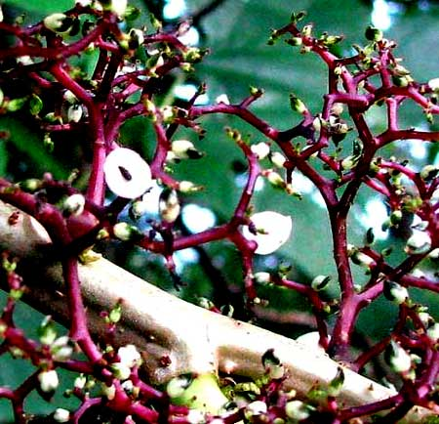
Cow Itch commonly occurs in the hot, humid American tropics from Mexico to Peru and Argentina. In Mexico the Aztecs used to make paper from Cow Itch's inner bark, while in Venezuela indigenous people boiled the root for a tea to eliminate kidney stones.
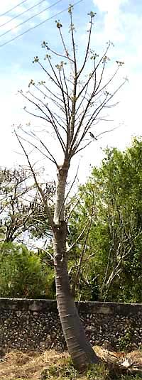

BONETE
When you see what looks like a small fruit tree sprouting from a gigantic elephant's leg -- like the dry-season-leafless one shown at the left -- probably it's what the Maya call Bonete. I find no English name for it. It's Jacaratia mexicana, endemic but frequent in the Mexican states of Yucatan and Campeche, and growing to about 40 feet high (12m).
Bonetes are members of the Papaya Family, which by itself is a bit interesting, since Papayas are so important..
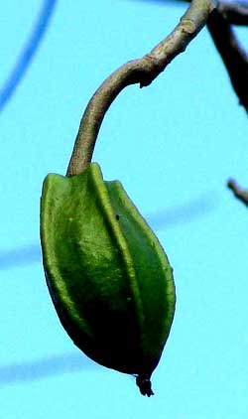
Bonetes flower in the middle of the dry season, in January or so. The male flowers are yellow and attractive, but the female ones are more interesting, being star shaped and bearing oversize, brown stigmas. The ovary bears longitudinal ridges along its sides, as shown at the right. Those ridges develop into "fins" on the Bonete's torpedo-shaped fruits:
The fruits grow to about six inches long (15cm) and may yellow. The local Maya eat them raw, and they're sweet, a lot like Papaya flesh The fruits take their time to ripen, about six months. Often by the time they ripen, leaves are present on the trees.
When I first saw the torpedo-like fruits pointed toward the ground and bearing such swooped-back fins, I imagined that when the fruits dropped the fins would stabilize their descent and the fruits would lodge nose-down in rainy-season mud. However, you can see the fruit's final destiny atop the next page.
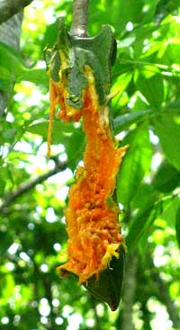
The ripe fruit, still green outside but orangish like ripe papaya inside, remains on the tree while animals eat it. Birds eat them and I suspect that fruit bats, Kinkajous and other critters do also. My Maya friends confirm that the fruits don't fall by themselves. "Use a pole," they advise. Maybe the "fins" serve as holds for animals as they feed on the fruit, before dispersing the seeds in their poop.
The Bonete's leaves emerge at the beginning of the rainy season, cluster toward the tips of branches and are "palmately compound" -- consisting of five to seven slender leaflets arising from atop a stem, or petiole, like fingers from the palm of a hand

HELICOPTER TREE
In the late dry season, around early March, you might be lucky enough to see a thick-stemmed, dry-season-leafless, smallish tree about 15 feet tall (4.5m) in full flower, appearing as shown stop the next page.
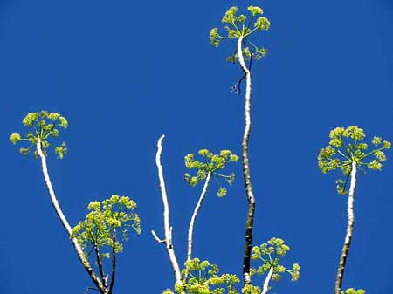
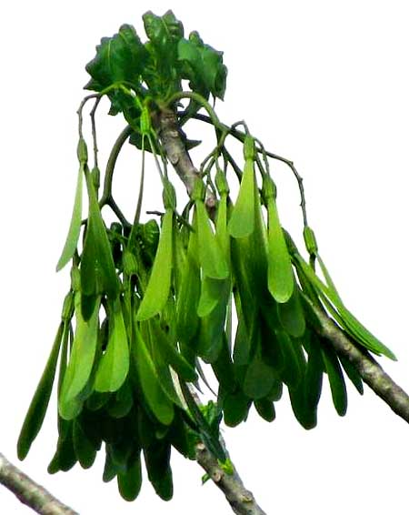
When I first saw this tree I couldn't imagine what it was. I knocked down a few flowers and their structure was unlike anything I'd ever seen. All I could do was wait for fruits in the hope that they would look like something familiar. However, when they appeared, I was even more amazed. That's them at the left.
I'd never seen such one-seeded, samara-type fruits bearing two rabbit-ear wings. Even with this extra information and long hours on the Internet I couldn't figure the tree's identity.
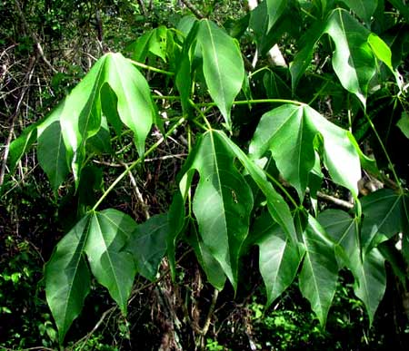
When the leaves expanded, revealing that they were "palmately lobed" -- with segments like thick fingers radiating from the palm of a hand -- that was a breakthrough.
The trees belong to a family I'd never seen before, the Hernandia Family, the Hernandiaceae. On the Phylogenetic Tree of Life the Hernandicaceae usually is placed near the Laurel Family. The tree itself is Gyrocarpus jatrophifolius, and the only English name I can find for it is Helicopter Tree, referring to the way its fruits spin as they fall. My Maya friends have nothing to say about it.
Helicopter Trees are spottily distributed throughout much of southern Mexico and Central America, but apparently nowhere are common. Little is known about them, and I regard them as one of the most interesting, obscure woody plants I've ever met.

"GAUMER'S BAKERIDESIA"
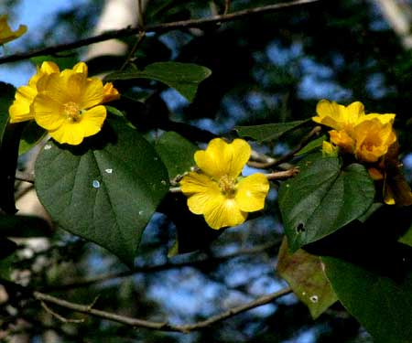
During most of the year, out in the forest, a certain 10-ft-tall tree (3m), a member the Hibiscus Family, handsomely bears the 1½-inch-wide (3.8cm), yellow flowers shown at the right.
That's Bakeridesia gaumeri, at this writing known only from the Yucatan Peninsula and a single collection stored in Honduras. It has no commonly accepted English name so I'm making up "Gaumer's Bakeridesia." Sometimes flowers have red "eyes" -- the bases of the individual petals are red.
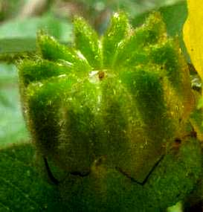
In the Hibiscus Family often fruit structure is more useful for identification than flower anatomy. An immature fruit, unusually hairy and divided into ten sections, or carpels, is shown at the left.
Apparently "Gaumer's Bakeridesia" is exquisitely adapted for the northern Yucatan's rather dry, scrubby forests, for the species disappears as the forest grows more lush and moist farther south.
"Gaumer's Bakeridesia" is pretty enough and long-flowering enough to be planted as an ornamental. It's a species just waiting to be noticed by the gardening world.

"DOG JASMINE"
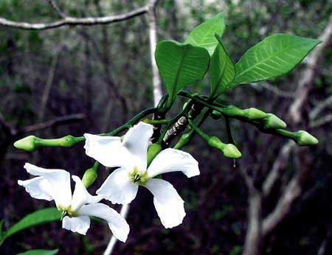
Here we end our superficial look at a few of the Yucatan's woody plants, and we're ending with another exceptionally pretty species whose name needs quotation marks around it because really it has no commonly accepted English name. In Spanish sometimes it's called Jazmín de Perro, which translates to "Dog Jasmine.," It's Tabernaemontana amygdalifolia, a member of the same family in which we also find Mandevilla vine, Oleander, Periwinkle and Frangipani, the Apocynaceae. The flowers appear in the late dry season, in April or so.
This wonderful little tree has been chosen to finish our project because it's like so many other species that are too uncommon, too hidden in deep shadows or living in too unusual environments to attract the attention they deserve.
But, you can see for yourself what a worthy being "Dog Jasmine" is, and how graciously it seems to be inviting us all to pay attention to the Yucatan Peninsula's natural environment.

